Enablers and Challenges of Kangaroo Mother Care practices
at different levels of newborn care services in India
Shashi N. Vani and Deepa Banker
Ahmedabad, India
Introduction
Globally, India faces the most difficult neonatal health care challenge of having the highest number of births as well as neonatal deaths. India has the highest number of low birth weight infants (LBWI)
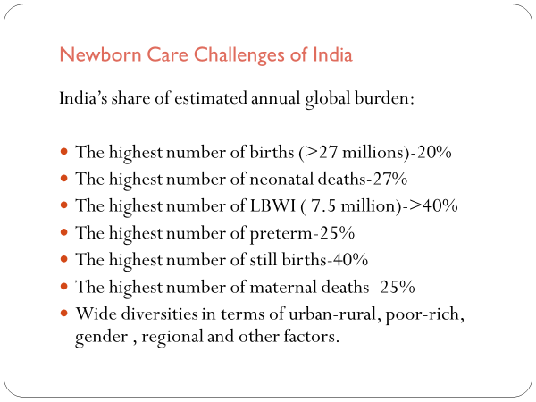
(There are strong reasons to assume that many more births are not reported despite the best efforts to collect accurate data because of difficult to reach population in difficult geographical terrains, in remote areas, migrant population and other reasons.)
Facility based newborn care is not yet available to all the newborns though the rate of institutional deliveries have considerably increased in recent years due to several efforts through Government including various cash incentive schemes for attracting people for institutional deliveries, increased awareness among general population and other reasons.
In this context of very high mortality rates and not very good public health services, simple interventions like breast feeding and Kangaroo Mother Care(KMC) have a very high potential of saving large numbers of these otherwise vulnerable newborns.
KMC in India
- Introduced in 1993 at Ahmedabad
- Gained momentum following national workshop in 2002 at New Delhi
- Formation of Indian Network of KMC 2003 (Six centers AIIMS, New Delhi, PGI, Chandigarh, KEM Bombay, ICH, Chennai, KEM, Lucknow, Jaipur)
(KMC guidelines, Training workshops, training material preparation like videos, charts etc., parent education material, Follow up services like little hut and other activities)
- 9th International conference of KMC at Ahmedabad, India 2012
- Inclusion of KMC in official policy of MOHFW of Government of India and release of operational guidelines for KMC and adequate feeding of LBWI for program managers and service providers
Included a roll out plan for training and KMC services all over the country and allocation of funds for starting KMC wards 2013
- KMC included as one of the core interventions in India Newborn Action Plan (INAP) in line with Global ENAP 2014
- Formation of KMC Foundation, India 2014 (NGO)

Thus, there is now great momentum in efforts to accelerate KMC and improving the quality practice to have better impact on neonatal health in India

Enablers and Challenges for KMC in India
(Information has been collected through authentic data
- Ministry of Health and family Welfare (MOHFW) (Child health Division) of Government of India (GOI)
- Reports of International agencies like WHO, UNICEF, SNL and others
- Special surveys
- Individual published studies from India and studies on KMC from post graduates of Pediatrics, Community medicine and nursing students from many universities of India
- Personal communications and experiences in last 20 years)
Enablers and Challenges for acceleration of KMC activities in our country have been discussed through following aspects:
1) Policy and Protocols
2) Knowledge, Awareness and Training /capacity building and Adequacy of Staff
(Doctors, consultants, nurses, community health workers and others)
3) Infrastructure, Staff, Equipment, Job aids, educational material for parents
4) Socio cultural and personal factors/perceptions of mothers and other providers of KMC in hospital as well as at home
5) Documentation, Record keeping, Data collection, audit, analysis and planning for further course of action
6) Scope of quality improvement of KMC in different settings of newborn care
7) Role of following agencies in implementation of KMC in India
A) Central and State governments
B) International Agencies like UNICEF, SNL, WHO and others
C) Public health institutions including medical colleges hospitals
D) Private newborn care institutions and hospitals
E) Professional organizations like National Neonatology Forum (NNF), Indian Academy of Pediatrics (IAP), Federation of Obstetrics and Gynecological Societies of India (FOGSI)
F) Trained Nurses Association, Association of nurses for neonatology in India, Preventive and social medicine association etc.
G) Kangaroo Mother Care Foundation and other voluntary health care agencies working for MNCH
H) Community Health workers of different cadres in promoting home based newborn care including KMC (HBKMC)

Information in the required format regarding status of KMC in India (As requested by Dr. Nathalie Charpak)
Number of Low Birth Weight infants per year:
About 7.5 million LBWI (Highest for any country)
Which constitute >40% of Global Burden of LBWI
About 26% of babies born in India are LBWI (60% are born at term IUGR and 40% are Preterm)
Preterm babies of India constitute 25% of global burden, highest for any country.
Percentage with access to some form of KMC
Data available through child health division of MOHFW of GOI
(only for babies cared for through Special /sick newborn care units (SNCU)all over India)
- Last year about 800 thousand neonates have been cared for through > 29000 operational SNCUs all over the country including government and private medical college NICUs. Of them, about 13.2% have been reported to have been given KMC with wide state to state variation as seen in the chart below)
(Countrywide, more than 50% of the newborns are cared for at home through home based newborn care by community based health workers though institutional deliveries are reported more than 70 %. Home based KMC has just started in very few centers.)
- No data available for those cared for in Private sector or at homes. Estimates suggest that in all, less than 10% neonates must be receiving KMC in private sector (with wide variations ranging from 70% to 0 %) though number of births are estimated to be much higher.
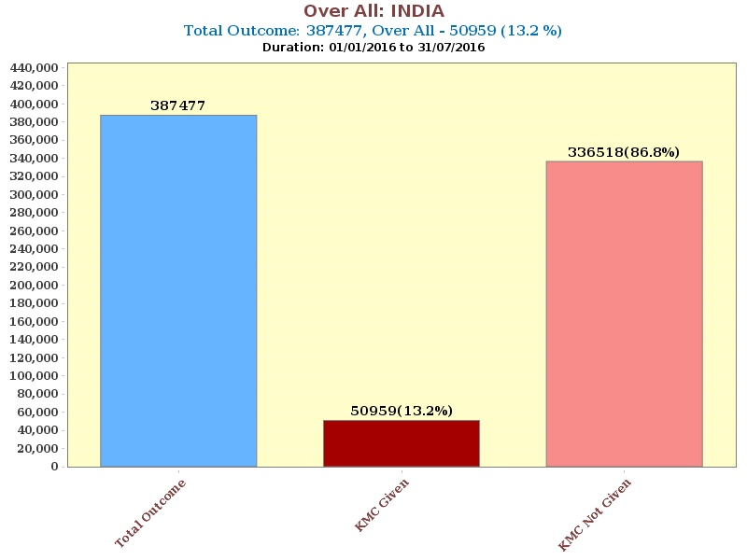
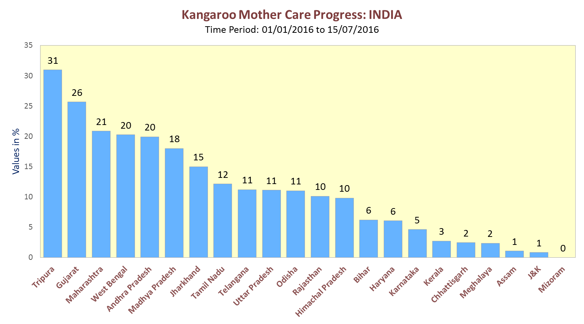

Percentage of access to full KMC implementation, including sustained follow up visits.
- Very few Teaching units affiliated to medical colleges and private hospitals have full KMC implementation. Overall it may amount to less than 0.5%
Analysis of access levels by income level, ethnic groups and urban/rural population etc.
- Exact data not available. In general, KMC services are more accessible to urban population as compared to rural population.
Description of strategy and approach for spread across regions within the country and for increased penetration within each region
- MOHFW of GOI has prepared official operational guidelines and roll out plan for promotion of KMC including adequate feeding of LBWI with all the detailed information and instructions (2014)
- KMC is one of the core interventions for preventing neonatal mortality in INAP and recently in SDG
- Champions of KMC amongst pediatricians, neonatologists and nurses have started KMC services in their own units even before Government guidelines have been released.
- NNF has included KMC as an obligatory requirement for the accreditation of a neonatal unit for training purposes. This should give more acceleration to KMC practice in India
- KMC Foundation, an NGO (working on the principles of no profit and charitable activities) has also taken up several activities to promote KMC in our country.
- State of Gujarat has declared KMC practice as an official state policy and introduced through all the SNCUs of the state. Similarly, many other states like Tamil Nadu, Telengana, Maharashtra, Andhra Pradesh, Haryana and others are also aggressively promoting KMC. A few states are yet to make any significant beginning.
Observations and insights regarding the obstacles and leverage points for achieving spread and penetration
- Policy and Protocols:
Enablers
Child health division of MOHFW of GOI has now included KMC as an official policy for ENBC in India, in year 2014 and have issued printed, clear cut, operational guidelines for KMC and adequate feeding of LBWI, for program managers and service providers.
KMC has been included as a core intervention in the India Newborn Action Plan(INAP)and recently, also in sustained developmental goals (SDG).
State governments have included KMC as an integral part in SNCUs.
Country specific protocols for facility based KMC have been prepared

Challenges/Barriers
- In most of the public and private hospitals and SNCUs written unit policies and protocols with suitable local modifications and in local languages, are not available.
- KMC is not introduced with standardized protocols in many hospitals and SNCUs
- This leads to empirical decisions and confusions among advisers and providers.

Suggestions
In every newborn care unit where KMC is practiced, written policy and local protocol regarding KMC should be available, prominently displayed diligently followed by all the staff members.

- Awareness, Knowledge and Training/capacity building
Enablers
For awareness creation
- For parent education, a few institutions have prepared handouts in local languages.
- KMCF has conducted several public awareness meetings, focused group meetings and prepared and distributed more than 10,000 educational charts in different languages
- Press notes and media coverage is also attempted by KMCF and many NICUs
For Knowledge and training/capacity building
- Roll out plan for training and capacity building has been prepared by government.
- KMC has been included in training manuals of national child health programs like FBNC, F-IMNCI, IMNCI, NSSK, JSSK, ENBC and others.
Large number of training programs are being conducted all over the country for different cadres of health workers including doctors and nurses.

Challenges /Barriers

- In most of the Government training programs, KMC is just a part of essential newborn care.
Special time is not dedicated for training of operational aspects of KMC.
The trainee gets some information and knowledge about KMC but does not develop expertize and confidence to guide the providers for KMC.
Hence knowledge is often not translated into adequate action.
- Very often trained persons are transferred to other duties and untrained persons are expected to advise KMC. Their lack of knowledge and skills leads to lack of motivation and less confidence for advising KMC.
- Major proportion of newborn care is happening at home in countries like India. The capacity of community health workers is not adequate for promotion of KMC practice at homes though many of them have some knowledge about KMC.
- Private sector including allopathic doctors (barring a few champions) as well as practitioners of alternative system of medicine do not take much interest in patient/parent education for KMC

Suggestions / solutions
- More funds and resources should be sanctioned for capacity building of all the cadres of health care workers for KMC with good quality of practice.
- Dedicated training programs for operationalizing KMC (through multiple agencies including Government programs, medical colleges, nursing colleges, training centers of community health care workers like ASHA, AWW, ANMs, Ayush (Ayurveda, Homeopathy and such alternate systems of medicine in India) doctors, and voluntary health care organizations, KMCF and other agencies) must be strengthened all over the country. There should not be any further delay or casual planning.
- Recently KMC foundation(KMCF)is also taking up a lot more training programs to support operationalizing and improving the quality of KMC in different states.
- A Certificate training course for master trainers of KMC is under consideration by KMCF.
- Mandatory preservice training including hands on experience along with breastfeeding promotion as a part of ENBC for medical as well as nursing students will enable in promoting KMC on a wider scale.
- In service training in lactation management and KMC, before posting to LR, NICU, postnatal wards, must be obligatory.
- A center for excellence for training of KMC must be created in each state to accelerate KMC in all the regions of the vast country.

- Infrastructure, equipment and job aids

Enablers
- GOI has allotted funds to build new SNCUs as well as adding to existing NICUs and postnatal wards.
- Detailed list of equipment for KMC with costing has been prepared.
- A comprehensive checklist for skill labs is also provided in the government guidelines.
- Job aids in terms of videos, charts and instructions are also provided.
- NNF has recently included KMC ward as a mandatory requirement for level II and level III newborn care units.

Challenges / Barriers
- The construction of new wards and modification of existing wards is happening very slowly.
- Timely flow of finances and payment for creating infra structure and providing staff and equipment is often a problem.
- In many units, space and staff constraints are acutely felt. Availability of trained and motivated staff is even more scarce.
- State governments are not uniformly proactive in starting KMC wards.
- Equipment availability is not uniform.
- Job aids in local languages are not available in most of the facilities
- Accountability and ownership is lacking in most of the units.
- The leadership is not very often convinced about the needs of KMC facilities.

Suggestions/solutions
- Hospital management and leadership personnel need sensitization in many hospitals.
- Equipment including reclining chairs/backrests/Pillows, KMC wraps /binders and other items mentioned in the check list given in the national guidelines must be made available and replenished from time to time.
- Job aids charts, videos suitable to local culture and language should be prepared and displayed prominently.
- KMC compliance charts also should be available and used properly.

- Documentation, Record keeping, data collection, audit, analysis and planning
Enablers
- GOI has included KMC practice in HMIS and data is being collected electronically through specially appointed data entry operators in SNCU.
- Many KMC champions, academicians and researchers have included KMC documentation in their individual units.
- A many research studies and dissertations/theses have been conducted on different aspects of KMC from India. The recent Cochrane study quotes 6 papers from India in the current review 2016
Challenges/ Barriers
This is one of the very weak component of KMC program in our country.
- Definition of KMC is not clear. A consensus has not been arrived at for a standard definition that needs to be adopted for India.
- Lack of quality assurance and standards
- The component of planned early discharge and regular follow up including neuro development is often not included in the definition of KMC in India. The minimum duration of KMC for one sitting is also variable. Many such details need close attention when the data on KMC is being collected and compared from different regions of such vast country with so many diversities.
- KMC compliance charts suitable for different levels of newborn care facilities, need to be prepared by experts and made available in all the KMC areas.
- Minimal essential data that may be of use should be available from every facility where KMC is practiced. Advanced centers or those who want to take up further research can add more data as per their requirement.
- At national level, KMC has been included in the HMIS
- The existing reporting platforms do not cover the essential/ entire component of KMC.
- But whatever has been reported is not being validated.
- No uniform system of data collection is available from all the units.
- Reports are not used for planning and midcourse corrections.
- Reporting about KMC from private sectors is almost not present.
- Collected data is not compiled and widely disseminated.
- System of auditing and planning for further action is not yet fully operational. Some beginning has been made.

- Socio cultural and Personal factors of mothers and other providers of KMC in hospital as well as at home
Enablers
- Despite many problems, most of the mothers are willing to provide KMC including breast milk feeding
- Family members including males are providing support to mother for giving KMC.
- Even in deprived sections of the society, support for KMC is now gradually increasing if properly counselled and guided.
- Joint family system has found to be of benefit for mothers to offer prolonged KMC at hospital as well as at homes.

Challenges /Barriers
- Low awareness regarding benefits and practice of KMC in society.
- No proper counselling and guidance to provide KMC by staff members.
- No support from family members for routine domestic chores or for KMC substitution.
- Lack of facility of a well ventilated clean place, privacy, reclining chairs/pillows/ back rest, KMC binders/wraps, food, drinking water, nearby clean toilets, facility for meeting family members and visitors and some recreational facilities.
- Lack of friendly behavior and proper guidance by the staff members.
- Over work for the staff members and lack of time for KMC activities.
- Personal health issues of the mothers, backache, stitch pains, anxiety and concerns for holding small babies
- Because of unavailability and/or affordability of good diapers, babies are not protected well from soiling and mothers do not like the soiling from babies.
- Caesarean and interventional deliveries pose additional obstacles for KMC in form of delaying or not doing at all.
- Mothers and family members do not feel like doing KMC as either they do not believe in the benefits or they are physically and emotionally not ready for the same.
- Family members as well as most of the medical practitioners do not perceive KMC as an important mode of intervention for care of Preterm and LBWI in NICU.
- The glamour of intensive care in terms of machines and monitors is not seen when KMC is given.
- No advice given by attending doctors as they feel that it is an income losing modality of care and some feel it is not beneficiary in any way as compared to conventional care.

Suggestions/ solutions
- All above mentioned points should be given attention.
- Focused group meetings, public meetings,
- Antenatal preparation of pregnant women should be done carefully for KMC immediately after birth and early breastfeeding. This step will increase her awareness and knowledge so that better compliance and promotion of KMC can be achieved. Role of obstetricians is very crucial in this stage.
- Publicity through print media, TV etc. to increase community awareness about KMC and increase demand generation.
- Behavioral change communications (BCC) among communities and health care workers of different categories including doctors, nurses and community health workers pay good dividends.

6) Scope of quality improvement of KMC in different settings of newborn care
In the last few years, India has shown strong political will to take on the complex and large scale problem of neonates and special attention is being given to care of sick babies, those born too soon and born too small. KMC including optimum feeding of low birth weight infants has been recognized as an important intervention for the care of the LBWI including IUGR as well as preterm babies.
If the current trend of efforts to promote KMC through awareness, training, providing support through good infrastructure including space, well trained, dedicated and motivated staff/human resource in all cadre in adequate numbers, equipment, documentation, auditing and mentoring continues properly there are definite possibilities of quality improvement of KMC practice in the country. Other socio cultural factors like educational status, inequities in income, urban/rural health care services, gender issues also will have influence.

- Role of Following agencies in promotion of KMC in India
- Central Government of India: Child health division of the Ministry of Health and Family Welfare(MOHFW)is the main nodal agency for the country for different activities related to Mother Newborn Child and Adolescent Health care activities through RMNCH-A and NHM (National Health Mission)
* It has officially recognized KMC as a core intervention and included in various training programs and have prepared a comprehensive, dedicated book of guidelines and a country wide roll out plan for providers and even program managers with all the details.
The biggest challenge is the huge population including large number of LBWI requiring facility based care and inadequate facilities to match the numbers. Along with medical college hospitals and private institutions, more than 29000 Special newborn care units have been created in smaller district hospitals and KMC has been integrated in all these hospitals. A separate budget has been sanctioned for constructing KMC wards at new SNCUs and upgrading the wards at the existing SNCUs.
As mentioned earlier there are a lot of disparities in the operationalization at state levels as states have to decide their priorities and decide the roll out plan for KMC.
- Role of International agencies in promotion of KMC in India
UNICEF
Supports training and promotion activities in different states along with the local Govt.
Supports KMC conferences and meetings at state, national and International level in a modest way.
Pace of activities are slow and variable from state to state.
In some states UNICEF has taken up a leadership role by helping to create new KMC wards, providing technical guidance and helping for data collection monitoring etc. Recently in Gujarat, UNICEF with the help of technical inputs from KMC foundation and local health ministry, has conducted a meticulous survey on status of KMC practices and suggestions for quality improvement. Some units have been rated very good and few units have been rated very low on the scaling system. The observations will help in deciding the further course of action and improvement of KMC in the state.
CARE, SNL are also helping to conduct a few training programs and sponsor meetings at state level
- Public health institutions and medical college hospitals
Recent surveys show a lot of variations. Some are centers of excellence and provide technical inputs to national and state level KMC activities. In many hospitals affiliated to teaching institutions, there are no KMC at all.
Medical council of India or the governing body for the accreditation of medical colleges should include pre service training of KMC for all the medical students along with breast feeding and the essential newborn care topics and KMC ward should be a mandatory requirement for recognition of a teaching hospital.
Similar guidelines should be there for the training institutions for the nurses also.
- Private institutions and hospitals for newborn care;
Must have KMC facilities to match their turnover and requirement to get accreditation. Their role in public awareness and demand generation is very important in countries like India where private hospitals are in great demand and families have to incur out of pocket expenses for health care including newborn care. There are a few examples of good KMC units in private hospitals run with the help of funding from corporate houses as a part of corporate social responsibility. But these are exceptions.
E) Role of Professional bodies in promotion of KMC in India
Enablers and challenges
National Neonatology ForumNNF) conducts workshops on KMC, only along with annual conferences.
No other special activities are undertaken
Very few practicing consultants participate, mainly government nurses and medical officers are deputed for these workshops.
NNF has included facilities and practice of KMC in their list of accreditation of newborn care units for training.
Indian Academy of PediatricsIAP) only recently some mention of KMC has started.
Recently in a manual on developmental pediatrics “Cradle to Crayons”, KMC has been mentioned.
One textbook of pediatrics has recently included a chapter on KMC.
Protocols and guidelines on newborn care: Recently a new book of Neonatology chapter of IAP on “Protocols and guidelines on newborn care” has included a chapter on KMC.
Many other official publications, so far have not mentioned about KMC.
Federation of Obstetrics and gynecology Societies of India: yet to show some interest.
- Nursing associations: Trained Nurses Association of India, Association of nurses for neonatology in India and other nursing associations
- Nurses show a lot of interest for KMC promotion in some hospitals.
- A few nurses have taken up KMC as a topic for Ph.D.
- A few operational research studies have been done by nurses.
- Training programs are conducted along with the conferences of doctors
Challenges /Barriers
- In India, generally doctors decide when to start KMC and stop KMC. Nurses have a very limited role in that area. But actual KMC practice including guiding mothers and family members becomes nurses’ responsibility, which they are doing well most of the time. Understaffing and over work often leads to some stiff and indifferent behavior by a few nurses.
- All nurses have not had training in KMC practice.
- There is often a mismatch in nurses’ postings in KMC units. Trained nurses are not posted in KMC units and untrained nurses are posted in KMC units creating problems

- Kangaroo Mother Care Foundation, India

A non profit organization of group of voluntary KMC champions of India who are working to accelerate KMC practice in India along with Government programs.
Vision: to make KMC as an accepted norm in the routine care of newborns and special emphasis on care of LBWI
To create awareness, increase knowledge, improve training and thus quality of KMC in all the components, promote research studies relevant to our needs, provide technical expertise and consultation to different governments and NGOs and carry out all such activities that are required to accelerate KMC throughout our country.
Formally started functioning since August 2015
It has conducted many activities for promotion of KMC till date and a lot more are in pipe line.

Key priorities to increase spread and penetration and corresponding leadership and investment requirements.
(Many points have already been mentioned. A few priority areas are again being repeated here.)
- More awareness to be created among community as well as the local policy makers and the leaders in hospitals, concerned professional bodies and all groups of health care workers including doctors and nurses
- Pace and coverage of training and capacity building needs to be accelerated including those working in resource restricted regions.
- Definition of KMC must be decided for the country with full details. There should not be any ambiguity and doubts.
- Quality of KMC (as early as possible, as frequent as possible and as long as possible should be implemented as much as possible covering all eligible low birth weight infants as many as possible, at least 90% of them) must be improved to get all the benefits.
- All the necessary facilities must be made available for mothers to carry out prolonged KMC in the hospital as well as at homes.
- The system of monitoring, minimum essential data collection and audit must be strengthened in all possible ways in all the states of India. Collected data must be quickly analyzed and used for suitable modifications of KMC practice relevant to each region. The quality of data generated must be factual and reliable.
- The scope of KMC during transport of newborns must be strengthened.
- For monitoring of newborns at home accurate weighing scales which can read up to a minimum of 5 grams or preferably digital weighing scales which are easily portable, usable and friendlier in handling and maintaining by the community health workers should be made available to all the community health care workers. Regular supply of KMC wraps/bags etc. should be ensured.
- Parent education material on KMC should be available in all languages of the country and in an attractive and easy to understand format which are culturally suitable and easily comprehensible. Other modes of publicity through press, TV, etc. and other methods should be tapped to full extent. Demand generation from the community members is the key point for the wide spread and sustainable practice of KMC.
- Research studies should be taken up through recognized agencies such as Indian Council of Medical research, Public health Foundation of India and others.
- One nodal person must be responsible for KMC activities at the child health division of ministry of health at central government.
- The GOI has already planned for a very good role out plan for the promotion of KMC in the country. But the planned activities must be fully translated into action.
- More funds may be allocated for expanding the scope of activities pertaining to acceleration of KMC in the country.
- The technical and experts group should be more proactive in strengthening KMC in the country
- KMC foundation and such NGOs should be able to expand their membership and give full support to KMC program in the country
- Coordination with other groups including breast feeding and infant feeding promotion groups will be very useful.
- Periodic stock taking and planning further course of action is very much needed.
- All the states must take up KMC acceleration in full speed.

