THE IMPACT OF KANGAROO CARE ON MOTHER’S BREASTFEEDING STATUS AND BABY’S GROWTH AND DEVELOPMENT IN PREMATURE INFANTS
Emine Serap Sarıcan*, Nazan TUNA ORAN*, Mehmet YALAZ**
*Ege University Faculty Of Health Science, Midwifery Depertment
** Ege University,Faculty Of Medicine, Neonatology Department
emine.serap.sarican@ege.edu.tr

Introduction and Aim: In studies growth and development of infants receiving kangaroo care is better, mothers that implementing kangaroo care are more willing to breastfeeding and babies were breastfed for a longer period and the nutritional status of exclusively breastfed suggest also high. This study aimed to evaluate the effect of mother's breastfeeding and on the baby's growth and development of kangaroo care for premature infants.
Method: Research was carried out at in the Children's Hospital Neonatal Department Neonatal Intensive Care Unit, an affiliation with Ege University Medical Faculty Hospital and data were collected between June 2011/June 2012. Population of the study constitude the premature babies that hospitalized in the Ege University Neonatal Intensive Care Unit between June 2011/June 2012, the sample of newborns hospitalized in the intensive care unit, according to the inclusion criteria consisted of 40 premature newborns and mothers (20 premature newborn that take kangaroo care in the study group, 20 premature newborn that not take kangaroo in the control group.). data were collected using Family Information Form, breastfeeding self-efficacy scale and Kangaroo Care Follow-up Form. In the data analysis, percentage distributions, chi-square, Mann-Whitney U, Kruskal-Wallis test was used.
Results: As a result; of evuleated the breastfeeding self efficiency mothers; there was significant difference between the mean scores of mothers who made kangaroo care and not made kangaroo care in first follow up, at discharge and after a mounth from discharge ( p<0.05) (Table 1). In percentile evaluation which is using for infant’s growht and development; there was no signifant difference between two group in terms of infant’ s weigth and height circumference (p ˃0.05), however there was signifant difference between two group in terms of height.
Discussion : As a result, studies of kangaroo care in order to improve the mother’ s breastfeeding self efficacy alone is not enough, families have been seen that they don’t attend regularly to kangaroo care. There for families to be informed and be educated regarding kangaroo care, kangaroo care practices for generalize to information and training of healthy personel kangaroo care practices for the dissemination of information and training of healthy personel, research on kangaroo care in our country is proposed to be increased.

Key words: Kangaroo care, breastfeeding, growth and development, premature

Table 1:Evuleated the breastfeeding self efficiency mothers
 | Study Group |  | Control Group
 | $$\overline{X}$$ | SS | $$\overline{X}$$ | SS | F | P
Breastfeeding Self Efficiency Scale
First visit | 125.15 | 13.72 | 118.90 | 16.94 | 9.709 | 0.00
Discharge | 127.85 | 12.35 | 122.00 | 15.34
After one mounth from discharge | 132.50 | 9.67 | 132.60 | 12.33

Table 2. Infant’s Growht And Development
 | Study Group |  |  |  | Control Group
Discharge | Min | Max | X ̅ | SS | Min | Max | X ̅ | SS | P
Weight | 1160 | 3060 | 1853 | 405.6 | 1140 | 2200 | 1743 | 240.0 | 0.303
Height | 36 | 47 | 42.50 | 2.43 | 34 | 44 | 40.50 | 3.03 | 0.027
Head | 21 | 34 | 29.65 | 3.39 | 25 | 34 | 29.55 | 2.11 | 0.911

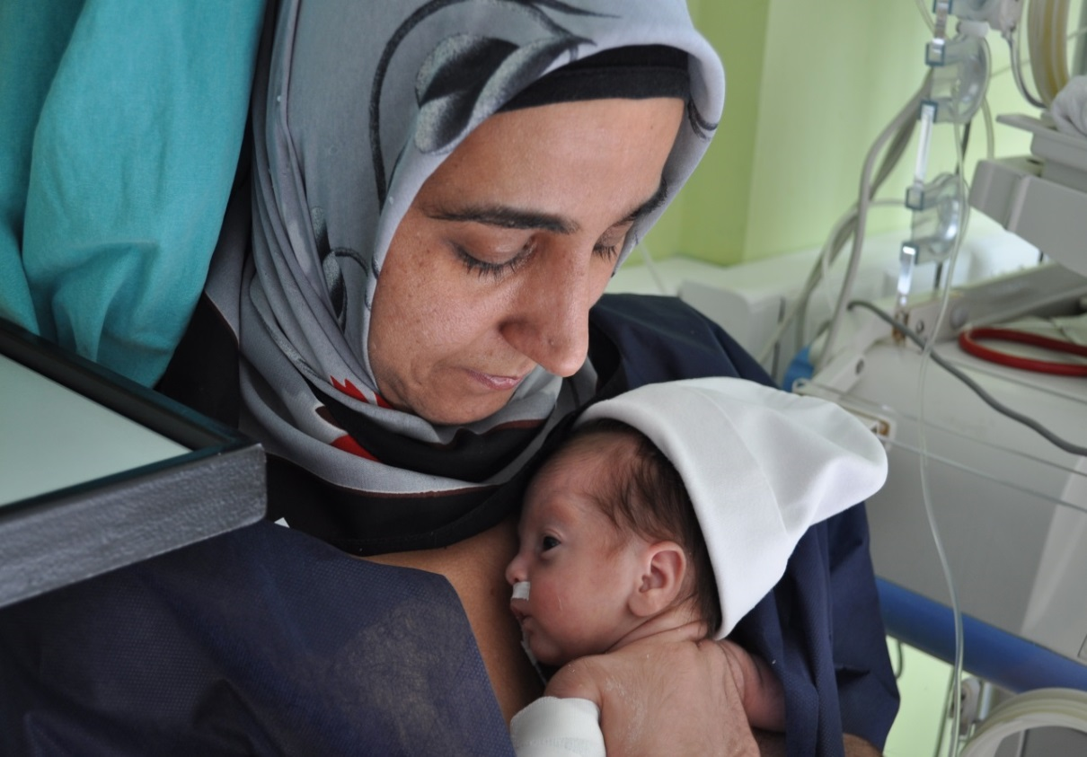
Şekil 1. Mother and baby while doing kangaroo care

Şekil 2. Baby is sleeping on kangaroo care

References

    - Venancio S.I., Almeida H. Kangaroo Mother Care:scientific evidences and impact on breastfeeding. J Pediatr (Rio J) 2004;80: 173-180
    - World Health Organization (2003). Kangaroo Mother Care: A Practical Guide. Geneva,Switzerland:1-48.
    - Heidarzadeh M. Hosseini M.B., Ershadmanesh M., Tabari M.G., Khazaee S. The Effect of Kangaroo Mother Care (KMC) on Breast Feeding at the Time of NICU Discharge. Iran Red Crescent Med J. 2013;15(4)

