THE PRE AND POST TRAINING KNOWLEDGE LEVELS AND FEEDBACKS OF PARTICIPANTS WHO ATTENDED KANGAROO CARE COURSE IN TURKEY
Demet TEREK**, Emine Serap SARICAN*, Aysun EKŞİOĞLU*,
Nalan BALTACI**, Rabia EKTİ GENÇ*, Mehmet YALAZ**
*Ege University Faculty Of Health Science, Midwifery Depertment
** Ege University,Faculty Of Medicine, Neonatology Department
demet.terek@yahoo.com

INTRODUCTION- AIM: Kangaroo care is growing for five years in Turkey and no clinic protocol is available. So five professionals who are working about kangaroo care started to give kangaroo care course in Turkey since 2013. The course’s topics are about individualized developmental care, importance and history of kangaroo care, maternal attachment and kangaroo care, kangaroo care and berastfeeding and kangaroo care on high risk babies. Before we start the course we make pre test, and after the course we make post test to train participants’ knowledge levels. The aim is this research that evaluate the pre and post training knowledge levels and feedbacks of participants who attended kangaroo care course in Turkey

METHOD: The study is a survey of educational intervention. Study was made fifteen different city between 2013 and 2016 in Turkey. Five expert person about kangaroo care gave a course with a daily programme. 358 health professionals attended to the course and 164 health professionals who filled the before/ after test were included in the study. 25 questions of questionnaire was used to measure knowledge of health professionals about kangaroo care before the training pre-test consisting. The same questionnaire was used after the training post- test. For evaluating feedback of participants, we used feedback form. 104 health professionals were included the study who filled the feedback form. We used SPSS program for data analysises.

RESULTS: The health professionals’ age range is 33,67±7,34 (min: 21, max:53) who attended kangaroo care course. %69,9 of health professionals were graduated from college/faculty.% 33,3 of health professionals were working in NICU, %33,7 of health professionals were working in delivery room .The health professionals said that they heard kangaroo care before the course. When we asked that were they heard kangaroo care, %28,6 of health professionals said that they heard from written and visual media and %22,9 of health professionals said that they heard form nurses. The participants’ s pre-test average is 71,24 ±13,97 (min:24, max:92) before training. The participants’ s post-test average is 82,55 ± 10,53 ( min:28, max:96) after training. The health professionals post test mean scores on the knowledge average is significantly higher than pre-test mean scores on the knowledge average(p< 0.05) (Table 1).
25 of participants filled the feedback form who included kangaroo care course. After the evaluated the feedback forms; %78,8 of health professionals said that the kangaroo care was appropriate to the course programme and it stated that their personal expectations (Table 2). %94,2 of health professionals said that the course was in a high link with their profession .%62,5 of health professionals said that the course was organized very well. %92,3 health professionals said that the time of subjects were very suitable and they said that the trainers told their subjects in enough time (Table 3). % 81,7 of health professionals say any negative feedback. %18,3 of health professionals said that the course have to repeat and the Ministry of health have to make regulation about kangaroo care in Turkey.

DISCUSSION: In conclusion, there was a significant difference between pre and post test knowledge levels. The health professionals post test mean scores is significantly higher than pre-test mean scores. And the health professionals said that the kangaroo care course useful for them and they said that the kangaroo care was appropriate to the course programme and it stated that their personal expectations. After the feedback, the materials of the course was worn expecialy in last courses, so we are thinking that the materials of the course should be changed. After the participants’ feedback, we are thinking that the course should be extended in Turkey.

KEY WORDS: Turkey, Kangaroo care, Knowledge Level, Feedback

Table 1.The parcicipants’ pre test and post test average
 | Mean | Std. Deviation | p
Pre-Test | 71,24 | 13,97 | ,000
Post Test | 82,55 | 10,53

Table 2. Participants' thoughts about course goal
 | Frequency | Percent
Middle | 1 | 1,0
Good | 21 | 20,2
Excellent | 82 | 78,8
Total | 104 | 100,0

Table 3. Participants thought of the usefulness of course topics
 | Frequency | Percent
Breastfeeding and kangaroo care | 13 | 12,5
Kangaroo care on high risk babies | 5 | 4,8
Maternal attachment and kangaroo care | 4 | 3,8
History and importance of kangaroo care | 10 | 9,6
Individualized developmenytal care | 9 | 8,7
All | 53 | 51,0

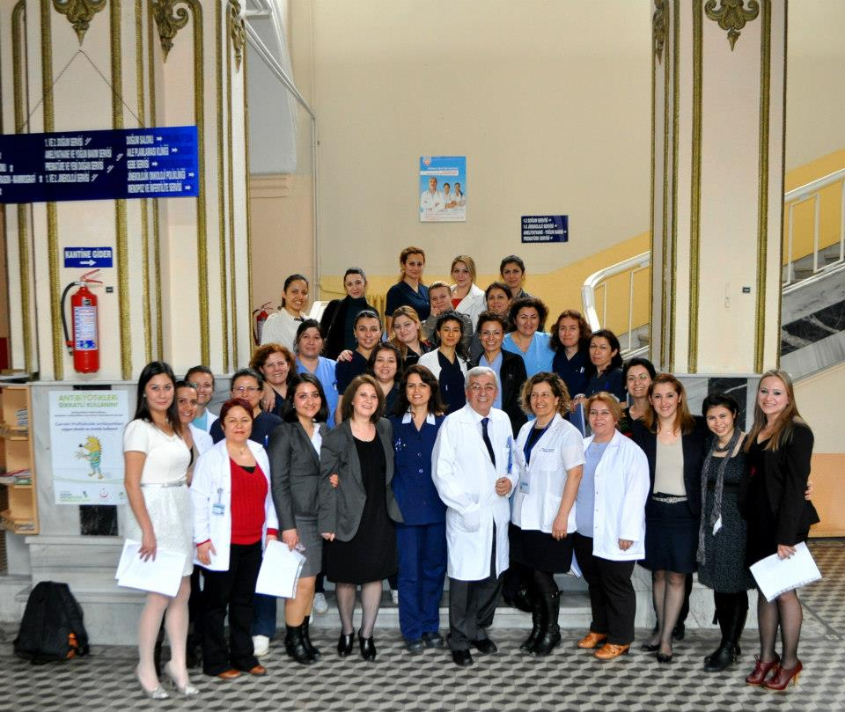
Şekil 1. First kangaroo care course in Izmir-2013
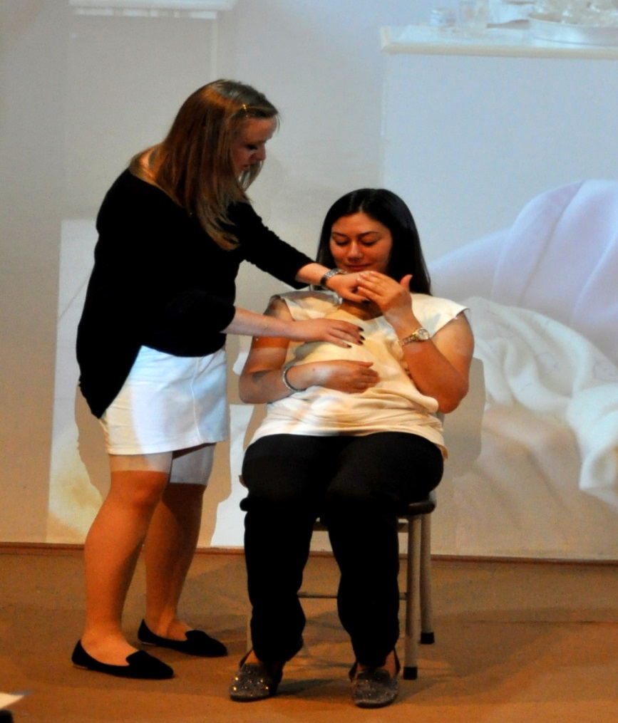
Şekil 2. Demostration

