Association of Kangaroo Mother Care on Hospital Stay and Infant Mortality:
A Meta-analysis
Ma. Esterlita V. Uy, MD¹, Michael Q. Van Haute, MD², Socorro dL Mendoza, MD³

¹Institute of Child Health and Human Development, National Institutes of Health, University of the Philippines- Manila, Philippines
²Department of Epidemiology, College of Public Health, University of the Philippines-Manila, Philippines
³Kangaroo Mother Care Foundation, Philippines, Inc.

Background: Kangaroo Mother Care is a cheap low-technology, high impact intervention for premature and low birth weight infants starting in the hospital. Evaluation of the length of hospitalization serves as a surrogate for cost of care.
Objective: To assess the effects of kangaroo mother care (KMC) compared with conventional methods of care (CMC) on length of hospitalization and mortality in premature low-birth-weight infants via a meta-analysis.
Methods: A search using keywords: Kangaroo mother care and hospital stay was performed using several search engines like PubMed, SCOPUS, Google Scholar, and ClinicalTrials.gov. and unpublished manuscripts. After removing studies which have no control group, are lacking in outcome data, non-English article and inaccessible full article, there were 39 articles obtained. Study designs such as RCTs, cohort and pre-and post-KMC implementation were accepted. A random-effects model was used to produce pooled odds ratios (ORs) and fixed effect model for the weighted mean differences.
Results: Of 145 articles screened, 39 articles included a total of 5,321 participants (2,827 in the KMC group and 2494 in the conventional group). KMC results in a significant reduction in overall hospital length of stay compared with CMC (weighted mean difference = –1.82 days; 95% CI, –2.41 to –1.22). Likewise, in 17 of the 39 articles, KMC was associated with a significant reduction in overall infant mortality (OR = 0.58; 95% CI, 0.43 to 0.80).

Figure 1. Summary data and Forest plot of the effect of kangaroo mother care (KMC) compared with conventional methods of care (CMC) on overall hospital length of stay. (n = 39)
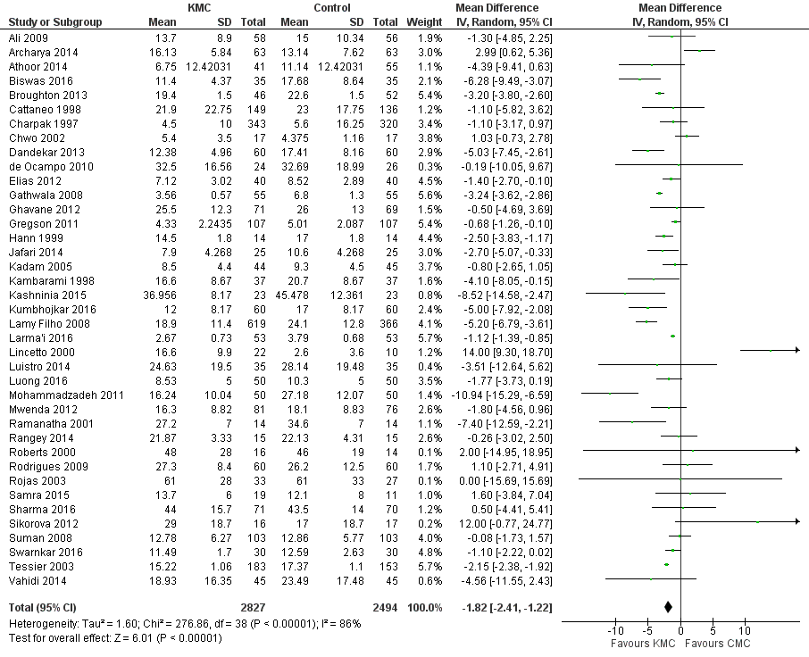

Figure 2. Summary data and Forest plot of the effect of kangaroo mother care (KMC) compared with conventional methods of care (CMC) on overall infant mortality (n = 17).
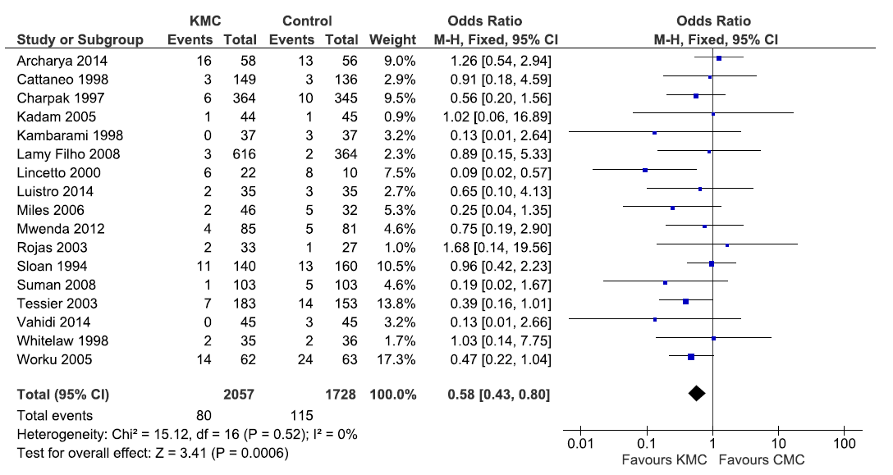

Conclusion: The practice of KMC appears to significantly reduce overall infant mortality and length of hospital stay.

