Método "mamá canguro" favorece la salud de los niños a largo plazo
Reuters15 de diciembre de 2016
Por Lisa Rapaport
(Reuters Health) - Los bebés que nacen prematuros o con bajopeso tendrían una niñez y una juventud más saludable si pasan sus primeros días de vida en contacto con la piel de su mamá.
Un equipo estudió el método "madre canguro", que está asociado con una disminución de la mortalidad y una mejoría del desarrollo en los bebés vulnerables. El sistema consiste en elcontacto piel con piel entre la mamá y el recién nacido, la
lactancia materna exclusiva, el alta temprana de la clínica dematernidad y el monitoreo cuidadoso en el hogar.
"El método madre canguro tiene un efecto protector social y conductual significativo y duradero 20 años después", dijo la autora principal, doctora Nathalie Charpak, directora de la Fundación Canguro en Bogotá, Colombia.Su equipo revisó datos de 228 jóvenes que, al azar, habían recibido los cuidados del método en un estudio cuando eran bebés. Los autores compararon los resultados con los de los 213
jóvenes que no habían recibido esos cuidados (grupo de control).Los primeros habían sido un 61 por ciento menos propensos a morir en la infancia que el grupo de control, según publican losautores en la revista Pediatrics.
Las tasas de lactancia materna también habían sido más altas con el método canguro, que también redujo las infecciones con internación.
En la niñez, los niños que habían crecido con el método canguro pasaron más años en el preescolar que el grupo de control y también obtuvieron mejores calificaciones en las pruebas de matemática y lengua, además de tener mejores salarios
en la juventud.
A los 20 años, ese grupo era menos agresivo, impulsivo,hiperactivo o menos propenso a las conductas antisociales que el grupo de control. Esta diferencia era aún más evidente si las madres eran pobres y tenían menos educación formal.
Los resultados sugieren que el método "madre canguro" brindaría una base sólida para la salud durante la vida, según opinó la doctora Lydia Furman, de Case Western Reserve University, Bebés Arco Iris y el Hospital de Niños de Cleveland
en Ohio.
FUENTE: Pediatrics, online 12 de diciembre del 2016

Phương pháp "da kề da" có lợi cho trẻ đến khi trưởng thành
Thứ sáu, 16/12/2016 13 giờ 48 GMT+0
Một nghiên cứu mới của Colombia cho biết, ủ ấm trẻ sơ sinh theo "phương pháp chuột túi" – tức là mẹ ôm ấp bé da kề da, giúp tăng cường sức khỏe, phát triển não bộ và kỹ năng xã hội của trẻ khi lớn lên.
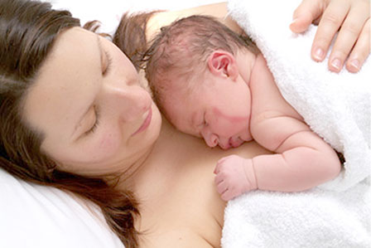
Chăm sóc bé sơ sinh bằng phương pháp chuột túi giúp tăng cường sức khỏe và trí não của trẻ sau này. Ảnh: Shutter Stock
Đây vốn là phương pháp mô phỏng cách những chú chuột túi chăm sóc con và thường được khuyến cáo áp dụng trên trẻ sinh non thay cho lồng ấp. Trong nghiên cứu, Tiến sĩ Nathalie Charpak thuộc quỹ Kangaroo ở Bogota tiến hành theo dõi hơn 700 trẻ sinh non trong giai đoạn 1993-1996. Các em được chọn ngẫu nhiên để nuôi bằng phương pháp chuột túi hoặc chăm sóc theo tiêu chuẩn bằng lồng ấp. Sau 20 năm, các nhà khoa học tiến hành so sánh lợi ích của hai phương pháp và ghi nhận nhóm các em bé được chăm sóc bằng phương pháp chuột túi có tỷ lệ chết non thấp hơn (3,5%) so với nhóm được nuôi trong lồng ấp (7,7%). Họ còn phát hiện khi trưởng thành, nhóm từng được ủ ấm bằng phương pháp chuột túi có bộ não lớn hơn và chỉ số thông minh (IQ) cũng cao hơn, nhưng ít có vấn đề về hành vi như hung hăng, hiếu động, bốc đồng so với nhóm đối chứng. Đặc biệt, họ cũng có thu nhập cao hơn 53% so với nhóm được chăm sóc bằng lồng ấp.
Tuy cách ủ ấm da kề da được biết đến từ lâu, nhưng Tiến sĩ Charpak cho biết kết quả nghiên cứu mới là bằng chứng cho thấy nuôi con kiểu chuột túi có lợi cho sức khỏe, trí não và hành vi xã hội của trẻ về lâu dài. Theo Tổ chức Y tế Thế giới (WHO), đây là giải pháp an toàn mà hiệu quả thay thế lồng ấp.
ĐƯỜNG THẤT (Theo Telegraph, NBC)

Các tin đã đưa

Phòng ngừa cục máu đông bằng miếng dán công nghệ cao (16/12/2016)
Thiết bị cấy ghép phục hồi cử động ở người chấn thương tủy sống(16/12/2016)
Miếng dán mã QR hữu dụng cho người già (13/12/2016)
Làm gì để tránh đau nhức cơ thể trong những ngày lạnh ? (13/12/2016)
Mang giày cao gót dễ bị bệnh viêm khớp (13/12/2016)
Những nghiên cứu giúp trì hoãn mất trí nhớ (13/12/2016)
Lạc quan giúp phụ nữ giảm nguy cơ tử vong vì bệnh tật (11/12/2016)
Ăn một nắm hạt mỗi ngày khỏi lo chết sớm (11/12/2016)
Triển vọng chữa Alzheimer nhờ liệu pháp chiếu sáng (10/12/2016)
Tâm trạng ảnh hưởng tới cơ quan nội tạng như thế nào? (10/12/2016)

En quoi le peau à peau avec un bébé né prématuré lui est favorable 20 ans plus tard ?
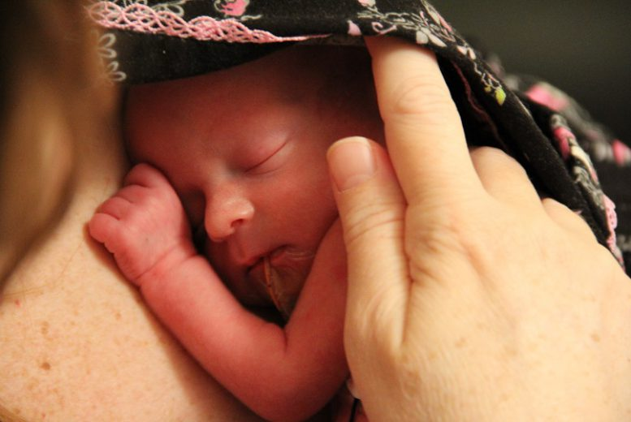
Nombreux sont les bébés à venir au monde avant terme, soit prématurément. Et en général, directement après la venue au monde trop tôt du petit bout, ce dernier est placé sous couveuse, afin de réguler sa température. Une séparation alors horrible pour la mère, qui voit son bébé lui être arraché, même si c’est pour son bien. Mais pour restaurer l’attachement mère-enfant, le peau à peau peut également être pratiqué (aussi appelé méthode kangourou, cela consiste à placer le nourrisson sur le torse de la mère ou du père, enveloppé dans une écharpe de portage). Cette pratique est bénéfique au bébé dans les jours qui suivent la naissance (favoriser l’allaitement, protéger le bébé contre des infections) mais pas seulement ! En effet, selon une étude réalisée par des chercheurs de l’organisation gouvernementale canadienne « Grands défis », en collaboration avec la Fondation Kangourou créée en Colombie, pratiquer le peau à peau serait également favorable au bébé… 20 ans plus tard !
Pour information, la méthode kangourou a été présentée pour la première fois dans une maternité de Bogota, en Colombie, au début des années 90. En effet, le service où travaillait une pédiatre française, le Dr Nathalie Charpak, à l’origine de la Fondation Kangourou, manquait de couveuses, et les pédiatres ont alors demandé aux parents de nourrissons nés prématurés de les blottir contre eux pour les réchauffer. Une solution simple, mais comprenant de nombreux bénéfices jusqu’alors ignorés ou du moins insuffisamment documentés…

Des bénéfices sur la santé et le comportement
Il y a deux ans, le Dr Nathalie Charpak, interviewée à Bogota par le magazine Neuf Mois, avait évoqué cette étude alors encore en cours, qui vient d’être publiée dans la revue médicale Pediatrics. Cette étude avait pour but d’analyser vingt ans plus tard 264 enfants nés entre 1993 et 1996 pour savoir ce que la méthode Kangourou leur avait apporté sur le long terme.
Eh bien voilà le résultat de l’étude : les enfants qui ont pu bénéficier de la méthode Kangourou auraient deux fois plus de chances de fêter leur 20ème anniversaire que ceux qui ont été placés sous couveuse. Mais ce n’est pas tout ! L’équipe du Dr Nathalie Charpak a également remarqué qu’à l’âge adulte, les enfants ayant pratiqué le peau à peau avec leurs parents étaient moins agressifs, moins impulsifs, moins hyper-actifs ou moins stressés que ceux ayant reçu les soins standard. La pédiatre a alors écrit dans son rapport : « Notre étude indique que la méthode Kangourou a un impact social significatif et durable ainsi que des effets positifs sur le comportement 20 ans après l’intervention ». Mais il semblerait que cette méthode aurait également eu un impact positif sur les parents. En effet, les couples qui ont pratiqué le peau à peau « seraient moins susceptibles de se séparer et semblent plus dévoués à leur enfant, comparé aux autres parents« , a également indiqué la pédiatre.

La méthode kangourou pour tous les bébés nés prématurés ?
Découvrir que son bébé souffre d’une maladie ou d’une fragilité liée à sa naissance prématurée est un moment douloureux à vivre et cela peut avoir un impact considérable sur les familles. Mais grâce aux nouvelles technologies d’imagerie actuelles, il est plus facile de diagnostiquer les problèmes éventuels et de les traiter. Avec les nouvelles avancées médicales, il est tout à fait possible à présent d’offrir un plus bel avenir à un bébé né prématuré. Également grâce à la méthode Kangourou ? Possible, pour renforcer les liens familiaux, souligne la pédiatre française : « Nous croyons fermement que cette intervention scientifiquement valable est puissante et efficace, et qu’elle peut être utilisée à la fois par ceux qui ont accès limité à la santé mais aussi ceux qui ont un accès illimité ». De fait, de nombreux parents aujourd’hui vivent le peau à peau à la maternité dès la naissance et sont adeptes du portage, même si bébé n’est pas prématuré. Une méthode à encourager !

LA CANGURO TERAPIA MIGLIORA LA SALUTE E L'INTELLIGENZA DEI BAMBINI PREMATURI
Il metodo, che prevede il contatto pelle a pelle con il genitore e l’allattamento al seno, secondo una ricerca comporta una serie di benefici per i figli prematuri
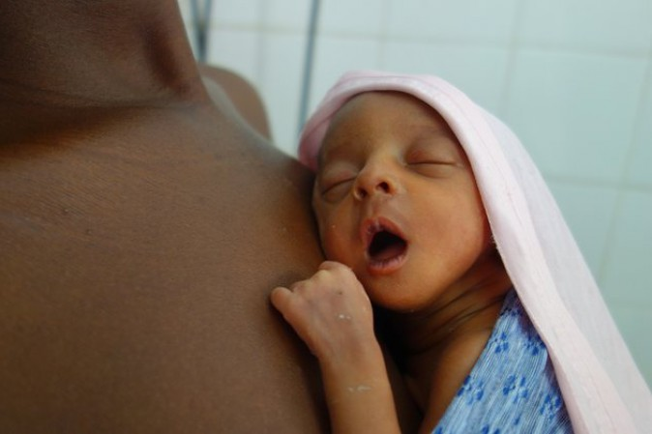
Un bambino durante una sessione di canguro terapia. Credit: Pediatrics journal
I bambini nati prematuramente che sono stati accuditi con la canguro terapia o marsupio terapia da adulti sviluppano cervelli più grandi, ottengono salari più alti e una vita meno stressante rispetto ai neonati per i quali si è fatto esclusivamente uso dell’incubatrice.
La ricerca, della Kangaroo Foundation di Bogotá, in Colombia, e pubblicata sulla rivista Pediatrics, ha esaminato ragazzi di età compresa tra i 18 e i 20 anni. Di questi, 228 erano stati sottoposti da neonati alla canguro terapia, per essere poi confrontati con altri 213 per i quali si era fatto ricorso quasi esclusivamente all’incubatrice.
Il metodo prevede che il bambino sia posto nudo, in posizione eretta sul seno scoperto della mamma. La testa è girata in modo tale che il suo piccolo orecchio, poggiato sul petto del genitore, possa sentirne il battito.
Dai risultati è emerso che coloro che avevano sperimentato il contatto pelle a pelle con la madre avevano il 61 per cento in meno di probabilità di morire durante l'infanzia rispetto ai neonati che non avevano ricevuto questo tipo di cura. Il tasso di allattamento era inoltre più alto e avevano un minor numero di infezioni gravi che richiedevano il ricovero in ospedale.
Oltre a regolarizzare la temperatura corporea, il battito cardiaco, l’ossigenazione e la respirazione del piccolo, la canguro terapia, secondo la ricerca, sembra comportare altri benefici, come rendere i bambini meno aggressivi, impulsivi e iperattivi.
Non solo: a venti anni di distanza chi ha sperimentato la canguro terapia ha un salario orario medio del 53 per cento più alto e i test del quoziente intellettivo hanno rilevato un vantaggio del 3,6 per cento rispetto a coloro per i quali invece si era fatto ricorso quasi esclusivamente all’incubatrice.
Secondo i dati dell’Organizzazione mondiale della sanità (Oms), in tutto il mondo nascono prematuramente circa 15 milioni di bambini, in media uno su dieci, con conseguenti complicazioni per la salute, che possono portare alla morte entro i primi cinque anni di vita. I tassi più alti sono nei paesi in via di sviluppo.

'Kangaroo care' makes premature babies healthier and wealthier, study finds
Research suggests method involving skin-to-skin contact and breastfeeding gives premature and low birth-weight infants better chance of thriving in later life

A baby nestled in a ‘kangaroo’ position on the mother’s chest. A new study indicates the technique has significant and enduring benefits. Photograph: Courtesy Pediatrics journal
Kate Hodal

Wednesday 14 December 2016 14.58 GMTLast modified on Wednesday 14 December 2016 15.41 GMT
Premature babies who were breastfed exclusively and kept warm through continuous skin-to-skin contact have become young adults with larger brains, higher salaries and less stressful lives than babies who received conventional incubator care, according to a study published this week.
The research (pdf), in the journal Pediatrics, compared 18- to 20-year-olds who, as premature and low birth-weight infants, were randomised at birth in Colombia to receive either traditional incubator care or kangaroo mother care (KMC) – a technique whereby parents or caregivers become a baby’s incubator and its main source of food and stimulation – until they could maintain their own body temperature.

Inequality has transformed surviving childhood into a global postcode lottery
Flavia B
The kangaroo method involves the baby nestling in a “kangaroo” position on the caregiver’s chest as soon as possible after birth, accompanied by exclusive breastfeeding. Parent and child leave the hospital together as soon as possible after birth, after which there is rigorous monitoring of baby and mother for one year after the infant’s original due date (rather than the actual birth date).
Researchers investigated 264 of the KMC participants who weighed less than 1.8kg at birth, and found that the technique offered significant protection against early death. The mortality rate among incubator-treated babies was 7.7%, more than double that of those in the KMC group (3.5%). Almost every other area investigated revealed further advantages: average hourly wages of the KMC group were nearly 53% higher than their counterparts; cerebral development was significantly higher; family life was found to be more nurturing and protective; and children spent more time in school and were less aggressive, hyperactive and stressed.
“This study indicates that kangaroo mother care has significant, long-lasting social and behavioural protective effects 20 years after the intervention,” said lead researcher Dr Nathalie Charpak, of the Kangaroo Foundation in Bogotá.
Advertisement
“We firmly believe that this is a powerful, efficient, scientifically based healthcare intervention that can be used in all settings, from those with very restricted to unrestricted access to healthcare.”
According to the World Health Organisation, nearly one in 10 babies worldwide is born preterm (before 37 completed weeks of gestation), with resulting birth complications the leading cause of death among children under five. Preterm birth rates are rising globally every year, yet more premature babies are born in low-income countries (9%) – where they face a greater risk of complications – than high-income countries (12%). In Malawi, for example, 18 in every 100 births are preterm.
Many survivors face a lifetime of disability – including learning disabilities and visual and hearing problems – and require extra care to avoid illness and death from secondary, preventable complications including hypothermia. In developing countries, where incubators are often scarce and unreliable, kangaroo mother care could save lives, said Dr Peter Singer, chief executive officer of Grand Challenges Canada, which supported the research.
“A premature infant is born somewhere in the world every two seconds,” he said. “This study shows that kangaroo mother care gives premature and low birth-weight babies a better chance of thriving. Kangaroo mother care saves brains and makes premature and low birth-weight babies healthier and wealthier.”
While the technique does not replace modern science or neonatology, it is an excellent complement, said Charpak. Hospitals in Scandinavia, among them the NICU in Uppsala, Sweden, are using KMC to stabilise preterm babies. Grand Challenges Canada is funding two “centres of excellence” and 10 treatment centres to deliver kangaroo care across Cameroon and Mali, where preterm birth rates are among the highest in the world.
The study’s positive findings are impossible to attribute to one reason alone, said Charpak. Rather, they result from a multidisciplinary approach involving regular skin-to-skin contact, breastfeeding, education of the mother and family, and support over a 12-month follow-up period.
“One of our hypotheses is that, by placing the infant in the mother, father or caregiver’s chest, the infant’s brain is in a less stressful environment,” said Charpak. “KMC also creates a climate in which the parents become progressively more aware of the child and more prone to sensitive caring.”
In contrast, said Charpak, a preterm baby born at 30 weeks could spend seven weeks in an incubator, where it is separated from its mother and faces a steady stream of light and noise. “It is easy to understand why this may not be the place for the baby’s immature brain to grow correctly,” she added.
Although a Cochrane review of 21 randomised control trials concluded that kangaroo mother care significantly reduces mortality among preterm babies and is a safe and effective alternative to conventional care, global use of the technique remains low. The Every Newborn action plan, endorsed by the World Health Organisation in 2014, set a target to reach at least 50% of the world’s low birth-weight infants with kangaroo mother care by 2020.
Charpak is hopeful that research efforts like the Colombia study will change attitudes to the care of preterm babies, not least among health workers.
“There are barriers related to the implementation of KMC programmes, particularly from health staff,” she said. “We believe long-term results will help convince the doubtful about the benefits of implementing KMC.”

Método canguru faz prematuros serem adultos mais saudáveis e promissores

Taxa de mortalidade desses bebês também é menor que a de crianças que ficaram na encubadora
POR O GLOBO
14/12/2016 16:13 / atualizado 14/12/2016 16:38
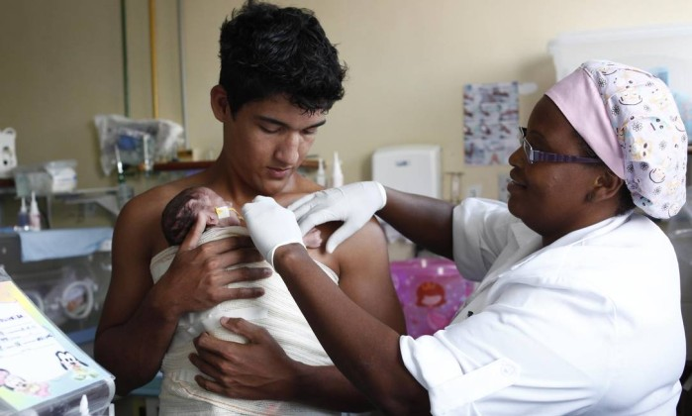
Projeto Pai Canguru, no Hospital Rocha Faria, no Rio - Maurício Bazílio / Divulgação
Prematuros faz com que as crianças fiquem mais saudáveis e promissoras na vida adulta. Segundo a pesquisa, os recém-nascidos submetidos ao contato com a pele da mãe ou do pai se tornam pessoas menos estressadas, com salários mais altos e cérebros maiores que aqueles que ficaram na encubadora.
Para realizar o estudo, os cientistas observaram um grupo de jovens de 18 a 20 anos nascidos na Colômbia. Entre os participantes, havia aqueles que foram submetidos à incubadora e os que foram tratados com o método canguru.
"Esse estudo indica que o método canguru tem efeitos sociais e comportamentais significativos e duradouros mesmo 20 anos após a utilização da técnica. Acreditamos que essa é uma intervenção eficiente e poderosa, com base científica, que pode ser usada em diversas realidades, por eauqeles com acesso restrito ou irrestrito aos serviços de saúde", afirmou a pesquisadora Nathalie Charpak, da Fundação Canguru, na Colômbia.
A primeira observação dos cientistas durante a pesquisa foi que a utilização do método canguru contribuía para um menor índice de mortalidade precoce. Enquanto a taxa de mortalidade dos bebês tratados com incubadora foi de 7,7%, a das crianças submetidas ao método canguru era de 3,5%.
"Uma das nossas hipóteses é que ao colocar a criança no peito da mãe, do pai ou do cuidador, o cérebro do bebê está em contato com um ambiente menos estressante. O método canguru também cria um clima no qual os pais se tornam progressivamente mais conscientes da criança e mais propensos a cuidar delas de maneira mais sensível", explica a pesquisadora.
O salário médio dos bebês que mantiveram o contato com a pele dos pais logo após o nascimento foi 53% maior que o das crianças que ficaram na encubadora. De acordo com a pesquisa, os pertencentes ao primeiro grupo ficaram mais tempo na escola e eram crianças menos agressivas, características que também refletiram em uma vida familiar mais amorosa.
Entre outros aspectos, os cientistas também identificaram uma maior desenvolvimento do cérebro desses bebês em comparação com aqueles que ficaram na encubadora.
Leia mais sobre esse assunto em http://oglobo.globo.com/sociedade/saude/metodo-canguru-faz-prematuros-serem-adultos-mais-saudaveis-promissores-20647612#ixzz4TTu3UJH0
© 1996 - 2016. Todos direitos reservados a Infoglobo Comunicação e Participações S.A. Este material não pode ser publicado, transmitido por broadcast, reescrito ou redistribuído sem autorização.

Método canguru beneficia prematuros no longo prazo
Pesquisa indica que intenso contato físico com pais provoca efeitos duradouros em prematuros. Cerca de 20 anos depois do nascimento, bebês apresentam melhor desenvolvimento que os tratados em incubadoras.
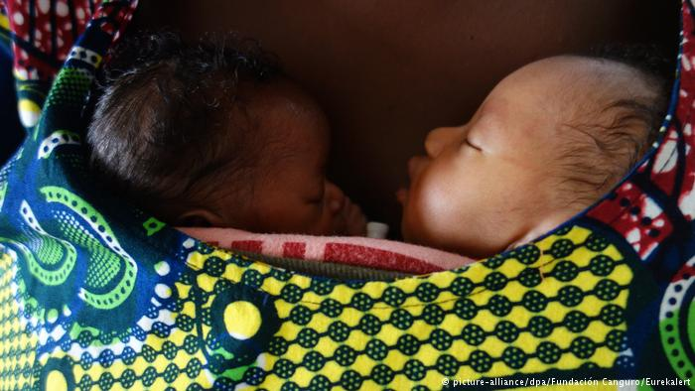
Um estudo divulgado nesta semana pela revista científica Pediatrics indica que bebês prematuros se beneficiam de um intenso contato físico com seus pais mesmo décadas depois do nascimento. A pesquisa sobre os benefícios do chamado método canguru foi realizada em Bogotá com ajuda de cientistas canadenses.
Financiado pelo governo do Canadá, o projeto analisou o desenvolvimento de 264 bebês tratados com o método canguru entre 1993 e 1996. Cerca de 20 anos depois, os jovens foram entrevistados e submetidos a provas durante três dias. Os pesquisadores constataram que eles são menos propensos a agressividade, impulsividade ou hiperatividade, têm cérebros maiores e um melhor desenvolvimento intelectual em comparação com recém-nascidos prematuros que receberam tratamento tradicional em incubadoras.
Método criado há 38 anos
Desenvolvido em 1978 pelos neonatologista colombiano Edgar Rey Sanabria, o método canguru busca incentivar o contato direto do bebê prematuro com a mãe ou o pai imediatamente após o nascimento, assim como durante a amamentação.
As crianças tratadas com esse método também apresentam menor taxa de mortalidade, dormem melhor e sofrem menos estresse do que aquelas que receberam tratamento tradicional de incubadora após o nascimento, segundo escreve a equipe liderada pela médica franco-colombiana, Nathalie Charpak, da Fundação Canguru, de Bogotá.
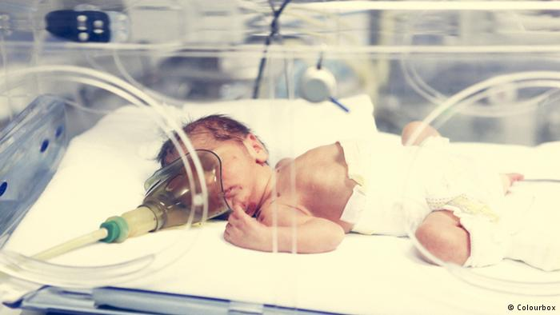
Método canguru foi criado como alternativa à incubadora
"No grupo que praticou o método canguru, as mães colocaram suas crianças em escolas mais cedo que o outro grupo e posteriormente, tiveram menos deserções escolares", afirmou Charpak. Para a médica, os resultados indicam que "o método canguru parece ter um maior impacto nas famílias com menos educação e mais pobres".
Peter Singer, diretor da Grand Challenges Canada (GCC), organização canadense que financiou a pesquisa, destacou a importância do método em todo o mundo. "No mundo, a cada dois segundos nasce um bebê prematuro. Esse estudo demonstra que o método canguru proporciona aos bebês prematuros e de baixo peso uma maior oportunidade para prosperar. O método salva cérebros e faz com que os prematuros e bebês de baixo peso sejam mais saudáveis", acrescentou.
Segundo a Organização Mundial da Saúde (OMS), nascem no mundo 15 milhões de crianças prematuras ´por ano, ou seja, antes da 38ª semana de gravidez.
MD/efe/dpa
[헬스코리아뉴스 / 권현 기자] 캥거루 케어가 미숙아의 건강과 지능발달에 도움이 될 수 있다는 연구결과가 나왔다.
캥거루 케어는 갓 태어난 아기의 가슴을 산모의 가슴에 대고 등을 쓰다듬어 애착관계를 형성하는 스킨십을 말한다. 콜롬비아에서 시작됐으며, 인큐베이터를 대체하는 방법으로 쓰인다.
콜롬비아 캥거루 재단(Kangaroo Foundation) 나탈리 차팍(Nathalie Charpak) 박사는 1993~1996년 사이 미국에서 태어난 미숙아 700명을 캥거루 케어와 인큐베이터 집단으로 나눠 20년 동안 추적·관찰해 이 같은 결과를 얻었다고 텔레그래프가 12일 보도했다.
추적·관찰한 결과, 캥거루 케어 집단의 조기 사망률은 3.5%로 인큐베이터 집단의 조기 사망률(7.7%)보다 2.2% 더 낮았다.
IQ의 경우 캥거루 케어 집단이 인규베이터 집단보다 3.5% 높았고, 중추신경계의 신경세포가 밀집된 뇌의 회색질(grey matter)의 용적도 인큐베이터 집단보다 큰 것으로 나타났다.
캥커루 케어 집단은 공격적인 성향도 인큐베이터 집단보다 덜 했고 무단결석률도 낮았다.
즉, 캥거루 케어 집단은 인큐베이터 집단보다 신체적·정신적 건강이 우월한 것으로 평가가 가능하다.
▲ 캥거루 케어가 미숙아의 건강과 지능발달에 도움이 될 수 있다는 연구결과가 나왔다.
차팍 박사는 “캥거루 케어의 효과가 20년이 넘게 지속된 것을 확인했다”며 “미숙아의 건강 증진에 효율적이고 과학적인 중재가 될 것”이라고 말했다.
이 연구결과는 소아과학 저널(Journal Paediatrics)에 게재됐다.
<저작권자 © 대한민국 의학전문지 헬스코리아뉴스 무단전재 및 재배포금지>
권현 기자의 다른기사 보기

Klokan metoda čini nedonoščad zdravijom i bogatijom
Prijevremeno rođene bebe koje su isključivo dojene i koje su s roditeljima konstatntno ostvarivale kontakt koža na kožu kasnije će biti pametnije, imat će veće plate i manje stresan život u odnosu na bebe koje su sve vrijeme bile u inkubatoru, pokazala je nova studija koja je objavljena ove sedmice.
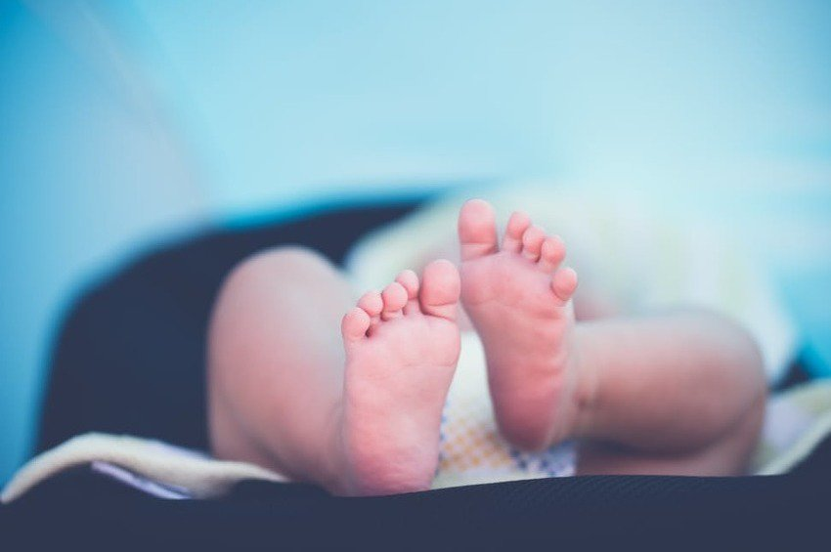
U istraživanju su učestvovali mladi od 18 do 20 godina koji su rođeni prije termina, a koji su ili bili u inkubatoru ili su imali kontakt s majkom, takozvanu klokan metodu. Klokan metoda podrazumijeva postavljanje bebe u klokan poziciju na majčina prsa što je moguće prije nakon porođaja, uz isključivo dojenje. U tom slučaju, važno je da majka i beba što prije odu iz bolnice nakon čega godinu dana bivaju pod strogim nadzorom stručnjaka.
Istraživači su ispitivali 264 osobe koje su po rođenju težile 1.800 grama i utvrdili da je klokan metoda odigrala značajnu ulogu u zaštiti od prerane smrti. Stopa smrtnosti među bebama koje su bile u inkubatoru je bila 7,7 posto, dok je ta stopa kod beba o kojima je brinuto klokan metodom bila 3,5 posto. Osim toga, otkrivene su i brojne druge prednosti kao što su znatno bolji razvoj mozga, plata veća za 53 posto, bolji porodični život, te manje agresivnosti i hiperaktivnosti.
"Ova studija pokazuje da je klokan metoda utiče na društveno ponašenje i odnose 20 godina nakon rođenja", rekla je voditeljica studije Nathalie Charpak iz Udruženje Klokan u Bogoti.
Prema podacima Svjetske zdravstvene organizacije, jedna od 10 beba u svijetu je nedonošče. Mnoge od onih koje prežive imaju određenu vrstu invaliditeta, uključujući poteškoće u učenju i probleme sa vidom i sluhom. Doktor Peter Singer ističe da u zemljama u razvoju, gdje su inkubatori rijetkost ili su nepouzdani, klokan metoda može spasiti živote beba.
Kængurupleje' gavner for tidligt fødte bedre end kuvøse
theguardian.com
15 december 2016
ANDRE SKRIVER
BØRN & UNGE
Hvis et spædbarn kommer for tidligt til verden, kan forældrene med fordel hente inspiration fra kænguruens meget tilknyttede pleje af sine unger.
For tidligt fødte børn, som kun blev ammet, ikke madet med flaske, og holdt varme gennem vedvarende hud-mod-hud kontakt, voksede op og blev unge voksne med større hjerner, højere lønninger og mindre stressfulde liv, end de babyer, der lå i kuvøse, skriver theguardian.com.
Det viser et nyt studie, som er udgivet i tidsskriftet Pediatrics.
»Dette studie indikerer, at moderens 'kængurupleje' har en betydningsfuld, langvarende social og adfærdsmæssig beskyttende virkning, selv 20 år efter tiltaget,« siger hovedforfatter på studiet, Nathalie Charpak fra the Kangaroo Foundation i Bogotá, til theguardian.com.
LÆS OGSÅ: Mors hjertebanken og godnatsange giver for tidligt fødte større hjerner
Studiet sammenlignede 264 18-20-årige, der blev født for tidligt og dengang enten modtog traditionel behandling i kuvøse eller såkaldt 'kængurupleje'; en teknik, hvor forældre eller værger bliver barnets menneskelige kuvøse og hovedkilde til næring og stimulering, indtil barnet selv kan opretholde sin kropstemperatur.
Kænguruplejen indebærer desuden, at den nyfødte baby så hurtigt som muligt putter sig i en 'kænguruposition' på forælderens bryst og kun ammes.
Kænguruplejen kan, udover at gavne de for tidligt fødte børn senere i livet, være en betydningsfuld metode til at beskytte mod tidlig død, viser det nye studie.
Dødeligheden blandt kuvøsebehandlede spædbørn var 7,7 procent, hvilket er mere end dobbelt så højt som hos de kænguruplejede, hvor andelen kun var 3,5 procent.
Kænguruplejen kan ikke erstatte moderne videnskab eller neantologi - det lægefaglige område, der beskæftiger sig med sundhed og sygdomme hos nyfødte børn - men det kan være et glimrende supplement, fortæller Nathalie Charpak til theguardian.com.
LÆS OGSÅ: For tidligt fødte og demente: Hvornår er et liv værdigt?
LÆS OGSÅ: Genvariant kan rumme hemmelighed til at redde for tidligt fødte
lsd
Ovenstående er udvalgt og resumeret af Videnskab.dk, men redaktionen har ikke udført selvstændig research. Gå til den oprindelige kilde for flere detaljer.
Videnskab.dk Redaktionen

Τα πρόωρα βρέφη γίνονται πιο υγιή και... πλούσια με τη φροντίδα «καγκουρό»

Τα βρέφη που γεννιούνται πρόωρα, όταν τρέφονται αποκλειστικά με μητρικό γάλα και βρίσκονται σε συνεχή επαφή «δέρμα με δέρμα», ως ενήλικες έχουν μεγαλύτερους εγκεφάλους, υψηλότερους μισθούς και λιγότερο αγχώδεις ζωές σε σύγκριση με τα μωρά που φροντίζονται με τον συμβατικό τρόπο, όπως αποκαλύπτει επιστημονική μελέτη.

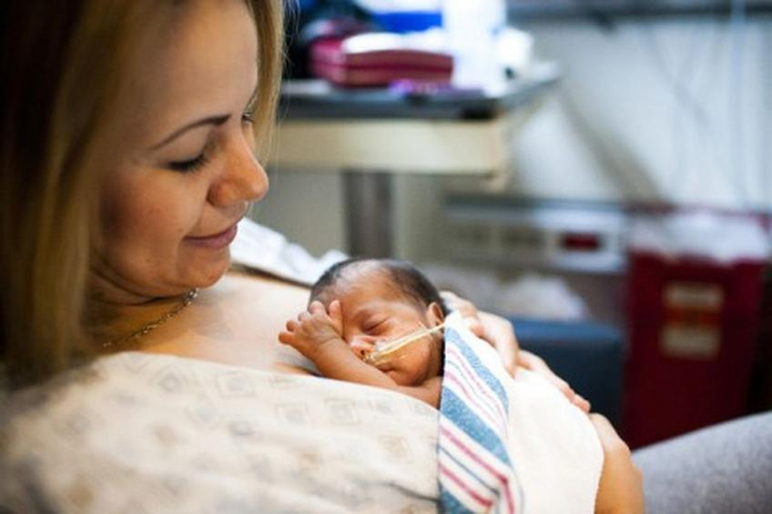
Στην έρευνα που δημοσιεύτηκε στο περιοδικό «Pediatrics» συμμετείχαν νεαροί ηλικίας 18-20 ετών, που γεννήθηκαν πρόωρα και είχαν χαμηλό βάρος ως βρέφη, και είτε πέρασαν τις πρώτες ημέρες της ζωής τους σε θερμοκοιτίδα ή έλαβαν την φροντίδα «καγκουρό» (τεχνική επαφής του μωρού με τη μητέρα «δέρμα με δέρμα», που θυμίζει τον τρόπο που κρατούν τα καγκουρό το μωρά τους στο μάρσιπο).
Με την εφαρμογή της μεθόδου «καγκουρό» η μητέρα και το παιδί παίρνουν εξιτήριο από το νοσοκομείο σχεδόν αμέσως μετά τη γέννα και επί ένα χρόνο βρίσκονται υπό αυστηρή παρακολούθηση.
Οι ερευνητές παρακολούθησαν 264 βρέφη που έλαβαν τη φροντίδα «καγκουρό» (KMC) και ζύγιζαν λιγότερο από 1,8 κιλά κατά τη γέννησή τους και διαπίστωσαν ότι η συγκεκριμένη μέθοδος προσέφερε ένα σημαντικό ποσοστό προστασίας από ενδεχόμενο πρόωρο θάνατο. Το ποσοστό θνησιμότητας τον βρεφών που μπήκαν σε θερμοκοιτίδα ήταν 7.7%, διπλάσιο από εκείνα που έλαβαν την KMC (3,5%).
Επιπλέον, είχαν κατά 53% υψηλότερο μισθό, μεγαλύτερη εγκεφαλική ανάπτυξη, καλύτερη οικογενειακή ζωή, έκαναν περισσότερες σπουδές και ήταν λιγότερο επιθετικά, υπερδραστήρια και αγχωμένα.
«Αυτή η μελέτη αποδεικνύει ότι η φροντίδα “καγκουρό” έχει σημαντικές κα μακροχρόνιες επιπτώσεις, ακόμη και μετά από 20 χρόνια», είπε η επικεφαλής της ομάδας έρευνας Nathalie Charpak.
«Πιστεύουμε πως πρόκειται για μία ισχυρή, αποτελεσματική και επιστημονικά βασισμένη παρεμβατική φροντίδα που μπορεί να εφαρμοστεί σε κάθε περίπτωση», πρόσθεσε.
Σύμφωνα με τον Παγκόσμιο Οργανισμό Υγείας, παγκοσμίως, ένα στα 10 βρέφη που γεννιούνται είναι πρόωρα.
Πηγή: the guardian

What We Can Learn from Kangaroos
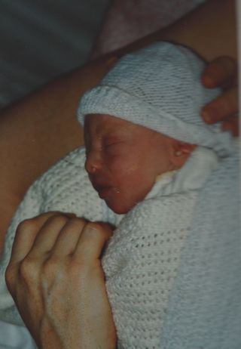
Source: Randi Hutter Epstein
What a nice scientific study to read on my son’s twenty-third birthday. Turns out that cuddling and nursing premature babies instead of just putting them in an incubator and giving them a bottle turns them into grounded, social adults.
So 23 years ago today, my son was born a month before his due date. Just the night before that, I showed my husband a photo from one of my medical school books and under the caption of an image of a 34-weekish-old unborn baby, it said: at this point the baby is fully formed, it just has no body fat. I’m paraphrasing, but it said something of that ilk.
A few hours later my water broke (much to our shock) and a few hours after that Jack came out. The book was right. He was skinny. We were living in London at the time. My doctor was really relaxed about pregnancy and birth. No whisking baby Jack away to a nursery, no extra exams. It was just me and Jack in the hospital room to snuggle and nurse. We went home the next day. I’m not sure we were in the hospital 24 hours.
The researchers in the new study—published in the December issue of Pediatrics—compared mothers of premies who got so-called Kangaroo care, to those who didn’t. Kangaroo care was adopted from Kangaroos who hop around with their little Joeys. For pouchless humans it means skin-to-skin contact, exclusive breastfeeding and leaving the hospital as soon as medically possible. This new study, by doctors in Bogota, Columbia tracked about 200 kids for twenty years, about half had been randomly chosen for the kangaroo category. They found that the Kangaroo kids scored lower on aggression, anti-social behavior, and attention deficit disorder.
I’ve got to believe that one-on-one time with a newborn plus breastfeeding is a better approach than nurseries and bottles. I’m not completely convinced that the snuggling and breast milk is why my son (or any kid) is grounded, social, and not-aggressive. In any event, I was pleased to see the email of the results in my inbox on his birthday. It seemed like a sort of gift. And, well, if it’s more evidence—even just a little—to push for mothers and babies to be together with fewer medical intrusions, then that’s a good thing.
But the study made me think of the reverse. Sure, babies benefit from being held closely, but we new mothers benefit too. Not sure if it’s hormonal thing and not sure if a study could prove a statistically significant advance for kangarooing moms, but I’ve got a hunch that the time my premature baby Jack and I spent together did just as much good for me as it did for him.
References
Charpak, Nathalie, et. al, "Twenty-year Follow-up of Kangaroo Mother Care Versus Traditional Care," Pediatrics, 139:1, January, 2017

Pelle a pelle con mamma e papà, benefici 'canguro-terapia' durano decenni

Migliora salute e intelligenza nati prematuri
Redazione ANSA ROMA
13 dicembre 201617:34
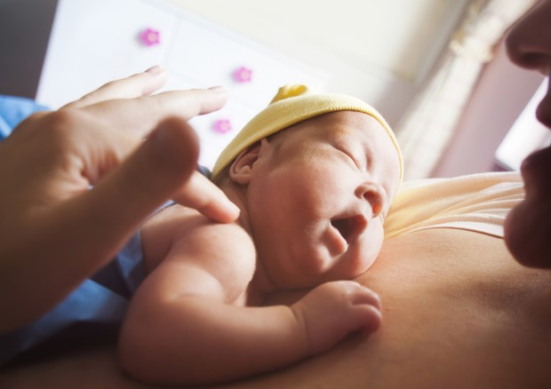
Pelle a pelle con mamma e papà, benefici 'canguro-terapia' durano decenni © ANSA/Ansa
+CLICCA PER INGRANDIRE
Un contatto pelle a pelle con mamma e papà dopo la nascita è un vero e proprio toccasana per i bimbi, in particolare quelli nati prematuri, circa 15 milioni ogni anno nel mondo. Questa pratica, chiamata anche "canguro- terapia" o "marsupio-terapia" migliora la loro salute complessiva e offre una marcia in più termini di intelligenza, oltre a renderli meno aggressivi, impulsivi e iperattivi. Gli effetti sono duraturi e si osservano fino a 20 anni dopo.
È quanto emerge da una ricerca guidata da Nathalie Charpak, della Kangaroo Foundation di Bogotá, in Colombia, pubblicata sulla rivista Pediatrics. Gli studiosi hanno esaminato ragazzi di età compresa tra i 18 e i 20 anni: 228 erano stati sottoposti alla "canguro-terapia" da neonati e riarruolati da un precedente studio e sono stati confrontati con altri 213 per i quali invece si era fatto ricorso quasi esclusivamente all'incubatrice. Dai risultati è emerso che coloro che avevano sperimentato il contatto pelle a pelle con mamma e papà avevano il 61 per cento in meno di probabilità di morire durante l'infanzia rispetto ai neonati che non avevano ricevuto questo tipo di cura. Il tasso di allattamento era inoltre più alto e avevano un minor numero di infezioni gravi che richiedevano il ricovero in ospedale. Un test del quoziente intellettivo ha rilevato inoltre un piccolo ma significativo vantaggio di chi aveva sperimentato la 'canguro-terapia' del 3,6 per cento e la tendenza a sviluppare un cervello più grande, con volumi significativamente maggiori di materia grigia. Un ultimo beneficio? Coloro che da neonati erano stati a contatto diretto con mamma e papà avevano un salario orario medio del 53 per cento più alto.

Le peau à peau pour accompagner les bébés prématurés
Topsante13 décembre 2016
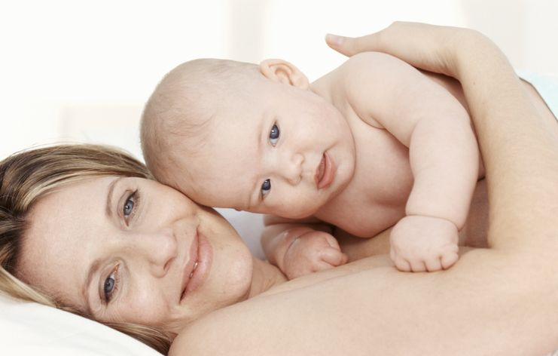
Voir les photos
Une nouvelle étude privilégie la méthode du peau à peau pour une bonne santé physique et mentale des bébés prématurés.
Plus
Un bébé prématuré a besoin à sa naissance d'une maman « kangourou » et du contact rassurant du peau à peau, selon les résultats d'une étude menée par Grands challenges Canada . Cette méthode permettrait de réduire le risque de mortalité précoce des nourrissons, mais aussi qu'ils grandissent en bonne santé et avec un meilleur développement cognitif à l'âge adulte.
Les chercheurs de l'organisation gouvernementale canadienne "Grands challenges Canada" et de la Kangaroo Foundation, en Colombie, ont mené une étude avec 264 nourrissons nés prématurément entre 1993 et 1996 pour comprendre quels étaient les bénéfices de la couveuse et du « peau à peau ». Ils ont retrouvé les enfants 20 ans plus tard pour établir leurs conclusions.
La pollution favoriserait les naissances prématurées

Favoriser le peau à peau pour les bébés prématurés
Les nourrissons prématurés et de faible poids de naissance ont été répartis à la naissance au hasard pour recevoir soit des massages peau à peau soit des soins traditionnels jusqu'à ce qu'ils puissent maintenir leur propre température corporelle.
Les chercheurs ont documenté les avantages à court et à moyen terme, du peau à peau sur la survie des bébés, le développement du cerveau, l'allaitement maternel et la qualité de la liaison mère-enfant.
Le lait maternel favorise le développement du cerveau des bébés prématurés
Les résultats de l'étude ont révélé que le « peau à peau » a offert une (...)
Lire la suite sur Topsante.com
A lire aussi
- Accouchement : respecter le rythme de la naissance
- La péridurale réduirait le risque de dépression post-partum
- Qu'est-ce qu'une hémorragie placentaire ?
- Les grossesses tardives associées à une longévité plus longue
- Bébés prématurés : le peau à peau apaise aussi les mamans

Kangaroo mother care' turns out to be vital for pre-term babies

It's found that around 15 million pre-term babies are born prior to completing 37 weeks of gestation annually, according to WHO statistics.
Nupur Jha

- December 13, 2016 17:55 IST

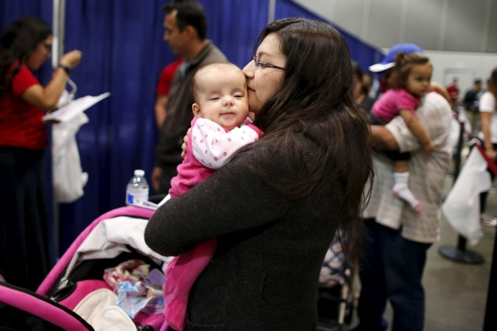
Ads by Kiosked
"Kangaroo mother care" is likely to improve the health of the pre-term and underweight infants. [Representational image]Reuters
A recent study reveals that "Kangaroo mother care" is likely to improve the health of the weak, pre-term and underweight infants.
Kangaroo mother care refers to providing the preemies or pre-term babies with intensive care by keeping skin-to-skin contact with them almost every time through the day and also providing the little one with exclusive or near-exclusive breastfeeding, that doctors recommend.
It was found that the low weight and preterm babies who received more of mother's warmth and nursing were likely to live into their 20s, unlike the premature babies of the control group who were provided incubator's care instead of their mother's care.
The babies who received warmth of their mother's skin performed much better on the measures of behavioural and social health than the infants who didn't receive it. They even turned out to be lesser hyperactive, impulsive and aggressive than the babies who belonged to the control group.
It was noteworthy that the brains of the babies who received Kangaroo mother care had larger brains, the part of the brain which is responsible for the learning mechanism was specially larger, the researchers stated.
A full-term pregnancy lasts for 39 to 41 weeks and it's found that around 15 million preemies are born prior to completing 37 weeks of gestation annually, according to a WHO statistics. Children under five years of age die of pre-term birth complications, which caused around 1 million deaths in 2015.
In the US, one out of ten babies is found to be pre-term, a March of Dimes statistics revealed. March of Dimes is an organisation working towards improving the health of infants by preventing premature birth, birth defects and infant mortality
Though this study proved that skin-to-skin care is linked to better outcomes in the pre-term babies, the direct cause-and-effect relationship is yet to be found.
The Kangaroo mother care was started in Bogota, Colombia, a decade back due to lack of incubators. This way of taking care was very beneficial for the vulnerable pre-term babies and helped in taking care of vulnerable pre-term and underweight infants.
The underweight newborns were strapped to the chest of their mothers for a minimum of 20 hours a day, just like baby kangaroo in their mother's pouch.
Some changes were observed in this method over the years when fathers were given a chance to become care giving kangaroos to their little ones, even skin-to-skin care method got into use.
"What began as a bold innovation is now a widely practised, wonderful method of promoting bonding and breast-feeding," said Dr Lydia Furman, a paediatrician at University Hospitals Rainbow Babies and Children's Hospital in Cleveland, chicagotribune.com reported.
"Hospitals need training, though, so that no one falls asleep with an infant on their chest," she cautioned.
Dr Lydia Furman explained the above in a journal editorial that accompanied the study.
The study was published online December 12, 2016 in the journal Pediatrics.
Study Suggests Moms Take Preemies Out of the Incubator
Is kangaroo care better for kids, or are parents who do it simply better parents?
By Elizabeth Armstrong Moore, Newser Staff
Posted Dec 13, 2016 8:39 AM CST
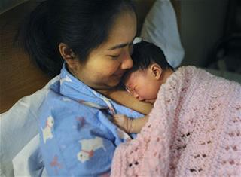
In this Dec. 30, 2014 photo, Sing Kham, of Derby, Conn., prepares to nurse her one-day-old newborn baby, Hana, in Derby, Conn. According to the 2014 Breastfeeding Report Card issued by the CDC, 83.3%... (AP Photo/Hearst Connecticut Media/Connecticut Post, Brian A. Pounds)
(NEWSER) – The age-old practice of mothers holding their naked newborns to their skin and nursing them appears to benefit children—specifically those who were born premature or small—two decades later. Researchers at the Kangaroo Foundation in Bogota, Colombia, revisited a group of preemies who were studied in the mid-1990s and found that 228 young adults who'd received so-called kangaroo care as infants fared better in pretty much every way measured compared to 213 young adults who hadn't had the same level of physical closeness, reports Reuters Health. While the study, published in Pediatrics, builds on a wealth of previous research showing the benefits of physical contact at birth, the researchers say these findings show "a significant, long lasting social and behavioral protective effect 20 years [later]," the lead author says.
Those held skin-to-skin at birth were more likely to be breastfed and much less likely to die young. By 20, they were less aggressive, hyperactive, and anti-social. Researchers note their study did not prove causation: It's still unclear, for instance, whether the care itself has a biological effect on children's brains or whether those children are snuggling with parents who are, well, more nurturing. NBC News also reports that kangaroo care doesn't beget "miracles": Children with cerebral palsy, for instance, saw no change in their symptoms. But considering about one in 12 babies born in the US are preemie or weigh less than 5.5 pounds at birth, according to the March of Dimes, kangaroo care may be beneficial for millions. (This dying baby is now 5 after his parents cuddled him.)

Babies Given Skin-To-Skin Contact Show Benefits DECADES Later
BY AMANDA CASSIDY
Holding your baby in your arms when they are born is one of the most precious moments of your life.
We all strive to maintain that strong bond from infancy to adulthood. And it all begins with a touch.
The very primal gesture of holding your baby close skin to skin can send messages to the baby in its earliest moments letting them know they are safe and loved. By mum or Dad.
It is also known as Kangaroo care because snuggling your baby close to you is similar to the mama Kangaroo's pouch.
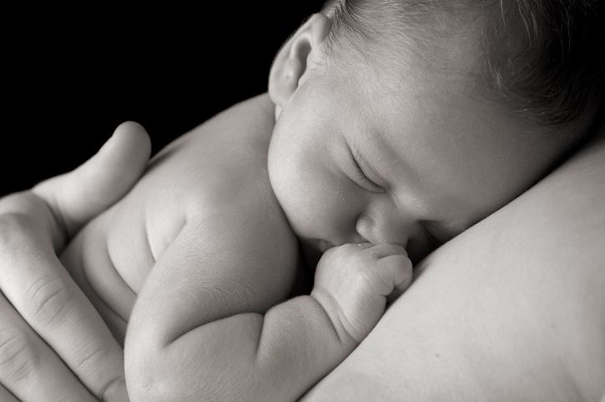
inRead invented by Teads
I was always told that skin-to-skin was important with my baby and despite having a slight delay (I had c-sections) I did it because it felt great.
Now an amazing new study focusing on premature babies has found surprisingly long-term health implications for those who were given Kangaroo care in infancy.
The study, which is expected to be published in full in Pediatrics in January, followed two groups of babies born premature, for 20 years.
Lead author of the study is Nathalie Charpak:
"This study indicates that kangaroo mother care has significant, long-lasting social and behavioural protective effects 20 years after the intervention. The young ex-kangaroo mother care participants, especially in the poorest families, had less aggressive drive and were less impulsive and hyperactive. They exhibited less antisocial behaviour, which might be associated with separation from the mother at birth."
In addition, the skin-to-skin babies had bigger brains, they had less school absences, higher wages and their families were more nurturing.
Dr Charpak attributes some of these factors to parents becoming more motivated and child-orientated when the baby was born. Deciding to take on advice such as skin-to-skin shows that parents took more seriously such benefits for their little one's wellbeing.
Never underestimate the power of the human touch.
Did you deliberately do skin-to-skin when your baby was born or is this something you plan to do? We would love to hear your comments!

DIE KÄNGURU-METHODE UNTERSTÜTZT DIE ENTWICKLUNG VON FRÜHGEBURTEN
Einer neuen Studie zufolge hilft Hautkontakt mit der Mutter zu früh geborenen Kindern dabei, sich zu entwickeln.
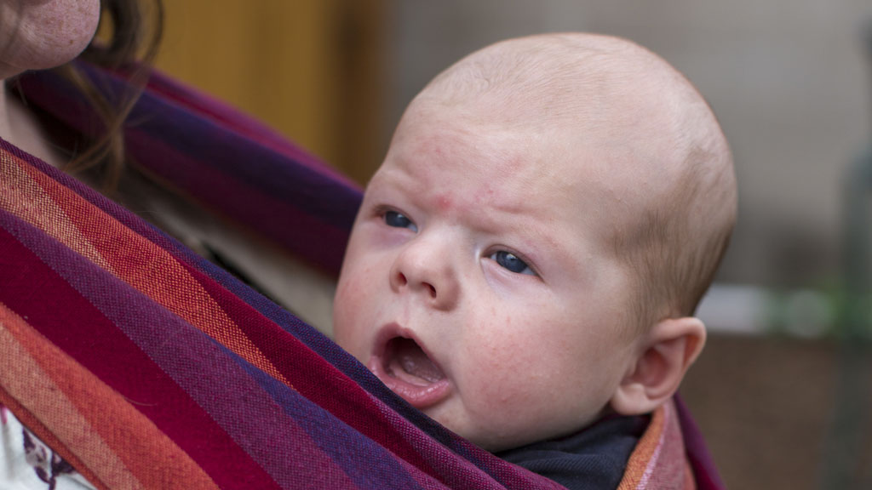
Die Känguru-Methode unterstützt die Entwicklung von Frühgeburten (© Cover Media)
Frühgeburten entwickeln sich besser, wenn sie viel Hautkontakt mit der Mutter haben, anstatt in einem Inkubator zu liegen. Das behauptet zumindest eine neue Studie.
Die Methode, bei der die Mutter das Neugeborene unmittelbar nach der Geburt an ihre Brust schmiegt, nennt sich Kangaroo Mother Care (KMC).
Im Rahmen ihrer Untersuchungen beobachteten Forscher in Kolumbien 700 Frühgeburten im Zeitraum zwischen 1993 und 1996. Die Neugeborenen wurden nach der Geburt entweder in einen Inkubator gebracht oder per KMC-Methode aufgezogen. Zwei Monate darauf führte die kanadische Regierung eine Folgebefragung aus, die ergab, dass die KMC-Methode die Entwicklung der Neugeborenen gefördert hatte.
Die Ergebnisse der Studie wurden im 'Journal of Pediatrics' veröffentlicht. Die Forscher gaben an, dass bei den Neugeborenen, die mit der KMC-Methode gepflegt wurden, die Sterberate lediglich bei 3,5 Prozent lag, im Vergleich zu 7,7 Prozent in der Kontrollgruppe. IQ-Tests konnten ebenfalls einen kleinen, aber nicht unmerklichen Vorteil von 3,5 Prozent feststellen.
Die leitende Wissenschaftlerin Dr. Nathalie Charpak von der Kangaroo Foundation in Bogota erklärte, dass diese Methode erhebliche Vorteile für die Entwicklung von frühgeborenen Kindern habe.
"Wir sind überzeugt davon, dass es sich hierbei um eine wissenschaftlich bewiesene Methode handelt, die in jedem Umfeld angewendet werden kann; selbst dann, wenn Zugang zu medizinischer Versorgung eingeschränkt ist", sagte sie in einem Statement.
Die Studie belegte ebenfalls, dass Babys, die mit der KMC-Methode aufgezogen wurden, ein größeres Volumen an grauer Gehirnmasse entwickelten. Sie neigten seltener zu Verhaltensauffälligkeiten.
Dr. Charpak fügte hinzu, dass diese neue Erkenntnis dazu eingesetzt werden müsse, um weltweit Frühgeburten und ihre Mütter zu unterstützen. Laut Dr. Charpak kommen jährlich 18 Million Neugeborene zu früh oder mit gefährlichem Untergewicht zur Welt.
© covermg.com

Kangaroo mothering' boosts mental, physical health in babies
DAILY SABAH
ISTANBUL

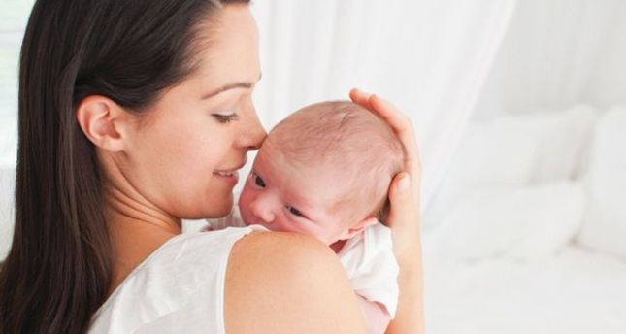
Skin-to-skin contact with the mother is essential for newborns and a new study says "kangaroo mothering," a recommended nurturing technique in which infants are breastfed and kept warm through extensive skin-to-skin contact, improves the health and behavioral nature of babies.
Taking its name from the way that kangaroos carry their babies in a pouch on their bodies, this technique is highly influential for preterm infants. For this technique, infants are being carried, usually by the mother, with skin-to-skin contact. The study shows that kangaroo mothering helps premature children have better development. The study began when a group of parents in Columbia were shown the method for caring for their tiny, premature babies. The results have been published in the journal, Pediatrics.
"This study indicates that Kangaroo Mother Care has significant, long-lasting social and behavioral protective effects 20 years after the intervention," says lead researcher Dr. Nathalie Charpak of Kangaroo Foundation in Bogota, according to Science Daily. The practice allows babies of a low birth weight to have a better chance of development. Family solidarity around the frail child is a key element in the success of the Kangaroo Mother Care technique.
About 15 million premature infants are born each year, according to the World Health Organization. Preterm birth complications are the leading cause of death among children aged under 5, responsible for nearly 1 million deaths in 2015. Many survivors face a lifetime of disability, including learning disabilities and visual and hearing problems.
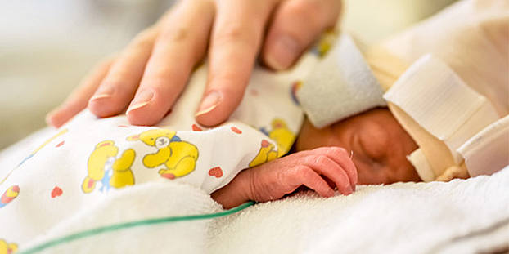
Frühchen haben offenbar deutlich bessere Chancen, wenn sie bereits von Beginn an engen Körperkontakt zu ihrer Mutter haben.
© Tobilander - Fotolia.com
Di. 13. Dezember 2016

Wie Frühchen von der Känguru-Methode profitieren
Viele Frühgeborene verbringen die erste Zeit ihres Lebens in einem Brutkasten. Eine Alternative ist die Känguru-Methode: Darunter versteht man dauerhaften Haut-zu-Haut-Kontakt zwischen Frühchen und Mutter. Eine neue Studie belegt nun, dass Frühgeborene selbst zwei Jahrzehnte später noch von dieser Methode profitieren.

Eng an die Brust der Mutter gebettet: So hatten kolumbianische Eltern vor rund 20 Jahren gelernt, ihre zu früh geborenen Babys warm zu halten und zu versorgen. Diese Kinder profitieren auch heute noch von der damals angewandten Känguru-Methode. Wie Forscher aus Kanada und Kolumbien berichten, zeigten sie als junge Erwachsene weniger häufig aggressive, impulsive oder hyperaktive Verhaltensweisen. Außerdem war bei ihnen die Wahrscheinlichkeit größer, dass sie das 20. Lebensjahr erreichten. Verglichen wurden sie mit einer Kontrollgruppe, die damals als Frühchen klassisch in einem Brutkasten versorgt worden waren.
Die Studie deute darauf hin, dass die Känguru-Technik auch 20 Jahre später noch einen deutlichen und langandauernden Schutzeffekt habe, sagt Dr. Nathalie Charpak von der Kangaroo Foundation in Bogotá. Dies spiegle sich auch darin wieder, dass die Kinder weniger häufig in der Schule fehlten, ihre Gefühle besser ausdrücken konnten und als junge Erwachsene weniger hyperaktiv, aggressiv oder antisozial waren. Die Känguru-Methode gebe Frühgeborenen mit einem geringen Geburtsgewicht bessere Chancen zu gedeihen, sind sich die Forscher sicher.
Laut Weltgesundheitsorganisation (WHO) werden jedes Jahr rund 15 Millionen Kinder zu früh geboren. Komplikationen, die mit einer zu frühen Geburt einhergehen, seien die Haupttodesursache für Kinder unter fünf Jahren, schreiben die Forscher. Viele Überlebende hätten zudem später ein Leben lang mit Problemen zu kämpfen, darunter mit Lernschwierigkeiten sowie Problemen beim Hören und Sehen.
HH

Heilende Nähe zur Mutter: Känguru-Methode nutzt Frühchen noch Jahrzehnte später
14. DEZEMBER 2016

Körperkontakt statt Brutkasten: Känguru-Methode hilft Frühchen über Jahrzehnte
Jedes Jahr werden weltweit rund 15 Millionen Babys zu früh geboren. Meist kommen die Frühchen in ihren ersten Lebenswochen dann in einen Brutkasten. Eine Studie hat jetzt jedoch gezeigt, dass Frühgeborene, die viel Körperkontakt mit der Mutter haben, selbst Jahrzehnte später noch davon profitieren können.
Intensiver Körperkontakt wichtig für das Baby
Laut dem „Global Action Report on Preterm Birth 2012“ der Weltgesundheitsorganisation (WHO) werden weltweit jährlich etwa 15 Millionen Babys zu früh geboren. Von einer Frühgeburt wird gesprochen, wenn der Säugling vor Vollendung der 37. Schwangerschaftswoche zur Welt kommt und damit weniger als 260 Tage im Mutterleib verbracht hat. Die sogenannten Frühchen wiegen nur zwischen 500 und 2.500 Gramm und werden in vielen Fällen in den ersten Lebenswochen im Brutkasten medizinisch betreut. Sie haben daher wesentlich weniger körperlichen Kontakt zu den Eltern. Eine neue Studie zeigt nun aber, wie wichtig der intensive Körperkontakt für die Kleinen ist.
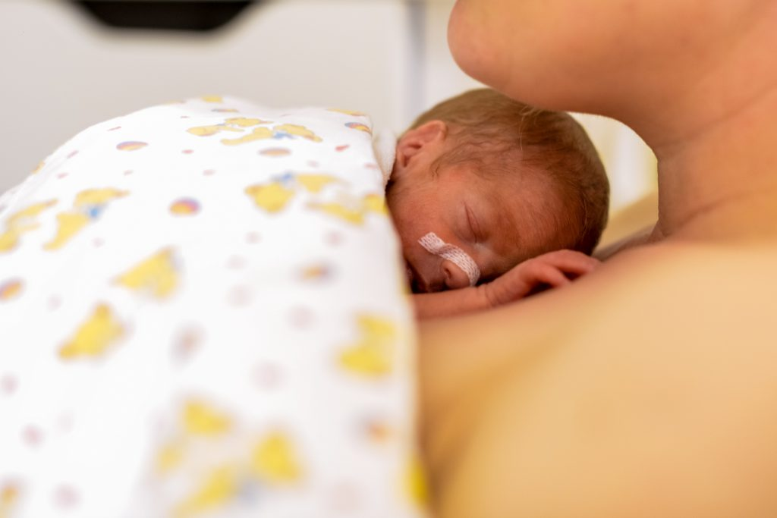Eine Studie hat gezeigt, dass Frühchen, die viel Körperkontakt mit der Mutter haben, noch Jahrzehnte später davon profitieren. Zudem schützt die sogenannte Känguru-Methode vor Krankheiten. (Bild: Tobilander/fotolia.com)
Känguru-Methode kann Todesfälle vermeiden
Gesundheitsexperten zufolge steigt die Zahl der Frühgeburten weltweit. Für eine frühzeitige Geburt kommen eine Vielzahl von Gründen in Betracht. Häufige Ursachen sind Mehrlingsschwangerschaften, Infektionen und chronische Erkrankungen wie Diabetes und Bluthochdruck.
Darüber hinaus können beispielsweise Schwangerschaftskomplikationen, Rauchen oder psychosoziale Faktoren wie chronischer Stress ein Auslöser sein, in vielen Fällen lässt sich auch gar kein eindeutiger Grund finden.
Mehr zum Thema:
- Kinder besser vor Vergiftungsunfällen schützen
- Familie erleidet Kohlenmonoxid-Vergiftung
- Eltern lassen ihre Kinder viel draußen spielen
Über eine Million Frühchen weltweit sterben bereits in den ersten Lebensmonaten. Experten, wie etwa Mitarbeiter der Organisation „Save the Children“ weisen schon seit Jahren darauf hin, dass sich die Zahl der Todesfälle deutlich senken ließe, wenn Müttern gezeigt würde, wie sie ihre Kinder mit der sogenannten Känguru-Methode beim Tragen auf der Brust warm halten können. Es gibt aber noch weitere gute Gründe für diese Methode.
Kinder profitieren noch nach Jahrzehnten
Dass der direkte Hautkontakt gut für Frühchen ist, wurde nun erneut in einer wissenschaftlichen Untersuchung bestätigt. Die Langzeitstudie zur Känguru-Methode hat ergeben, dass frühgeborene Babys von intensivem Körperkontakt mit ihren Eltern auch noch Jahrzehnte später profitieren.
Bei der Studie, die mit Unterstützung kanadischer Forscher in Kolumbiens Hauptstadt Bogota durchgeführt wurde, wurden die untergewichtigen Frühchen von ihren Müttern viel auf nackter Haut getragen, gewärmt und gestillt, berichtet die Nachrichtenagentur dpa.
Familie wird im Umgang mit den Winzlingen geschult
Darüber hinaus wurde die gesamte Familie mit einbezogen und im Umgang mit den Winzlingen geschult. Kontrollgruppe waren Babys, die Helfer in ihren ersten Lebensmonaten auf herkömmliche Weise vor allem im Brutkasten betreuten.
18 bis 20 Jahre nach der Geburt wurden die Heranwachsenden wieder befragt und untersucht. Insgesamt wurden Daten von 264 zwischen 1993 und 1996 geborenen Frühchen mit weniger als 1.800 Gramm Geburtsgewicht berücksichtigt.
Weniger aggressiv und impulsiv
Wie die Wissenschaftler im Fachjournal „Pediatrics“ berichten, zeigten sich für die Känguru-Frühchen klare Vorteile. Den Angaben zufolge seien sie im Mittel weniger aggressiv, impulsiv und hyperaktiv wie solche, die ihre ersten Lebenswochen zumeist im Brutkasten verbrachten.
Zudem schreiben die Autoren um Nathalie Charpak von der Fundación Canguro in Bogota, dass die Sterberate der Känguru-Frühchen merklich niedriger war als bei der Kontrollgruppe im Brutkasten.
Des Weiteren wuchs ihr Gehirn, speziell in den für das Lernen wichtigen Bereichen, stärker. Insbesondere unter den sehr zarten Babys war der Intelligenzquotient 20 Jahre später etwas höher.
Die Forscher stellten weiterhin fest, dass die Kinder aus dem Känguru-Programm in der Schule besser abschnitten und seltener im Unterricht fehlten. Als junge Arbeitnehmer verdienten sie im Durchschnitt mehr.
Liebevollere Grundstimmung in der Familie
Von den Wissenschaftlern werden die positiven Folgen auch damit erklärt, dass die Eltern der Känguru-Gruppe dank der begleitenden Schulungen besser über die Bedürfnisse von Babys Bescheid wussten und dieses Wissen anhaltend umsetzten.
Vor allem bei ärmeren Familien mit geringem Bildungsgrad hatte dies eine Effekt: „Die alltäglichen Aktivitäten zuhause haben langfristig den größten direkten Einfluss auf ein Kind.“
Wie es heißt, habe sich das Programm auch auf die Familien insgesamt positiv ausgewirkt. So sei ihr Zusammenhalt besser und die Grundstimmung liebevoller gewesen. Darüber hinaus zeigte sich, dass Paare eher zusammengeblieben waren, wenn auch der Vater seinen frühgeborenen Nachwuchs im Tuch herumgetragen hatte.
Schutz vor schweren Krankheiten
Erwähnt werden muss jedoch, dass die Ergebnisse aufgrund der vergleichsweise kleinen Zahl berücksichtigter Teilnehmer noch mit Vorsicht zu bewerten sind. Doch auch in anderen Studien zeigten sich positive Effekte der Känguru-Methode.
So konnten kanadische Forscher der Université Laval nachweisen, dass 15-Jährige, die als Frühchen geboren wurden und durch die Känguru-Methode vermehrt Hautkontakt mit ihren Eltern hatten, „in bestimmten Bereichen vergleichbare Gehirnreaktionen beziehungsweise -funktionen aufwiesen wie zum Geburtstermin Geborene“, berichtete der Berufsverband der Kinder- und Jugendärzte (BVKJ) schon vor Jahren.
Und laut einem Bericht der Weltgesundheitsorganisation (WHO) kann der Körperkontakt vor schweren Krankheiten schützen, sich positiv aufs Stillen auswirken und das Stresslevel der Mütter senken.
Tiefgreifende Effekte
„Wir sind fest überzeugt, dass diese effiziente, wissenschaftlich basierte Methode in allen Umgebungen angewendet werden kann – von solchen mit sehr beschränktem bis zu solchen mit uneingeschränktem Zugang zu Gesundheitseinrichtungen“, erläutert Charpak.
Gerade weil Technik zur Frühgeborenen-Betreuung mittlerweile in vielen Regionen der Welt verfügbar sei und es daher weniger schwere gesundheitliche Folgeschäden gebe, komme es darauf an, auf die kleinen Effekte zu achten.
„Kleine Auswirkungen wie geringfügige kognitive Defizite, eine schlechtere Feinmotorik, verminderte Hör- oder Sehfähigkeit und Konzentrationsstörungen können unentdeckt bleiben, haben aber tiefgreifende Effekte auf das Leben der Familien.“
Frühes inniges Beisammensein
Das „Känguruen“ ist auch in deutschen Frühgeborenenstationen verbreitet. „In Europa setzten die Behandelnden vor allem auf die psychologischen Vorteile, die sich aus dem engen Zusammensein zwischen Eltern und ihrem Kind ergeben. Ziel ist die Förderung des Eltern-Kind-Kontaktes und der Beziehung zum Kind. Denn die Känguru-Methode ermöglicht ein frühes inniges Beisammensein“, berichtet die Kinderklinik Datteln auf ihrer Webseite.
Neben den Babys profitieren auch die Eltern. Sie lernen, mit den zerbrechlich wirkenden Winzlingen umzugehen, Berührungsängste zu überwinden und eine Beziehung aufzubauen. In manchen Fällen fühlen sich Frühchen-Mütter insgeheim schuldig, weil sie ihr Baby nicht wie erhofft neun Monate austragen konnten. (ad)

Incredible Study Shows Cuddling Preemies Helps Them For Decades

Babies who had “kangaroo care” were healthier 20 years later.
12/13/2016 10:42 am ET
Catherine PearsonWomen & Parents Senior Reporter, The Huffington Post
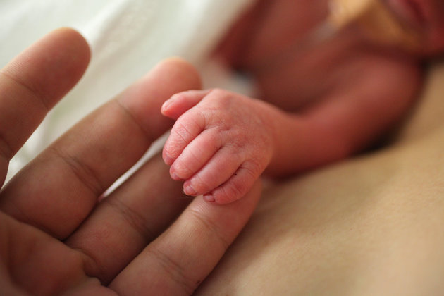
JENNIFER POLIXENNI BRANKIN VIA GETTY IMAGES
Advances in neonatal technology have fundamentally changed doctors’ ability to help preterm infants, and yet one of the most effective interventions is still the simplest: Holding babies skin-to-skin.
A striking new study published Monday in the journal Pediatrics shows just how profound and long-lasting the benefits of so-called “kangaroo care” can be.
Babies who received kangaroo care in the hospital after birth had fewer behavioral problems, as well as measurable changes in parts of the brain linked to learning 20 years down the road.
“This study shows that kangaroo mother care gives premature and low birth weight babies a better chance of thriving,” said Dr. Peter A. Singer, CEO of the Grand Challenges Canada (which provided support for the study) in a statement. “[It] saves brains and makes premature and low birthweight babies healthier and wealthier.”
The core of kangaroo care is direct, skin-to-skin contact. Babies lay on a caregiver’s chest, ideally for long stretches of time wearing nothing but a diaper and a blanket to stay warm. (It is often the mom, but that is not necessary.) Research has shown clear real-time benefits, including faster weight gain and improved oxygen saturation.
To assess potential long-term effects, researchers followed a group of young adults who were born in Colombia in the 1990s. They were either preterm (before 37 weeks) or with a low birthweight (less than 5 pounds, 8 ounces). Researchers were able to follow-up with 264 of the 716 patients who’d been enrolled in the original clinical trial, analyzing their health and social function ― as well as looking at the structure of their brains.
Compared to babies who were kept in incubators, the kangaroo care babies were generally found to be less aggressive, less impulsive and less hyperactive as young adults. They also had more volume in a part of the brain known as the caudate nucleus, which is thought to help with learning and memory.
And while the study cannot establish clear cause-and-effect, outside experts say the findings hold promise.
“The fact that they were able to study [this group] longterm and still see benefits is pretty amazing,” Dr. Amy Hair, a neonatologist and director of the neonatal nutrition program at Texas Children’s Hospital, told The Huffington Post.
“It’s like holistic care for the babies,” Hair continued. “They’re so fragile when they’re in the NICU ― some are the size of a Coke can ― and their parents are, understandably, afraid to touch them.”
In other words, the benefits include factors that can be hard to measure, like emotional connection.
Another benefit is the low cost. In the United States, one out of every 10 babies is born preterm, and low maternal income is one of the associated factors. Globally, there are 15 million preterm births every year. Promoting human touch is something that can be done by anyone, anywhere.
“It’s such a simple intervention that works in resource-limited areas where they don’t have as many isolettes,” Hair said. “So it not only helps in developed countries. It has benefits that span across resources.”

Maternité : le contact peau à peau, un atout pour les prématurés
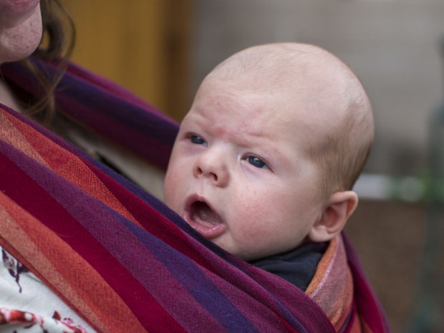
Maternité : le contact peau à peau, un atout pour les prématurés
Photo: Cover Media

Le contact peau à peau est particulièrement bon pour aider les bébés prématurés à se développer. C’est ce qu’a montré une étude financée par le gouvernement canadien.
Les chercheurs viennent de montrer que le contact peau à peau avec les enfants prématurés est particulièrement important pour les aider à se développer. Cette technique consiste à blottir l’enfant nu contre sa poitrine également dénudée.
Entre 1993 et 1996, plus de 700 enfants nés prématurément en Colombie ont été de manière aléatoire placés dans un incubateur ou ont été nourris selon la technique du contact peau à peau. Deux décennies plus tard, une étude de suivi financée par le gouvernement canadien démontre que la technique de contact avait été très bénéfique.
Publiée dans le journal Paediatrics, la recherche montre que le contact peau à peau offre une protection significative contre la mort précoce, avec un taux de mortalité de 3,5% par rapport à un taux de 7,7% dans le groupe témoin. Les tests de QI ont également montré un léger avantage, mais néanmoins remarquable, de 3,5% par rapport à d'autres nourrissons. La chercheuse principale, le Dr Nathalie Charpak, de la Kangaroo Foundation, estime que la méthode a des effets « significatifs » sur l'enfant. « Nous croyons fermement qu'il s'agit d'une méthode forte, efficace et scientifiquement fondée qui peut être utilisée dans tous les contextes, pour ceux qui ont un accès restreint aux soins et tous les autres », a-t-elle déclaré dans un communiqué.
L'étude a également constaté que, comparativement aux bébés dans le groupe témoin, ceux ayant bénéficié du contact peau à peau ont développé des cerveaux plus gros, avec des volumes beaucoup plus importants de matière grise. Ils étaient également moins susceptibles d'avoir des problèmes de comportement tels que l'agressivité; que le groupe témoin.
Cover Media

Évtizedekig tarthat a koraszülötteknél alkalmazott módszer jótékony hatása

KÖVESS MINKET A FACEBOOKON!

Egy kolumbiai kutatás szerint akár évtizedekkel később is profitálnak a szüleikkel megtapasztalt intenzív testi kontaktusból a koraszülött babák.
Kanadai kutatók közreműködésével a kengurumódszer hatásait vizsgálták hosszú távú kutatásuk során a Bogotái Egyetem szakértői. A kívántnál kisebb súlyú koraszülötteket anyjuk közvetlenül a bőrén hordozta, melengette és szoptatta.
A vizsgált program azonban jóval több dolgot foglalt magába ezeknél a módszereknél: az egész családot bevonták a kutatásba, és megtanították nekik, hogyan bánjanak az apróságokkal.
A kontrollcsoportot olyan koraszülött babák alkották, akik életük első hónapjait hagyományos módon elsősorban inkubátorban töltötték. A résztvevőket 18-20 évvel később háromnapos intenzív vizsgálatnak vetették alá. Összesen 264, 1993 és 1996 között kevesebb mint 1800 grammal született koraszülött vett részt a programban.
A „kengurus” gyerekek kevésbé agresszívak és okosabbak is a kutatás szerint (Fotó: Tumblr)
A kengurumódszer pozitívumai egyértelműen megmutatkoztak, ezek a koraszülöttek általában kevésbé agresszívek, impulzívak vagy hiperaktívak, mint azok, akik az első heteiket inkubátorban töltötték – írják a szakértők a Pediatrics című szaklapban.
Az eredmények szerint a „kengurus” babák halálozási aránya jóval alacsonyabb, mint a kontrollcsoporté. Agyuk, főként a tanulásért felelős területeken, erőteljesebben fejlődött. Húsz évvel később még a nagyon törékeny babáknál is húsz százalékkal nagyobb volt az intelligenciahányados. A testkontaktusos gyerekek jobban teljesítettek az iskolában és kevesebbet hiányoztak. Fiatal munkavállalóként átlagosan többet kerestek.

Skin-to-skin ‘kangaroo’ baby care tied to better health years later
By Lisa Rapaport
(Reuters Health) - Premature and underweight newborns may be healthier as children and young adults if they pass their early days with their bare chests nestled directly against their mothers’ breasts, a new study suggests.
Researchers focused on a practice known as “kangaroo care,” which has been linked to lower infant mortality and better developmental outcomes for vulnerable babies. Kangaroo care includes skin-to-skin contact between the newborn and mother, exclusive breastfeeding, early discharge from the hospital after delivery and close follow-up care at home.
“Kangaroo mother care has a significant, long lasting social and behavioral protective effect 20 years after the intervention,” said lead study author Dr. Nathalie Charpak, director of the Kangaroo Foundation in Bogota, Colombia.
For the current study, researchers examined data on 228 young adults who had been randomly chosen to receive kangaroo care as part of a study done when they were babies. Charpak and her colleagues compared outcomes for these kids to those of 213 young adults from the infant study who didn’t receive kangaroo care.
Babies that received kangaroo care were 61 percent less likely to die during infancy than newborns who didn’t receive this type of care, the researchers report in Pediatrics.
Breastfeeding rates were higher for the kangaroo care babies than the other infants, the study found. In addition, the infants who got kangaroo care had fewer severe infections requiring hospitalization.
As children, the kangaroo care kids typically spent more years in preschool than the control group of participants who didn’t receive this infant care, the study found.
Students who got kangaroo care as babies also scored higher on standardized math and language tests and earned higher hourly wages as young adults.
By age 20, the former kangaroo care babies were less likely to be aggressive, impulsive and hyperactive or to exhibit anti-social behaviors compared to their peers who didn’t receive kangaroo care as infants, the study also found. This difference was most pronounced when their mothers were poor and less educated.
It’s possible some of these outcomes might be the result of kangaroo care’s protective effect on the immature brains of preemies, Charpak said by email. This type of care might foster brain development that occurs late in pregnancy for full-term babies but that doesn’t have a chance to happen before premature infants are born.
Another possibility is that parents who provide kangaroo care also nurture children in other ways that are beneficial to health, social and behavioral outcomes, Charpak added.
One limitation of the study is that it doesn’t prove how kangaroo care may benefit babies, only that there are associations between receiving this treatment and several positive health outcomes, the authors note.
Even so, the findings suggest that kangaroo care provides a solid foundation for health later in life, said Dr. Lydia Furman, a pediatrics researcher at Case Western Reserve University and Rainbow Babies and Children’s Hospital in Cleveland, Ohio.
“Perhaps doing the kangaroo mother care helped the parents become more attentive and bonded and nurturing parents – certainly this is a thought and hope,” Furman, who wrote an accompanying editorial, said by email. “Biological responses would follow, not lead.”
While the benefits of kangaroo care during infancy have been well established, the current study offers fresh insight into the lasting effects of kangaroo care in adulthood, said Susan Ludington, executive director for the United States Institute for Kangaroo Care.
“Kangaroo care has remarkably positive outcomes on both biology – the brain's maturation, cerebral blood flow, cerebral oxygenation, connectivity between neurons and neuronal networks – as well as nurturing the mother's confidence and competence in child rearing, the quality and quantity of her interactions, strengthening the infant’s identity with his family members, and promotion of the infant’s mental, motor, and social development,” Ludington, who wasn’t involved in the study, said by email.
SOURCE: bit.ly/2gwPq4T and bit.ly/2gREgnf Pediatrics, online December 12, 2016.

Los beneficios de método canguro para bebé prematuros duran décadas, dice un estudio
EFE - Toronto (Canadá)

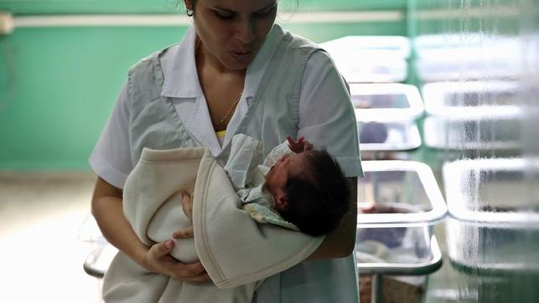
Los beneficios del método canguro para bebé prematuros duran décadas, dice un estudio
Los beneficios del método "madre canguro", creado por un doctor colombiano hace casi 40 años, sobre bebés prematuros perduran décadas después de su nacimiento, según un estudio dado a conocer hoy y financiado por el Gobierno canadiense.
El estudio, que analizó la progresión de 264 bebés tratados con el método entre 1993 y 1996, concluyó que en su juventud tienen menos tendencia a la agresividad, la impulsividad o hiperactividad y sus cerebros son mayores comparados con prematuros que recibieron el cuidado tradicional de incubadora.
El método madre canguro, creado en 1978 por el neonatólogo colombiano Edgar Rey Sanabria, consiste en el contacto directo del bebé prematuro con la piel de la madre inmediatamente después de nacer, así como la alimentación con la leche materna.
Los bebés tratados mediante ese procedimiento también tienen más probabilidades de sobrevivir hasta la juventud, duermen mejor y sufren menos estrés que aquellos prematuros que recibieron el tratamiento de incubadora tras nacer.
En declaraciones a Efe, la doctora franco-colombiana Nathalie Charpak, autora del estudio que fue publicado en la revista estadounidense "Pediatrics" y es integrante de la Fundación Canguro de Colombia, añadió que los bebés prematuros tratados con este método viven en familias más sólidas.
"Un efecto colateral es que los papás que cargaron a sus bebés durante el periodo perinatal, estaban más presentes un año después y más involucrados con su desarrollo. Y veinte años después, en las familias donde los padres participaron en el método madre canguro, existía menos divorcio", explicó Charpak.
La doctora razonó que fue porque esos matrimonios "compartieron un trabajo pesado juntos. Y acaso eso une a las familias".
Charpak también señaló otro beneficio adicional del uso del "método canguro": menor deserciones escolares.
"En el grupo canguro, las madres colocaron a sus bebés en preescolar más temprano que en el grupo de control y posteriormente, tuvieron menos deserciones escolares", dijo.
Para la doctora, estos resultados indican que "el método canguro parece tener un mayor impacto en las familias de más baja educación y más pobres".
El profesor Peter Singer, director de Grand Challenges Canada (GCC), la organización canadiense que financió el estudio, destacó la importancia de los beneficios del método en todo el mundo.
"En el mundo, cada dos segundos, un bebé nace de forma prematura. Este estudio demuestra que el método 'madre canguro' proporciona a los bebé prematuros y de bajo peso una mejor oportunidad para prosperar. El método salva cerebros y hace que los prematuros y bebés de bajo peso sean más sanos y con más recursos", añadió Singer.
La doctora Charpak agregó, por su parte, que todavía hay mucho más que descubrir sobre los beneficios del método canguro, ya que "apenas estamos empezando a mirar en el cerebro mismo".
"Tenemos 358 resonancias magnéticas y ahora estamos empezando a ver si encontramos cambios en la anatomía y fisiología del cerebro. Tenemos varios grupos trabajando en esto y en un año probablemente tengamos las primeras conclusiones", precisó.

Babies Given Kangaroo Care Show Benefits Decades Later
New research says premature babies given skin-to-skin contact with their mothers reap benefits into young adulthood.
ShutterstockWhen it comes to preemies or babies born with a very low birthweight, new research shows that skin-to-skin contact with their mothers, also known as kangaroo care, has some pretty amazing benefits for long-term health—even as much as 20 years later!
For the study—published in the January 2017 issue of Pediatrics—researchers tracked two groups of preemies over 20 years in order to determine whether the benefits of kangaroo care persisted into young adulthood. Turns out, they did.
"This study indicates that kangaroo mother care has significant, long-lasting social and behavioral protective effects 20 years after the intervention," explained lead study author Nathalie Charpak, M.D., of the Kangaroo Foundation in Bogota, Colombia. "The young ex-kangaroo mother care participants, especially in the poorest families, had less aggressive drive and were less impulsive and hyperactive. They exhibited less antisocial behavior, which might be associated with separation from the mother at birth."
Not only that, but the kangaroo babies were also more likely to have survived into their 20s and had bigger brains than those who received traditional care. Plus they had had fewer school absences, higher average hourly wages, and their families were found to be more cohesive and nurturing—something the Charpack attributes to the fact that the introduction of kangaroo care immediately following the NICU motivates families to become more child-oriented.

Kangaroo Care: 5 Benefits of Skin-to-Skin Contact
"This study indicates that kangaroo mother care has significant, long-lasting social and behavioral protective effects 20 years after the intervention," she explained.
In an accompanying editorial in Pediatrics, Lydia Furman, M.D., of University Hospitals Rainbow Babies and Children's Hospital and Case Western Reserve University School of Medicine in Cleveland agreed that the researchers may be on to something.
- Want the latest parenting news? Sign up for our Parents Daily newsletter
"Kangaroo mother care straddles the great divide between the medical and nonmedical, and between the parent and the professional," she said. "Bridging that divide and continuing to assess the impact of intervention, as [the authors] have worked so long to do, brings us closer to optimal care for every infant and family."
Hollee Actman Becker is a freelance writer, blogger, and mom of two who writes about parenting and pop culture. Check out her website holleeactmanbecker.com for more, and then follow her on Instagram and Twitter.

Children's and parenting health centre

Kangaroo mothering 'helps premature babies'
By Peter Russell
WebMD UK Health News
Medically Reviewed by Dr Rob Hicks
12th December 2016 – A nurturing technique known as 'kangaroo mothering' can improve the health of babies born prematurely, according to a study.
Infants raised in this way are breastfed and kept warm through extensive skin-to-skin contact with their mums.
The term kangaroo mothering was coined because of the way that kangaroos carry their offspring in a pouch in their body.

Larger brains
Now, results from a 20-year research project suggest that Kangaroo Mother Care for premature babies leads leads to better behaved children with larger brains and better prospects in life than premature or low birth weight babies who were given traditional care.
The study began when a group of parents in Columbia were shown the method for caring for their tiny, premature babies.
Twenty years on, the results are published in the latest edition of the journal, Pediatrics.
"This study indicates that Kangaroo Mother Care has significant, long-lasting social and behavioural protective effects 20 years after the intervention," says lead researcher Dr Nathalie Charpak, of the Kangaroo Foundation in Bogotá.
According to the World Health Organisation around 15 million babies are born prematurely every year. Almost 1 million children under 5 die each year due to complications caused by premature birth. For those who survive past their 5th birthday, learning disabilities, and visual and hearing problems are common.
The problem is particularly acute in developing countries, where incubators and intensive baby care are less likely to be available.
The women trained in kangaroo mother care are taught how to become their baby's incubator and his or her main source of food and stimulation. They are shown how to maintain skin-to-skin contact for at least 12 hours each day and told tobreastfeed exclusively.
The study found that success from the technique was still evident 2 decades later.

Reduction in deaths
Crucially, kangaroo mothering cut the risk of babies dying early. Death rates were 3.5%, compared to 7.7% among those who did not adopt the technique.
Compared to other mothers, results for those reared using the kangaroo technique showed that:
- School absenteeism was lower
- They were likely to be in work in later life
- They were more likely to be in a relationship after 20 years
- They were more likely to have grown up in a family environment where both parents stayed together
- They were less likely to be a victim of violence while at school
- They were less likely to have asthma
- They had larger brains and a small increase in overall intelligence, as measured by IQ.
According to Dr Charpak: "We firmly believe that this is a powerful, efficient, scientifically based health care intervention that can be used in all settings, from those with very restricted to unrestricted access to health care."
The study has been funded by the Government of Canada through Grand Challenges Canada's 'Saving Brains' programme, as well as Colombia's Administrative Department of Science, Technology and Innovation.

Kangaroo mothering 'helps premature babies'
(continued)

Reaction
Dr Martin Ward-Platt, a consultant paediatrician from Newcastle and fellow of the Royal College of Paediatrics and Child Health, says the findings have important implications for the way we interact with babies here in the UK.
"It's almost paradoxically more important in the more resource-rich world," he tells us, "because when you're doing neonatal care you tend to have more personnel, you tend to have more equipment, and one of the side-effects of that is the real possibility of isolating the baby more from their parents than was ever the case if you were in a resource-poor setting."
He adds: "The fact that they managed to demonstrate this in a resource-poor setting, and in the long-term, I think it's absolutely fantastically important because it suggests that the impact of kangaroo care in the more better off world is actually anything likely to be greater."

Känguru-Methode hilft Frühchen über Jahrzehnte
Die Känguru-Methode sorgt für intensiven Körperkontakt zwischen Eltern und Frühchen. Eine Langzeitstudie deutet darauf hin, dass die Kinder auch 20 Jahre später noch davon profitieren könnten.
von Daniela Zeibig
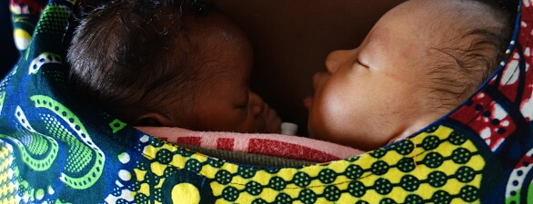
© Fundación Canguro
(Ausschnitt)
Die so genannte Känguru-Methode, bei der Neugeborene bereits von Beginn an intensiven Körperkontakt zu ihren Eltern haben, könnte dazu beitragen, dass Frühchen sich auch über Jahrzehnte hinweg besser entwickeln. Darauf deutet nun das Ergebnis einer Langzeitstudie hin, die Wissenschaftler um Nathalie Charpak in Kolumbien durchführten. Die Forscher teilten zwischen 1993 und 1996 mehrere hundert Babys mit einem Geburtsgewicht von unter 1800 Gramm per Zufall in eine von zwei Gruppen ein: Die eine Hälfte der Frühgeborenen wurde klassisch im Säuglingsinkubator versorgt, die anderen kamen in den Genuss des "Känguruens" mit ihren Eltern. Dabei werden die Babys so früh wie möglich regelmäßig in "Känguru"-Position Haut an Haut auf den Oberkörper von Mutter oder Vater gelegt und können dabei gewärmt und gestillt werden.
20 Jahre nach dieser initialen Studienphase untersuchten die Wissenschaftler 264 der ehemaligen Frühchen erneut. Dabei entdeckten sie, dass nicht nur die Sterblichkeit unter den Känguru-Kindern niedriger war, sondern dass diese auch als junge Erwachsene noch von der kontaktintensiven Neugeborenenpflege zu profitieren schienen. So fehlten sie nicht nur seltener in der Schule, sondern hatten auch im Beruf einen um 50 Prozent höheren Stundenlohn als Frühchen, die die ersten Lebenstage ausschließlich im Inkubator verbracht hatten. Die Probanden zeigten sich zudem seltener hyperaktiv oder aggressiv, hatten größere Gehirne und mehr graue Hirnsubstanz in verschiedenen Regionen. Auch ihr Intelligenzquotient war im Schnitt geringfügig höher. Wesentlich mehr der ehemaligen Frühchen wuchsen zudem in intakten Familien mit beiden Elternteilen auf.

Kangaroo Mother Care 20 Years Later: Connecting Infants and Families
Lydia Furman
KMC — kangaroo mother care
SSC — skin-to-skin care
Kangaroo mother care (KMC), developed in Bogota, Columbia in the 1970s, was considered an innovative and daring practice at the time. Dr Nathalie Charpak and several colleagues introduced the world to a new way of caring for low birth weight infants: In comparison with the usual cautious practice of incubator nursing with severely restricted parental access and discharge only when a weight of 1700 g was attained, KMC involved “strapping the baby upright to the mother's chest in skin-to-skin contact, frequent [exclusive or nearly exclusive] breast feeding, formula supplements if weight gain did not exceed 20 g/day, and early discharge.”¹ What now seems a usual intervention was at the time a revolution in newborn care. These scientist–clinicians courageously tested their new method in an observational cohort study² and a randomized controlled trial,³ documenting equivalent survival among infants in the KMC and traditional care groups, thus demonstrating the safety of KMC to skeptics around the world.
Since then, KMC in its original and newer flavors has been integrated into the mainstream of newborn care. A 2016 Cochrane review examined 21 studies including 3042 infants and concluded that KMC for (stabilized) low birth weight infants in low-resource settings was preferable to conventional neonatal care, with lower risk of death and severe infection and higher rates of breastfeeding at term postmenstrual age or discharge from the hospital.⁴Variations of KMC involving briefer periods of infant holding by the mother or father, appropriately called skin-to-skin care (SSC), are practiced in birthing hospitals in high-, low-, and middle-income countries in support of the Baby Friendly Hospital Initiative Step 4 (“help mothers initiate breastfeeding within one hour of birth”). By placing babies in SSC with their mother immediately after birth, “baby crawl” is facilitated (http://www.breastcrawl.org/video.shtml), mothers can learn early feeding cues, and breastfeeding outcomes are improved.⁵ Paternal KMC and SSC offer a wealth of benefits too.^{6,7} Despite technical obstacles, provider concern, and infant fragility, SSC is being practiced cautiously in NICUs in high-income countries, even with ventilator-dependent infants, because it can promote parental attachment, decrease stress, and increase breast milk volumes.^{8–11} KMC clearly makes the world a better place for babies and families.
Some 20 years after the original KMC randomized controlled trial, Dr Charpak et al⁷systematically recontacted, reenrolled, and examined the (now) young adults who were infants in the original study, and present to readers of Pediatrics the results of extensive psychological testing comparing their outcomes. Certainly there is good precedent for examining the long-term impact of neonatal care on young adult outcomes of preterm infants.¹² But the challenges of this specific KMC-based research are several. First, KMC is a “bundled intervention” in which parental nurturing, nearly exclusive breastfeeding, and SSC may have individual, synergistic, and overlapping contributions to the studied outcomes. Second, it is difficult to quantify and qualify parent-associated and parent-delivered interventions because all parents are different. Third, we are a full 20 years out, and “life has happened,” so numerous potentially unmeasured contributions to each individual child’s life (and outcomes) have occurred. Demonstrating these very challenges, in a seminal 10-year cohort follow-up study that compared preterm infants who received 1 hour of SSC daily for 14 days versus traditional care, the results were not straightforward. Although there was a positive impact on executive function and mother–child reciprocity predicted by SSC, other factors may also have contributed, including maternal–child attachment and neonatal respiratory sinus arrhythmia.¹³ Similarly, in their current study Charpak et al identify significantly reduced school absenteeism, a more optimal home environment (as best can be measured), and clinically meaningful reduced hyperactivity, aggressiveness, and externalization in the KMC group at 20 years. Yet the authors are pressed to explain the significantly higher math and language academic scores in the traditional care group. In other words, it is complicated.
Important efforts are ongoing to examine the impact of neonatal events and interventions not traditionally considered medical, which may help explain major outcome differences between infants. For example, untreated pain or stressful events such as procedures may actually lead to localized changes in brain structure and function in premature infants.^{14,15}Human milk, just 1 piece of the KMC puzzle, may be an even more powerful and beneficial intervention for both full-term and preterm infants than we have ever realized, with both short- and long-term brain effects.^{15–17} KMC straddles the great divide between the medical and nonmedical, and between the parent and the professional. Bridging that divide and continuing to assess the impact of intervention, as Dr Nathalie Charpak and colleagues have worked so long to do, brings us closer to optimal care for every infant and family.
Accepted October 13, 2016.
- Address correspondence to Lydia Furman, MD, Division of General Pediatrics and Adolescent Medicine, Rm 784, MS 6019, Department of Pediatrics, Rainbow Babies and Children’s Hospital, 11100 Euclid Ave, Cleveland, OH 44016. E-mail: lydia.furman@uhhospitals.org

Kangaroo care for preemies shows profound power of touch

It makes sense how mother or father's touch has profound effects lasting into adulthood, pediatrician says
CBC News Posted: Dec 12, 2016 10:25 AM ET Last Updated: Dec 12, 2016 10:25 AM ET
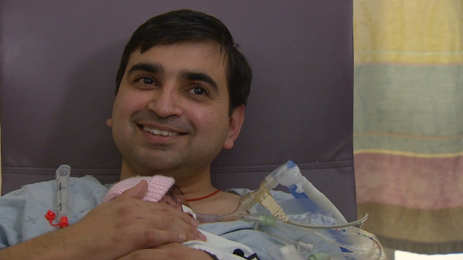
Rohit Bhambi said he had tears in his eyes the first time he nestled his daughter, Prisha, in kangaroo care at Related Stories
- Need a snuggle? Vulnerable infants bond with volunteer cuddlers
- C-section newborns to bond skin-to-skin for study
- Researchers use science of cuddling to counter drug withdrawal in babies
- Skin-to-skin cuddles help moms, babies

External Links
- Kangaroo Mother Care 20 Years Later: Connecting Infants and Families
- Twenty-year Follow-up of Kangaroo Mother Care Versus Traditional Care
(Note: CBC does not endorse and is not responsible for the content of external links.)
Simply keeping tiny, preterm babies warm and nourished through skin-to-skin contact and breastfeeding offered considerable benefits over 20 years, researchers have found.
In Kangaroo Mother Care, a parent or caregiver becomes an infant's incubator and main source of food and stimulation, through continuous skin-to-skin contact between the baby and adult. The infant nests directly on the upper abdomen soon after birth, with a timely discharge from hospital and close followup.
Kangaroo care was originally developed in Colombia as an outpatient alternative to neonatal care units, where infants stay in an incubator while they gain weight.
Now, Dr. Nathalie Charpak in Bogota and her team have reviewed the records of participants from a 1993 to 1996 study to see whether the benefits of kangaroo care for 228 babies continued into young adulthood, compared with a control group of 213 babies who did not receive kangaroo care.
"What we found was first the benefit on mortality, it's clear," Charpak said in an interview. "Yes, really it's a protector for mortality.
"In the group of the lowest education of the mother, we found less [aggressiveness], less hyperactivity and less antisocial conduct behaviour in the kangaroo group."
The kangaroo-care parents also seemed to be more protective and nurturing.
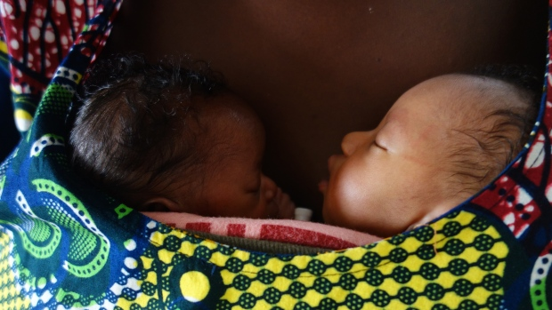
Twin infants are receiving skin-to-skin Kangaroo Mother Care contact at Gabriel Touré Hospital in Bamako, Mali. Resarchers hope their findings will be applied to extend kangaroo care to the 18 million preterm and low-birth-weight infants born worldwide each year who are eligible. (Fundación Canguro)
"We showed that when the father is carrying the baby in Kangaroo Mother Care during the neonatal period, he was more present at one year," Charpak said. "He is more present at one year you have less separated family at 20 years after. It's sympathetic."
The researchers hope their findings will be applied to extend kangaroo care to the 18 million preterm and low-birth weight infants born worldwide each year who are candidates.
The long-term study, published Monday in the journal Pediatrics, confirms what the neonatal intensive care team (NICU) at Toronto's Sunnybrook Hospital has long believed about the benefits of kangaroo care for babies and families, said Dr. Paige Church, who's with the NICU followup clinic.
"I think it's profound. I mean to be held by a human is what we all crave," Church said. "It makes sense to me that the power of a mother or a father's touch has profound effects that will last into adulthood."

'Makes the world a better place'
In her experience, Church said kangaroo care empowers parents with a baby in the artificial environment of the NICU to re-establish their relationship with the infant.
Church said she thinks the benefits of kangaroo care "cascade throughout life," by changing the parents and how the baby experiences the environment, such as accommodating the sounds and stresses in the hospital.
"The babies are calmer here. They're more regulated here. There are less desaturations where they have less instability, so that's protective to their brains," Church said.
Kangaroo care infants have also been shown to have better sleep states, which boosts the potential for growth and learning, as well as improves breast milk supply.
At Sunnybrook, Rohit Bhambi and his wife are using kangaroo care with their daughter, Prisha, who is 2½ weeks old. She was born at nearly 24 weeks gestation.
"It was like [an] out of the world experience," Bhambi recalled of the first time he held Prisha, when she was a week old. "Literally I had tears in my eyes holding her. Felt so good."
Bhambi said that when he holds Prisha on his chest, his tiredness goes away. The baby is also calmer, he said.
A journal commentary published with the study commended the researchers for courageously testing their method, first with an observational study and then a randomized controlled trial, to document the survival advantage to skeptics.
"[Kangaroo Mother Care] clearly makes the world a better place for babies and families," Dr. Lydia Furman of the pediatrics department at Case Western Reserve University School of Medicine in Cleveland wrote.
The research was funded by the government of Canada through Grand Challenges Canada's Saving Brains program, as well as Colombia's Administrative Department of Science, Technology and Innovation (COLCIENCIAS).
With files from CBC's Melanie Glanz

Kangaroo Mother Care' May Improve Preemies' Lives Into Adulthood
Dec. 12, 2016, at 9:00 a.m.
MORE
'Kangaroo Mother Care' May Improve Preemies' Lives Into Adulthood
By Karen Pallarito
HealthDay Reporter

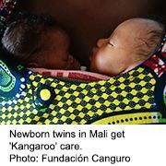
(HEALTHDAY)

MONDAY, Dec. 12, 2016 (HealthDay News) -- When Einat Zemach's son was born early at 32 weeks' gestation, she and her husband would snuggle him skin-to-skin upon their chests for two or three hours at a time. They did the same for their second born, a daughter delivered at 34 weeks' gestation.
The Melbourne, Australia, stay-at-home mom was told "kangaroo care" would keep her premature babies warm, help them breathe better and promote bonding with mom and dad.
"I could sit like that with them for hours," said the 37-year-old.
Now, a new study suggests "kangaroo mother care" -- a more intense version involving nearly round-the-clock skin-to-skin contact and exclusive or near-exclusive breast-feeding -- may extend and enhance the lives of these vulnerable infants well into adulthood.
Premature and low birth weight babies nursed and nestled on their mothers' bosoms were much more likely to live into their 20s than those in a control group who received incubator care, the study found.
In addition, the skin-to-skin care babies did better on measures of social and behavioral health, the findings suggested. They were less aggressive, impulsive and hyperactive, for example.
And they have significantly larger brains, particularly the part of the brain responsible for learning, the researchers reported.
The March of Dimes defines a full-term pregnancy as one that lasts 39 to 41 weeks.
Although the study found a link between the skin-to-skin care and better outcomes in the infants, the study cannot prove a direct cause-and-effect relationship between these factors.
The study was published online Dec. 12 in the journal Pediatrics.
Premature babies can be prone to more health problems -- even long-term ones that can affect their whole lives. About one in 10 babies is born prematurely each year in the United States, according to the March of Dimes.
Kangaroo mother care was pioneered decades ago in Bogota, Colombia, where a scarcity of incubators gave rise to a different way of caring for vulnerable infants.
Newborns weighing less than a small sack of sugar would be strapped upright to mom's chest, much like a joey (a kangaroo's baby) in its kangaroo mother's pouch, for at least 20 hours a day.
Variations of this method involving briefer periods of skin-to-skin care and allowing dads to be kangaroo caregivers, too, are now part of mainstream newborn care, Dr. Lydia Furman explained in a journal editorial that accompanied the study.
"What began as a bold innovation is now a widely practiced, wonderful method of promoting bonding and breast-feeding," said Furman, a pediatrician at University Hospitals Rainbow Babies and Children's Hospital in Cleveland.
Hospitals need training, though, "so that no one falls asleep with an infant on their chest," she cautioned.
Dr. Marielle Nguyen said it also humanizes the neonatal intensive-care unit experience. She's a neonatologist with Kaiser Permanente in Southern California.
It gives moms and dads the sense that "they are part of their babies' care," Nguyen said.
It's been 20 years since Colombia pediatrician Dr. Nathalie Charpak and her colleagues conducted the first randomized controlled trial showing that kangaroo mother care is as safe as incubator care.
For the new study, Charpak and her team followed children from the earlier trial to see how they were faring. A social worker contacted the now-young adults from 2013 to 2014.
Of the 716 original study participants, 264 young people, who weighed about 4 pounds or less at birth, were re-enrolled. Researchers compared their results with a control group of similar-weight preemies who received incubator care.
Impressively, those who received kangaroo mother care had a death rate less than half of those in the control group. They also had fewer school absences, a small but significant difference in intelligence and higher hourly wages, the investigators found. And they grew up in families that were more cohesive, the study authors added.
However, they had lower math and language scores than the incubator kids -- a finding Charpak's team had difficulty explaining.
Furman said that teasing out the long-term effects of care delivered 20 years earlier is challenging but doesn't diminish the importance of the kangaroo strategy.
Dominique McMahon is program officer of Grand Challenges Canada's Saving Brains program, one of the study's funders. She sees potential to expand the technique, especially in resource-poor areas.
"It is something that developing countries can take on where incubators are very expensive, poorly maintained and have interrupted energy sources," she said.
More information
Visit the World Health Organization for more on caring for preterm and low birth weight babies.
Copyright © 2016 HealthDay. All rights reserved.

袋鼠育儿法”有助于提升早产儿的健康和智力
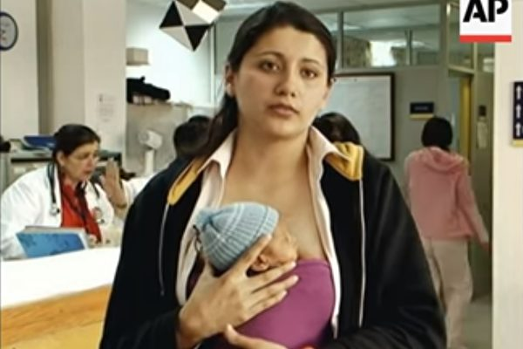
哥伦比亚以袋鼠培育法照顾早产儿，经过20年后的追踪访问发现，这些早产儿更健康、更聪明和成功。（视频截图）
人气: 132
【字号】 大 中 小
更新: 2016-12-12 11:23 PM 标签: 保温箱, 健康, 早产儿, 智商, 袋鼠培育
【大纪元2016年12月12日讯】（大纪元记者韩婕编译报导）一项新的研究发现，母亲与新生婴儿经常饥肤相亲，将可培育出更健康、聪明和成功的下一代。一项具有里程碑的试验在经过20年的追踪访问后发现，当年用袋鼠育儿法培育的初生婴儿，其智商测验的得分比对照组婴儿多53%，而且比较不会有行为偏差，如侵略或缺勤的表现。
袋鼠育儿法优于保温箱
袋鼠育儿法，顾名思义就是仿效袋鼠妈妈的做法，在婴儿出生后，尽快将婴儿放在妈妈胸部的位置上。受过训练的妈妈以温暖的胸部充当婴儿的保温箱，和婴儿肌肤相亲提供了亲密接触的刺激和以母乳喂养的食物来源。这个方法经常用于替代早产儿的保温育婴。
1993年至1996年期间，哥伦比亚对超过700多名早产儿，以随机选择的方式分别将这些早产儿放在保温箱中培育或使用袋鼠育儿法。
20年后，由加拿大政府资助的追踪调查显示，那些接受“袋鼠育儿法”的婴儿相比之下受益较大。不仅早产儿的死亡率较低，只有3.5%（对照组的死亡率为7.7%）,而且智商测验也比对照组略微优越3.5%，脑容量和灰质较多。
波哥大袋鼠基金会领导这项研究的契帕克博士（Nathalie Charpak）认为这种方法“经过20年仍具有显著、持久的社会和行为保謢作用”。
责任编辑：茉莉

How 'kangaroo cuddles' can help premature babies: Infants given skin-to-skin contact with mothers develop better than those placed in incubators
- The technique, known as ‘kangaroo’ care, involves a mother nestling her child
- Baby is exclusively breastfed and mother is main source of heat and stimulation
- The revealing study tracked two groups of premature babies over 20 years
- Those given kangaroo care were less prone to being aggressive and impulsive
By Ben Spencer, Medical Correspondent For The Daily Mail
PUBLISHED: 01:38 GMT, 12 December 2016 | UPDATED: 02:14 GMT, 12 December 2016

Premature babies given skin-to-skin contact with their mothers develop better than those placed in incubators, researchers have found.
The technique, known as ‘kangaroo’ care, involves a mother nestling her child on her chest – as if in a pouch – as soon as possible after birth.
The baby is exclusively breastfed and the mother becomes its main source of heat and stimulation in its first few weeks.
The study, published in the Pediatrics medical journal, tracked two groups of premature babies over 20 years.
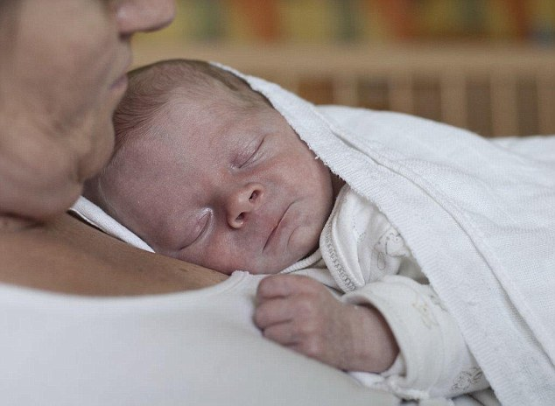
+1
The technique, known as ‘kangaroo’ care, involves a mother nestling her child on her chest – as if in a pouch – as soon as possible after birth
It found those given kangaroo care were less prone to aggressive, impulsive and hyperactive behaviour compared to a group who received conventional incubator care in hospital.
The kangaroo babies were more likely to have survived into their 20s and had bigger brains. Their families were also found to be more cohesive and nurturing.
Lead researcher Dr Nathalie Charpak, of the Kangaroo Foundation in Bogota, Colombia, said: ‘This study indicates that kangaroo mother care has significant, long-lasting social and behavioural protective effects 20 years after the intervention.’ Dr Peter Singer, chief executive of non-profit group Grand Challenges Canada which funded the study, added: ‘A premature infant is born somewhere in the world every two seconds. This study shows that kangaroo mother care gives premature and low birth weight babies a better chance of thriving.
‘Kangaroo mother care saves brains and makes premature and low birth weight babies healthier and wealthier.’ The technique is used to protect vulnerable babies from harm in places where incubators are scarce or too expensive.

RELATED ARTICLES
The researchers tracked 264 premature babies in Colombia. The death rate among those who had been placed in incubators were more than double that of the babies cared for using the kangaroo method – 7.7 per cent compared to 3.5 per cent.
Kangaroo babies spent 23 per cent more time at kindergarten and had less than half the rate of school absenteeism. When they later went out to work, their average hourly wages were almost 53 per cent higher.
Scores for aggressiveness and hyperactivity were also 16 per cent lower, particularly among children from less-educated families. And tests after 20 years found a 3.6 per cent advantage in IQ for kangaroo babies.
Dr Charpak said: ‘One of our hypotheses was that changes induced by the kangaroo mother care intervention ... are sustained by anatomical or functional changes in the immature brain during the neonatal period.
‘Kangaroo mother care might allow better maturation of brain tissues and pathways.’
Read more: http://www.dailymail.co.uk/health/article-4023388/How-kangaroo-cuddles-help-premature-babies-Infants-given-skin-skin-contact-mothers-develop-better-placed-incubators.html#ixzz4TUAtdsGz
Follow us: @MailOnline on Twitter | DailyMail on Facebook

Kangaroo mothering' helps boost a child's health and intelligence, study finds
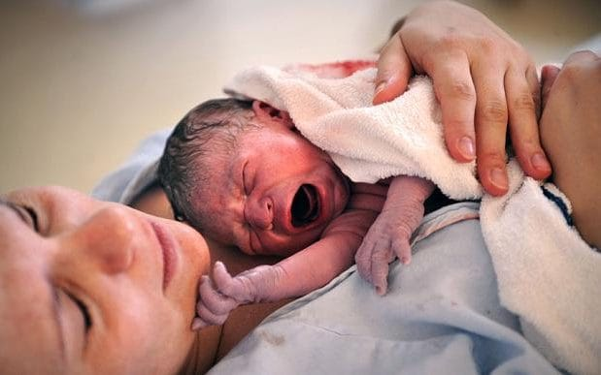
Keeping the baby close to the mother's chest is supposed to have benefits CREDIT: LIONEL WOTTON/ALAMY
- Henry Bodkin
12 DECEMBER 2016 • 6:00AM
Kangaroo mothering”, the practice of continuous skin-to-skin contact with a newborn baby, results in healthier, more intelligent and successful offspring, a new study reveals.
A 20-year follow-up from a landmark trial found that those nurtured in the kangaroo method scored higher in IQ tests and earned 53 per cent more.
They were also found to be less likely to have behavioural problems such as aggression and display absenteeism than babies in a control group.

Recommended by
This is a powerful, efficient, scientifically based healthcare intervention that can be used in all settingsDr Nathalie Charpak
Followers of the method nest an infant in a “kangaroo” position on their chest as soon as possible after birth. Both mother and baby are supposed to go home as quickly as safely feasible.
The technique is often used as an alternative to incubation in cases ofpremature birth, whereby the trained mother or caregiver acts as the child’s incubator and its main source of stimulation and food, in the form of breast feeding.
Between 1993 and 1996 a group of more than 700 prematurely born babies in Columbia were, on the basis of randomized selection, placed either in an incubator or were nurtured using the kangaroo method.
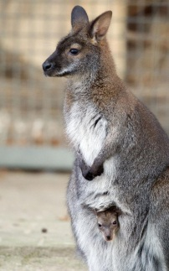
The term comes from the way kangaroos look after their youngCREDIT: FRISO GENTSCH /AFP / GETTY
Two decades later, a follow-up survey funded by the Canadian Government, has shown that those who underwent the latter method benefited by comparison.
Published in the journal Paediatrics, the research shows that kangaroo mothering offered significant protection against early death, with the a 3.5 per cent mortality rate compared to a 7.7 per cent rate in the control group.
IQ test also showed a small but significant advantage of 3.5 per cent compared to other infants.
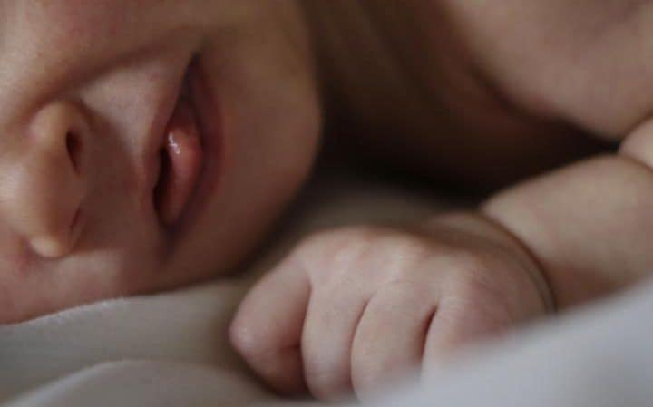
The mother can act as the baby's incubator CREDIT: DANNY LAWSON /PA
Lead researcher Dr Nathalie Charpak, of the Kangaroo Foundation in Bogota, said the method has “Significant, long-lasting social and behavioural protective effects 20 years after the intervention”.
“We firmly believe that this is a powerful, efficient, scientifically based healthcare intervention that can be used in all settings, from those with very restricted to unrestricted access to healthcare.”
The study also found that, compared with babies in the control group, those nurtured in the kangaroo method went on to develop bigger brains, with significantly larger volumes of grey matter

How 'kangaroo mothers' help tiny, premature babies survive and thrive

Kangaroo Mother Care reduces mortality among premature babies and improves their lives as adults.
By Léa Surugue
December 12, 2016 05:15 GMT
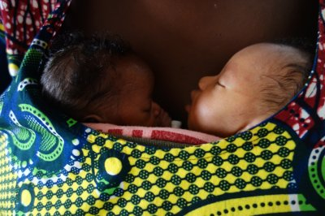The kangaroo care technique can help premature babies on the short and long term.Fundación Canguro
Premature babies who benefit from 'Kangaroo Mother Care' when they are at their most tiny and vulnerable are more likely to thrive when they grow up. As young adults, they are less impulsive, aggressive and hyperactive, and do better in school and in the office.
According to the World Health Organisation, pre-term births remain a global health concern, with 15 million babies being born too early every year – before 37 years weeks of pregnancy are completed. The related complications are the biggest killer of children under the age of five and 1m deaths have been reported in 2015. As for the infants who make it, long-term health issues as well as psychological, behavioural problems and learning disabilities are common.
More from IBTimes UK
- Why time seems to fly at the weekend but stretches on when we are bored
- Chinese Imperial site tells story of ancient animal sacrifices to the deities
- John Glenn: Five things that defined the last American hero
Why advertise with us
Incubators can prevent complications following the birth, such as hypothermia and infection, but in many countries around the globe, these technologies are scarce, costly and unreliable.
This is why the Kangaroo Mother Care technique was invented, to try and replace them and make sure all premature babies get the same chances to survive and thrive in their later lives.

What is Kangaroo Mother Care?
The technique of Kangaroo Mother Care defined by the World Health Organisation involves a parent, usually the mother, becoming its baby's own 'incubator'. This means exclusive breast feeding as well as continuous skin-to-skin contact between parent and child. Very soon after the birth, the baby is nested in a "kangaroo" position on the parent's chest – hence the name given to the technique.
The short- and mid-term benefits of the technique on survival, neurodevelopment, breastfeeding, and the quality of mother–infant bonding were documented in a randomised controlled trial taking place in Colombia in 1993–1996.
A total 716 premature babies were followed-up and the scientists at the time found that the method was effective at avoiding the worse complications following birth. Babies survived and were in better health than those in a control group.

Benefits in adulthood
In the new research published in the journal Pediatrics, they explored whether young adults who had been premature babies could still draw benefits from Kangaroo Mother Care.
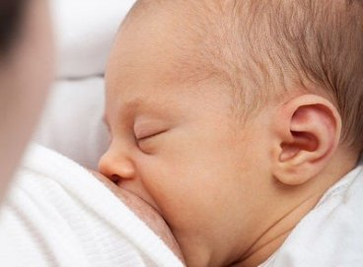
Breastfeeding is an essential part of Kangaroo mother careWiki Commons
Over two years, between 2012 and 2014, 441 of the original trial participants were re-enrolled, and results for the 264 participants weighing less than 1.8kg at birth were analysed.
The scientists investigated in particular their health status and neurological, cognitive, and social functioning using a range of neuroimaging, neurophysiological, and behavioural tests.
The scientists looked at mortality and found that premature babies in the control group, who had not received Kangaroo care had a mortality rate 7.7% while babies who had been cared for with the technique had a mortality rate of 3.5%.
The benefits were also felt in other areas, as these individuals were found to have been raised in a more more protective and nurturing, and had less behavioural problems such as hyperactivity, aggressiveness, and deviant conducts as young adults. Brain scans also suggested that their brain volume was also larger.
The study thus confirms that 'kangaroo mothers' have the power to help their premature babies survive and thrive decades on.
The study was supported by the Government of Canada through Grand Challenges Canada's "Saving Brains" program, as well as Colombia's Administrative Department of Science, Technology and Innovation (COLCIENCIAS),

Kangaroo Care Still Benefits Preemies 20 Years Later
Tara Haelle ,
CONTRIBUTOR
For the most fragile newborns—those born as preemies or with a very low birth weight—the simplest, most natural intervention in the world can have a profound impact on their survival and long-term health—even 20 years later.
The use of “kangaroo mother care” with a group of these infants led to greater brain volume in an area related to learning and memory, a more nurturing home environment and subsequently lower levels of behavioral problems that all persisted two decades on, found a new study. It's likely that at least some of these outcomes were driven by the longer duration of breastfeeding among infants receiving kangaroo care.
“At 20 years, the young ex-kangaroo mother care participants, especially in the poorest families, had less aggressive drive and were less impulsive and hyperactive,” reported Nathalie Charpak, M.D., of the Kangaroo Foundation in Bogota, Colombia, and her coauthors. “They exhibited less antisocial behavior, which might be associated with separation from the mother at birth. Kangaroo mother care may change the behavior of less well-educated mothers by increasing their sensitivity to the needs of their children, thus making them equivalent to mothers in more favorable environments.”
Kangaroo care includes three main components: the first is continuous skin-to-skin contact with the baby’s mother (and sometimes father) in the “kangaroo position,” laying on or against the parent’s bare chest. The second is exclusive breastfeeding when possible, and the third is “timely” discharge with close followup.
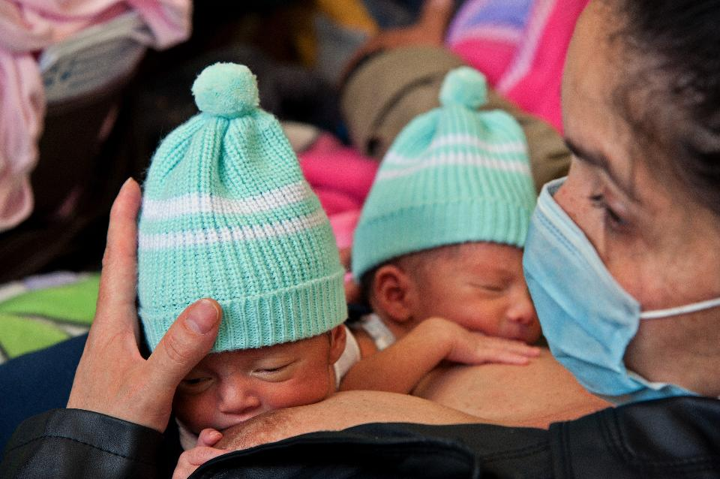
A mother breastfeeds her premature babies at the San Ignacio hospital in Bogota, Colombia, on March 26, 2014. The technique in which parents hold their newborns, usually premature babies, skin-to-skin, is known as 'kangaroo care' -- in a nod to the marsupials who carry their young in a pouch after birth to complete their development -- and started in Colombia more than 30 years ago due to a shortage of incubators. (Guillermo Legaria/AFP/Getty Images)
“This study drives home the point how important simple interventions in the NICU are to long term outcome,” said Amy Hair, MD, a neonatologist as Texas Children's Hospital in Houston, who was not involved in the study. “This is a simple intervention. It doesn’t have any harmful effects. If anything, we should make it universal standard of care,” she said. It is necessary that kangaroo mother care take place following a specific protocol and under the supervision of a nurse or other trained health provider at all times, however, to ensure that the baby does not become overheated or that the mother does not inadvertently fall asleep, which could be dangerous for the baby.

It was in Colombia that kangaroo mother care was first developed as an option besides keeping infants in neonatal unit incubators while they gained weight. The new study, published in Pediatrics, followed up on 264 Colombian babies who were involved in a randomized controlled trial for kangaroo care 20 years ago.
Because the study was a randomized controlled trial, the researchers can confidently state that the kangaroo mother care did in fact cause the better outcomes among babies who received it, though factors that occurred in the intervening years may have contributed as well.
For example, the children in the kangaroo mother care group “had slightly less severe abnormal neurologic results than the control group,” the researchers reported, but they could not separate out effects caused by the kangaroo care versus effects that the family may have had.
All the infants in the followup had weighed 4 pounds (1,800 grams) or less at birth and survived to at least age 1. The social worker originally involved in the first study was able to find 61% of the original 433 babies who had survived to 1 year old, but some had died, and others had moved out of the city or refused to participate.
Infants who received kangaroo care were about half as likely to die as those in the control group, with death rates of 3.5% among the original kangaroo care participants and 7.7% among the participants in the control group. After adjustments for the babies’ weight and gestational age (pregnancy week) at birth, the odds of survival for those receiving kangaroo care was even a little better than that.
Because more infants in the control group died before their first birthday than did infants receiving kangaroo care, the researchers used 15 factors to assess the infants’ vulnerability and determine whether the survival rate differences could have added bias in the followup study. Both groups had similar levels of vulnerability before randomization, however, so no bias was expected from survival differences.
Overall average IQ scores did not differ much between the kangaroo care and control groups at 20 years old—both were around 88—but slight differences did show up in a subgroup of infants who had undergone neurological examinations at 6 months old. Most chronic health conditions also occurred at similar rates in the groups, though more of the kangaroo care children had hypothyroidism than those in the control group.
Although rates of cerebral palsy were similar in both groups, those in the kangaroo care group fared better: 38% of those in the control group had functional motor problems, compared to 12% in the kangaroo care group.
The bigger long-term differences showed up in social and family areas. Those in the kangaroo care group, for example, had fewer absences from school and higher hourly wages that those in the control group. Interestingly, however, the language and math scores were better in the control group children than in the kangaroo care children, which the researchers were unable to explain.
Several family and nurturing factors were stronger among the children in the kangaroo care group whose fathers had participated in kangaroo care by holding their newborns as well. Those families were more stable and had more fatherly support one year after the child’s birth than families whose fathers were not involved with the kangaroo care.
Even after adjusting for that effect from the more involved fathers, however, children in the kangaroo care group still had more protective families and grew up in more stimulating home environments than those in the control group.
“We concluded that kangaroo mother care families were more dedicated to their children and that the effect is permanent,” the authors wrote. The kangaroo care kids also had lower levels of aggressiveness, hyperactivity and similar behavioral problems, though the authors could not determine whether this was directly related to the kids’ home environment.
MRI scans showed that the brain volume of those who received kangaroo care was larger than that of kids in the control group, and the difference was related to the intensity of the care. The longer children had spent in the kangaroo position, the larger their brain volume was.
“Obviously this study only looks at small babies, but with what we know about mother-infant bonding and its calming effect on the baby, I would support kangaroo mother care for all babies,” Hair said, adding that the intervention is simple and does not require any extra equipment. “For different places across the world that may not have isolates for small babies, it could benefit all types of resource-specific NICUs.”
Hair specializes in human milk for tiny babies, and she said she expects that breastfeeding and/or breastmilk played a significant role in the findings. Past research has established that exclusively receiving human milk has a significant impact on the survival and health outcomes of preemies and babies with a low birth weight.
“To me it’s really incredible because kangaroo mother care helps mom’s milk production and supply,” Hair said. “It helps her body to make milk in a certain way to meet her baby’s needs.”
Indeed, previously published findings from the authors show that "exclusive breastfeeding duration was longer in the kangaroo mother care group up to 3 months of corrected age," according to Charpak. "We did not have any correlation between IQ and breastfeeding at 20 years, but we are still analyzing the metabolic part of the study," she added.
Hair said she hopes to see more studies like these that provide additional evidence on the benefits of simple NICU interventions.
“This is probably one of those studies starting the trend of looking at what the long term implications are of care we’re providing in the NICU,” Hair said. “These results from a long-term study are promising and further emphasize the importance of kangaroo care for babies in the NICU as well as highlighting how small changes for babies in the NICU can likely impact long-term outcomes for these babies.

Kangaroo Care Linked to Long-Term Benefits

Effects still present after 20 years
A 20-year follow-up study on "kangaroo mother" care, a multifaceted intervention for low birth weight infants and their parents centered on close physical contact, found that it led to significant long-term protective benefits.
First-year benefits of kangaroo mother care on IQ and home environment were still present after 20 years, wrote Nathalie Charpak, MD, Fundación Canguro de Colombia in Bogotá, and colleagues, online in Pediatrics.
The results pointed to other benefits including significantly better scores for school absenteeism and aggressiveness during follow-up.
"This study indicates that kangaroo mother care had significant, long-lasting social and behavioral protective effects 20 years after the intervention. Coverage with this efficient and scientifically based health care intervention should be extended to the 18 million infants born each year who are candidates for the method," wrote Charpak, who helped to develop the kangaroo mother care method in the 1970s.
The concept was developed as an outpatient alternative to the more conventional neonatal care situation for preemies in which infants remain in an incubator while they grow and gain weight. Kangaroo mother care comprises three components: continuous skin-to-skin contact between mother and infant, exclusive breastfeeding when possible, and early discharge from the hospital with close follow-up during the first year.
From 1993 to 1996, Charpak and colleagues conducted a randomized clinical trial to compare the kangaroo mother care intervention with "traditional" inpatient care for low birth weight infants.
Infants were included if they weighed ≤2000 g at birth, survived the transition to extrauterine life, and were eligible for neonatal minimal care. They were then randomly assigned to kangaroo mother care or the control group according to birth weight (≤1,200, 1,201-1,500, 1501-1800, and 1,801-2,000 g).
After concluding that kangaroo mother care offered short- and mid-term benefits, such as morbidity, mortality, and development that was equivalent to or better than usual care, the team decided to investigate the long-term effects.
From 2012 to 2014, approximately 20 years after the original trial, Charpak and colleagues systematically recontacted, re-enrolled, and examined as many participants, now young adults, from the original study as they could find. Ultimately, 441 of the 716 who had survived to age 1 were re-enrolled; the current analysis focused on 264 who had weighed 1,800 g or less at birth.
The researchers found that the benefits of kangaroo mother care were present 20 years after intervention and should be used to reduce medical and psychological disorders attributable to prematurity and low birth weight.
Overall cumulative mortality after entry into the study was 5.5%, with rates of 8 of 229 in the kangaroo mother care group and 16 of 204 in the control group (OR 0.42, 95% CI 0.18-1.02). After adjusting for weight and gestational age at birth, the protective effect of kangaroo mother care against mortality was significant (OR 0.39, 95% CI 0.16-0.94).
Charpak and colleagues also found that frequency of chronic conditions was similar in the kangaroo mother care and control groups, except for hypothyroidism which was higher among the kangaroo mother care cohort (6.5% versus 0.8%).
Participants from the kangaroo mother care group had significantly more years of preschool, but had the same number of years of schooling and the same age at completion as the control group. The kangaroo mother care group also had fewer absences from school, as well as significantly higher average hourly wages.
Finally, the researchers determined that kangaroo mother care participants who weighed ≤1,800 g (n=264) at birth and had good-quality nuclear magnetic resonance (n=195) presented with significantly larger cerebral volumes of total gray matter, cerebral cortex, and left caudate nucleus than control participants.
In an accompanying editorial in Pediatrics, Lydia Furman, MD, of University Hospitals Rainbow Babies and Children's Hospital and Case Western Reserve University School of Medicine in Cleveland, acknowledged the benefits of investigating the cohort, but addressed several challenges of this specific kangaroo mother care- based research.
"We are a full 20 years out, and 'life has happened,' so numerous potentially unmeasured contributions to each individual child's life (and outcomes) have occurred. Demonstrating these very challenges, in a seminal 10-year cohort follow-up study that compared preterm infants who received 1 hour of SSC daily for 14 days versus traditional care, the results were not straightforward."
Nevertheless, Furman agreed that the researchers may be on to something: "Kangaroo mother care straddles the great divide between the medical and nonmedical, and between the parent and the professional. Bridging that divide and continuing to assess the impact of intervention, as [the authors] have worked so long to do, brings us closer to optimal care for every infant and family."
Charpak and colleagues interpreted their findings to mean that introducing kangaroo mother care immediately after neonatal intensive care, without other developmental programs, may encourage families to become more child-oriented.
"Our long-term findings should support the decision to introduce kangaroo mother care to reduce medical and psychological disorders attributable to prematurity and low birth weight," they wrote.
The researchers reported no financial disclosures.

- Reviewed by Robert Jasmer, MD Associate Clinical Professor of Medicine, University of California, San Francisco and Dorothy Caputo, MA, BSN, RN, Nurse Planner

Primary Source

Pediatrics
Source Reference: Furman L "Kangaroo mother care 20 years later: connecting infants and families" Pediatrics 2016; DOI: 10.1542/peds.2016-3332.

Secondary Source

Pediatrics
Source Reference: Charpak N, et al "Twenty-year follow-up of kangaroo mother care versus traditional care" Pediatrics 2016; DOI: 10.1542/peds.2016-2063.

Känguru-Methode kann Frühchen lebenslang nützen

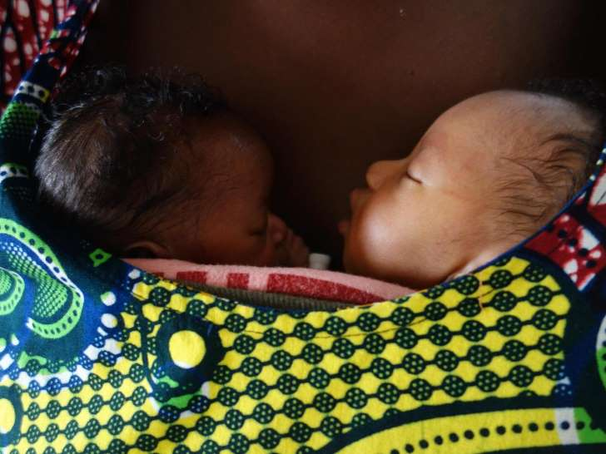
Bereitgestellt von dpa-infocom Frühchen brauchen Körperkontakt noch mehr als andere Neugeborene.
Frühgeborene Babys profitieren von intensivem Körperkontakt mit ihren Eltern auch noch Jahrzehnte später. Das hat eine Langzeitstudie zur sogenannten Känguru-Methode ergeben, die mit Unterstützung kanadischer Forscher in Kolumbiens Hauptstadt Bogota durchgeführt wurde.
Die untergewichtigen Frühchen wurden dabei von ihren Müttern viel auf nackter Haut getragen, gewärmt und gestillt.
Das getestete Programm umfasste aber weit mehr als diese Maßnahme: Die gesamten Familien wurden einbezogen und im Umgang mit den Winzlingen geschult. Kontrollgruppe waren Babys, die in ihren ersten Lebensmonaten auf herkömmliche Weise vor allem im Brutkasten betreut wurden. 18 bis 20 Jahre nach der Geburt wurden die Herangewachsenen drei Tage lang intensiv untersucht und befragt. Insgesamt wurden 264 zwischen 1993 und 1996 geborene Frühchen mit weniger als 1800 Gramm Geburtsgewicht berücksichtigt.
Für die Känguru-Frühchen zeigten sich demnach klare Vorteile: Sie seien zum Beispiel im Mittel weniger aggressiv, impulsiv und hyperaktiv wie solche, die ihre ersten Lebenswochen zumeist im Brutkasten verbrachten, schreiben die Autoren um Nathalie Charpak von der Fundación Canguro in Bogota. Allerdings ist das Ergebnis wegen der vergleichsweise kleinen Zahl berücksichtigter Kinder mit Vorsicht zu bewerten. Unterstützt wurde die Studie vom Förderprogramm Grand Challenges Canada der kanadischen Regierung.
Zu den im Fachjournal «Pediatrics» veröffentlichten Ergebnissen gehört auch, dass die Sterberate der Känguru-Frühchen merklich niedriger als bei der Kontrollgruppe im Brutkasten. Ihr Gehirn wuchs, speziell in den für das Lernen wichtigen Bereichen, stärker. Vor allem unter den sehr zarten Babys war auch der Intelligenzquotient 20 Jahre später etwas höher. Die Kinder aus dem Känguru-Programm legten eine bessere Schullaufbahn hin und fehlten weniger oft im Unterricht. Als junge Arbeitnehmer verdienten sie im Durchschnitt mehr.
Die Forscher erklären die positiven Folgen auch damit, dass die Eltern der Känguru-Gruppe dank der begleitenden Schulungen besser über die Bedürfnisse von Babys Bescheid wussten und dieses Wissen anhaltend umsetzten. Einen Effekt hatte dies vor allem bei ärmeren Familien mit geringem Bildungsgrad. «Die alltäglichen Aktivitäten zuhause haben langfristig den größten direkten Einfluss auf ein Kind.»
Das Programm habe sich auch auf die Familien insgesamt positiv ausgewirkt: Ihr Zusammenhalt sei besser und die Grundstimmung liebevoller gewesen. Zudem zeigte sich, dass Paare eher zusammengeblieben waren, wenn auch der Vater seinen frühgeborenen Nachwuchs im Tuch herumgetragen hatte.
Jährlich kommen nach Daten der Weltgesundheitsorganisation (WHO) weltweit insgesamt etwa 15 Millionen Kinder zu früh - vor der 38. Schwangerschaftswoche - auf die Welt. «Wir sind fest überzeugt, dass diese effiziente, wissenschaftlich basierte Methode in allen Umgebungen angewendet werden kann - von solchen mit sehr beschränktem bis zu solchen mit uneingeschränktem Zugang zu Gesundheitseinrichtungen», betont Charpak.
Gerade weil Technik zur Frühgeborenen-Betreuung inzwischen in vielen Regionen der Welt verfügbar sei und es daher weniger schwere gesundheitliche Folgeschäden gebe, komme es darauf an, auf die kleinen Effekte zu achten. «Kleine Auswirkungen wie geringfügige kognitive Defizite, eine schlechtere Feinmotorik, verminderte Hör- oder Sehfähigkeit und Konzentrationsstörungen können unentdeckt bleiben, haben aber tiefgreifende Effekte auf das Leben der Familien.»
Auch in Deutschland ist das «Känguruen» in Frühgeborenenstationen verbreitet. Nicht nur die winzigen Babys profitieren davon. Die Eltern lernen, mit den zerbrechlich wirkenden Winzlingen umzugehen, Berührungsängste zu überwinden und eine Beziehung aufzubauen. Vor allem Frühchen-Mütter fühlen sich manchmal insgeheim schuldig, weil sie ihr Baby nicht wie erhofft neun Monate austragen konnten.

Los bebés prematuros se benefician del contacto constante con la piel de la madre, según estudio 205 El método canguro defiende que los bebés prematuros y por tanto, con bajo peso, pasen mucho tiempo en contacto piel con piel con la madre. Foto Referencial: Pixabay COMPARTIR 0 VALORAR ARTICULO Indignado 0 Triste 0 Indiferente 0 Sorprendido 0 Contento 4 Agencia DPA Los bebés prematuros se benefician de haber mantenido un intenso contacto físico con sus padres aún décadas después del nacimiento, según revela un estudio sobre el llamado método canguro desarrollado en Bogotá con ayuda de investigadores canadienses y publicado en la revista Pediatrics. El método canguro defiende que los bebés prematuros y por tanto, con bajo peso, pasen mucho tiempo en contacto piel con piel con la madre. El programa analizado en esta investigación involucra además a toda la familia. Como grupo de control se utilizó a bebés que pasaron sus primeros meses de vida en una incubadora. Pasados entre 18 y 20 años, los adultos fueron entrevistados y sometidos a pruebas durante tres días. Los que siguieron el método canguro mostraron claras ventajas: eran menos agresivos, impulsivos e hiperactivos que los que estuvieron en incubadora, escribe Nathalie Charpak, de la Fundación Canguro en la capital colombiana. Además, la tasa de mortalidad entre los bebés prematuros criados según el método canguro fue claramente más baja que en los del grupo de control. Y el desarrollo intelectual que se constató 20 años más tarde también fue algo más elevado entre los primeros. Los niños criados por el método canguro tuvieron una mejor trayectoria escolar y, de media, ganaban sueldos mejores en sus primeros empleos. No obstante, debido a la reducida cifra de bebés analizados el estudio debe valorarse con precaución. En total, participaron 264 bebés prematuros nacidos entre 1993 y 1996 con un peso inferior a 1,8 kilos. La fundación estuvo apoyada por el programa Grand Challenges Canada del Gobierno Canadiense. Los investigadores aclaran sobre los efectos positivos del método canguro que los padres de estos bebés estaban mejor informados sobre las necesidades de los pequeños y aplicaban estos conocimientos. "Las actividades diarias en casa ejercen a largo plazo la mayor influencia directa sobre el niño", señalan. No obstante, el programa ha tenido en general un efecto positivo en las familias: éstas se han mantenido más unidas y con un ambiente más cariñoso. Además, resultó que las parejas en las que el padre había llevado al bebé piel con piel en el pañuelo tenían una mejor relación. Según la Organización Mundial de la Salud (OMS) anualmente nacen unos 15 millones de niños prematuros, es decir, antes de la semana 38 del embarazo. "Estamos convencidos de que este método eficiente y basado en estudios científicos puede usarse en todos los ambientes, desde los más humildes a los que tienen acceso ilimitado a servicios sanitarios", subraya Charpak. Bebés prematuros y de bajo peso quintuplican riesgo de autismo: estudio Los niños prematuros crecen más rápido durante los primeros años Las malformaciones congénitas ponen en riesgo la v
Este contenido ha sido publicado originalmente por Diario EL COMERCIO

Kanguru bakımı" çocukların sağlığını ve zekasını olumlu etkiliyor
12 Aralık 2016 Pazartesi, 12:16
ANKARA (AA) - Bilim adamları, yeni doğan bebekle sürekli ten teması kurulmasını içeren "kanguru bakımı"nın çocukların daha sağlıklı, daha zeki ve başarılı olarak yetişmesini sağladığını ileri sürdü.
"Paediatrics" dergisinde yayımlanan araştırma, kanguru bakımı uygulanan bebeklerin diğer bebeklere oranla zeka testlerinde yüzde 3,5 oranında daha yüksek puan aldıklarını gösterdi.
Araştırmada, kanguru bakımı uygulanan bebeklerin, beyinlerinde daha yüksek gri madde hacmi bulunduğu tespit edildi.
Kolombiya'da 1993 ve 1996 yılları arasında doğan 700'den fazla prematüre bebekle ilgili verilerin analiz edildiği araştırma, kanguru bakımı uygulanan bebeklerde erken ölüm oranının diğerlerine oranla daha az olduğunu da ortaya koydu.
Araştırmacılar, erken ölüm oranını sürekli ten teması kurulan bebeklerde yüzde 3,5, diğerlerinde yüzde 7,7 olarak belirledi.
Araştırma sürecinde, bebeklerin bir kısmı, doğduktan sonra kuvöze konulmuş, diğerleri "kanguru" pozisyonunda annelerinin göğsü üzerinde tutulmuştu. Deneye katılan bebekler, 20 yıl boyunca çeşitli aralıklarla kontrole çağrılmıştı.
Kanada hükümetinin desteklediği çalışma, kanguru bakımı alan bebeklerin diğerlerine oranla daha az davranış sorunu gösterdiğini de ortaya çıkardı.
Bogota Kanguru Vakfından araştırmacı Dr. Nathalie Charpak, kanguru yönteminin güçlü, etkili ve bilimsel tabanlı olduğuna ve sağlık hizmetlerine ulaşılan ya da ulaşılamayan her yerde kullanılabileceğine işaret etti.

Kangaroo mother care helps premature babies thrive
Toronto Telegraph (IANS) Monday 12th December, 2016

Toronto, Dec 12 (IANS) Kangaroo mother care, a method of caring for preterm infants that keeps the tiny babies warm and nourished through breastfeeding and continuous skin-to-skin contact, can leave lasting positive impact and make them healthier and wealthier later in life, new research has found.
In young adulthood, they are less prone to aggressive, impulsive and hyperactive behaviour compared to a control group of premature and low birth weight contemporaries who received "traditional" inpatient incubator care.
They are more likely to have survived into their 20s and they have bigger brains, showed the findings published in the journal Pediatrics
"This study indicates that Kangaroo mother care has significant, long-lasting social and behavioural protective effects 20 years after the intervention," said lead researcher Nathalie Charpak of the Kangaroo Foundation in Bogota, Colombia.
Kangaroo mother care involves continuous skin-to-skin contact between caregiver and infant, with the baby nestled in a "kangaroo" position on the caregiver's chest as soon as possible after birth.
The technique is accompanied by exclusive breastfeeding.
A premature infant is born somewhere in the world every two seconds, said Peter Singer, Chief Executive Officer of Grand Challenges Canada, a programme funded by Government of Canada.
"This study shows that Kangaroo mother care gives premature and low birth weight babies a better chance of thriving. Kangaroo mother care saves brains and makes premature and low birth weight babies healthier and wealthier," Singer said.
Premature and low birth weight infants generally require extra care to avoid illness and death from secondary, preventable complications such as hypothermia and infection.
This is a particular problem in developing countries, where incubators and similar technologies are often scarce, over-crowded or unreliable, as well as costly.
A trained Kangaroo mother care parent or caregiver becomes a child's incubator and its main source of food and stimulation.
The research compared 18 to 20 year olds who, as premature and low birth weight infants, had been randomised at birth to receive either Kangaroo mother care or traditional incubator care until they could maintain their own body temperature.
The researchers found that Kangaroo mother care can make all the difference in the world for premature and low birth weight infants and help them thrive.
--IANS

Kangaroo cuddles can help premature babies thrive: study
Washington, Dec 12 (PTI) Premature babies given skin-to-skin contact and nourishment through breastfeeding are better behaved, have larger brains, higher paychecks, more protective and nurturing families in later life than those placed in incubators, researchers claim.
Such children receiving Kangaroo Mother Care (KMC) - warmth and nourishment through breastfeeding and continuous skin-to-skin contact - are also less prone to aggressive, impulsive and hyperactive behaviour, said researchers from the Kangaroo Foundation in Colombia.
The children are more likely to have survived into their 20s and have bigger brains, they said.
Premature and low birth weight infants generally require extra care to avoid illness and death from secondary, preventable complications such as hypothermia and infection.
This is a particular problem in developing countries, where incubators and similar technologies are often scarce, over-crowded or unreliable, as well as costly.
A trained KMC parent or caregiver becomes a childs incubator and its main source of food and stimulation.
The technique involves continuous skin-to-skin contact between caregiver and infant, with the baby nested in a "kangaroo" position on the caregivers chest as soon as possible after birth. The technique is accompanied by exclusive breastfeeding.
"This study indicates that KMC has significant, long-lasting social and behavioural protective effects 20 years after the intervention," said lead researcher Nathalie Charpak from the Kangaroo Foundation.
The techniques early impact was still present 20 years later for those who started life as the most fragile individuals, she said.
Families trained in KMC were more likely to remain together and to be more protective and nurturing, reflected in their childrens lower school absenteeism, ability to express feelings, and reduced hyperactivity, aggressiveness and antisocial conduct as young adults.
"The study shows that KMC gives premature and low birth weight babies a better chance of thriving. It saves brains and makes premature and low birth weight babies healthier and wealthier," said Peter Singer from Grand Challenges in Canada.
The research compared 18 to 20 year olds who, as premature and low birth weight infants, had been randomised at birth to receive either KMC or traditional incubator care until they could maintain their own body temperature.
During that initial randomised control trial in 1993-96, researchers documented the short and mid-term benefits of KMC training on the infants survival, brain development, breastfeeding and the quality of mother-infant bonding.
In 2012-2014, 264 of the original participants who weighed less than 1800 grammes at birth were re-enrolled (61 per cent of infants that qualified).
KMC also offered significant protection against early death. The mortality rate in the control group (7.7 per cent) was more than double that of the KMC group (3.5 per cent).
The study was published in the journal Pediatrics. PTI NKS SAR SAR

Frühgeborene Babys brauchen besonders viel liebevollen Körperkontakt, um sich gut zu entwickeln: Eine Studie zeigt jetzt, dass die „Känguru-Methode“ mit ihnen noch viele Jahre später erfreuliche Folgen hat.
Die untergewichtigen Frühchen wurden dabei von ihren Müttern viel auf nackter Haut getragen, gewärmt und gestillt. Das getestete Programm umfasste aber weit mehr als diese Maßnahme: Die gesamten Familien wurden einbezogen und im Umgang mit den Winzlingen geschult.
Kontrollgruppe waren Babys, die in ihren ersten Lebensmonaten auf herkömmliche Weise vor allem im Brutkasten betreut wurden. 18 bis 20 Jahre nach der Geburt wurden die Herangewachsenen drei Tage lang intensiv untersucht und befragt.

Gehirn entwickelt sich besser
Für die Känguru-Frühchen zeigten sich demnach klare Vorteile: Sie seien zum Beispiel im Mittel weniger aggressiv, impulsiv und hyperaktiv wie solche, die ihre ersten Lebenswochen zumeist im Brutkasten verbrachten, schreiben die Autoren um Nathalie Charpak von der Fundación Canguro in Bogota. Allerdings ist das Ergebnis wegen der vergleichsweise kleinen Zahl berücksichtigter Kinder mit Vorsicht zu bewerten – die Forschergruppe untersuchte den Lebensweg von 264 Kindern, die zwischen 1993 und 1996 mit weniger als 1.800 Gramm Geburtsgewicht geboren wurden.

Die Studie
“Twenty-year Follow-up of Kangaroo Mother Care Versus Traditional Care”, Pediatrics, 12.12.
Zu den nun veröffentlichten Ergebnissen gehört auch, dass die Sterberate der Känguru-Frühchen merklich niedriger als bei der Kontrollgruppe im Brutkasten. Ihr Gehirn wuchs, speziell in den für das Lernen wichtigen Bereichen, stärker. Vor allem unter den sehr zarten Babys war auch der Intelligenzquotient 20 Jahre später etwas höher. Die Kinder aus dem Känguru-Programm legten eine bessere Schullaufbahn hin und fehlten weniger oft im Unterricht. Als junge Arbeitnehmer verdienten sie im Durchschnitt mehr.
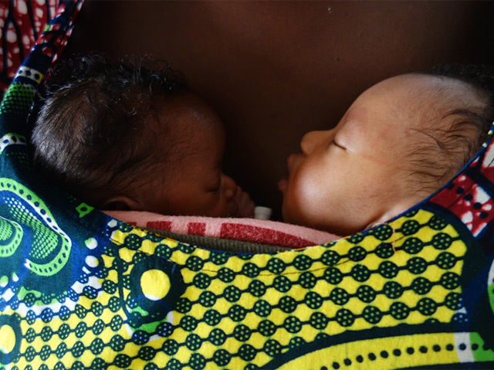
Fundación Canguro
Zwei Frühchen im Wickeltuch

Auch die Väter machen mit
Die Forscher erklären die positiven Folgen auch damit, dass die Eltern der Känguru-Gruppe dank der begleitenden Schulungen besser über die Bedürfnisse von Babys Bescheid wussten und dieses Wissen anhaltend umsetzten. Einen Effekt hatte dies vor allem bei ärmeren Familien mit geringem Bildungsgrad. „Die alltäglichen Aktivitäten zuhause haben langfristig den größten direkten Einfluss auf ein Kind.“
Das Programm habe sich auch auf die Familien insgesamt positiv ausgewirkt: Ihr Zusammenhalt sei besser und die Grundstimmung liebevoller gewesen. Zudem zeigte sich, dass Paare eher zusammengeblieben waren, wenn auch der Vater seinen frühgeborenen Nachwuchs im Tuch herumgetragen hatte.

15 Millionen Frühchen pro Jahr
Jährlich kommen nach Daten der Weltgesundheitsorganisation (WHO) weltweit insgesamt etwa 15 Millionen Kinder zu früh - vor der 38. Schwangerschaftswoche - auf die Welt. „Wir sind fest überzeugt, dass diese effiziente, wissenschaftlich basierte Methode in allen Umgebungen angewendet werden kann - von solchen mit sehr beschränktem bis zu solchen mit uneingeschränktem Zugang zu Gesundheitseinrichtungen“, betont Charpak.
Gerade weil Technik zur Frühgeborenen-Betreuung inzwischen in vielen Regionen der Welt verfügbar sei und es daher weniger schwere gesundheitliche Folgeschäden gebe, komme es darauf an, auf die kleinen Effekte zu achten.
„Kleine Auswirkungen wie geringfügige kognitive Defizite, eine schlechtere Feinmotorik, verminderte Hör-oder Sehfähigkeit und Konzentrationsstörungen können unentdeckt bleiben, haben aber tiefgreifende Effekte auf das Leben der Familien.“
science.ORF.at/dpa

Kenguruhoidetuilla keskosilla on aikuisena isommat aivot – ja palkkapussi

Kaksikymmentä vuotta sitten ennenaikaisesti syntyneet lapset hyötyivät sylistä ja ihokontaktista.
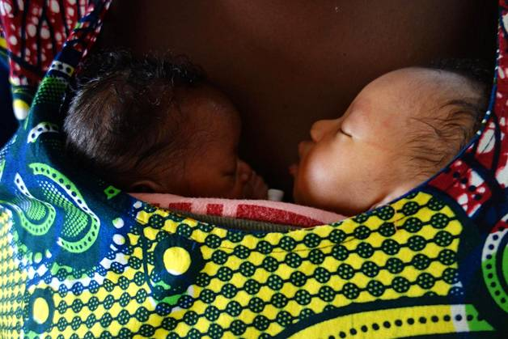
Kaksosvauvat kenguruhoidossa Gabriel Tourén sairaalassa. (KUVA: FUNDACIÓN CANGURO)
Kirsi Heikkinen
Julkaistu: 12.12. 11:25

PARIKYMMENTÄ vuotta sitten ryhmälle kolumbialaisia vanhempia neuvottiin uusi tapa hoitaa pieniä keskosvauvojaan: lasta piti muun muassa pidellä tiiviissä kontaktissa lämmintä ihoa vasten. Tämä niin kutsuttu kenguruhoito edisti näiden lasten kehitystä monin tavoin, osoittaa tuore seurantatutkimus.
Asiaa kartoittivat bogotálaisen Canguro-säätiön tutkijat. He vertasivat vuosina 1993–1996 keskosina syntyneitä lapsia, jotka oli tuolloin satunnaistettu joko kenguruhoitoryhmään tai perinnäiseen keskoshoitoon.
HOITOKOKEESEEN osallistuneiden keskosten kehitystä seurattiin tiiviisti. Kun nämä olivat ehtineet 18–20-vuoden ikään, 264 heistä tutkittiin taas. Jokainen heistä oli painanut syntyessään alle 1 800 grammaa.
Kävi ilmi, että kenguruhoidetut keskoset ovat nuorina aikuisina vähemmän aggressiivisia, impulsiivisia ja hyperaktiivisia kuin verrokkinsa. He nukkuvat paremmin ja ovat vähemmän stressaantuneita.
Aivot ovat keskimäärin suuremmat. Aivokuori on paksumpi. Häntätumake, joka on tärkeä osa oppimisjärjestelmää, on isompi.
Niin ikään ilmeni, että kenguruhoidetut kävivät aikoinaan ahkerammin esikoulua ja olivat pois koulusta harvemmin kuin verrokkiryhmäläiset. Palkkatöissä heidän tuntipalkkansa on yli puolet suurempi.
”Tulokset osoittavat, että kenguruhoidolla on pitkäkestoinen vaikutus käyttäytymiseen”, sanoo tutkijaryhmän jäsen Nathalie Charpak tiedotteessa.
KIINTEÄ varhainen kontakti näkyi koko perheen keskinäisissä suhteissa: kenguruhoitoryhmäläisten perheet ovat tiiviimpiä ja toisiaan kannustavampia kuin muut.
WHO:n mukaan maailmassa syntyy noin 15 miljoonaa keskosta vuosittain. Moni heistä kuolee. Moni niistä, jotka selviävät hengissä, kärsii myöhemmin kehityksen häiriöistä ja oppimisvaikeuksista.
Keskosina tai alipainoisina syntyneet lapset tarvitsevat yleensä erityishoitoa, jota erityisesti kehitysmaissa on vaikea saada. Muun muassa keskoskaapeista kun on pulaa.
Kenguruhoito voi paikata puutetta, koska se tekee vanhemmasta ”elävän keskoskaapin”, tutkijat huomauttavat.
Tulosten mukaan kenguruhoidetut keskoset selviävät todennäköisemmin aikuisuuteen kuin verrokit. Kuolleisuus oli kengurumenelmään turvautuneessa ryhmässä alle puolet pienempi.
Tutkimuksen julkaisi Pediatrics.

För tidigt födda verkar gynnas av känguruvård
Publicerat måndag 12 december kl 06.00

"Med enkla metoder kan man rädda liv"
(1:31 min)

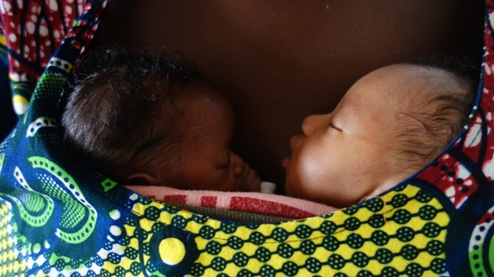
Tvillingar som får känguruvård på Gabriel Touré Hospital i Bamako, Mali. Foto: Fundación Canguro
För tidigt födda barn som behandlats med kängurumetoden verkar klara sig bättre än dem som legat i kuvös. Det visar en ny studie.
Kängurumetoden går ut på att föräldrar blir kuvösen och barnet får ligga mot bröstet för ständig hudkontakt.
I studien jämfördes för tidigt födda som fick känguruvård och de som låg i kuvös. Efter tjugo år ser man att de barn som fick känguruvård både överlevde i högre grad och fick bättre förutsättningar i framtiden. Exempelvis hade barnen lägre frånvaro i skolan och bättre social förmåga. De hade också större hjärnor, högre lön och föräldrar som höll ihop.
– Enkla tekniker ger lika mycket eller kanske ännu mer när det gäller att rädda liv och uppnå goda medicinska effekter. Det här är ju inget spektakulärt eller kräver någon speciellt sofistikerad teknik, säger Hugo Lagercrantz, senior professor i barnmedicin.
I Sverige används metoden på flera sjukhus, men resultatet borde kunna få ännu fler sjukhus att använda det här som standardbehandling för att vårda för tidigt födda barn säger Hugo Lagercrantz.
Den visar dock inte på ett orsakssamband men betyder ändå mycket för vården, speciellt i länder där man inte har råd med kuvös eller där elektriciteten inte alltid går att lita på, menar Hugo Lagercrantz.
Referens: N. Charpak et al, Twenty-year Follow-up of Kangaroo Mother Care versus Traditional Care, Pediatrics, DOI: 2016-2063.R2

Η αγκαλιά "καγκουρό" κάνει πιο υγιή και πιο
Νέα μελέτη αποδεικνύει ότι η αγκαλιά "καγκουρό", δηλαδή η επαφή του γονιού με το μωρό δέρμα με δέρμα, συμβάλλει στην καλύτερη σωματική και πνευματική υγεία των παιδιών.
Η πιο τρυφερή αγκαλιά, αυτή που η μαμά ή ο μπαμπάς κρατούν κατάσαρκα το μωρό τους, δεν είναι μόνο έκφραση απέραντης στοργής και φροντίδας, αλλά και ζωτικής σημασίας για τα πρόωρα μωρά, που αναγκάζονται να στερηθούν το γονεϊκό χάδι τις πρώτες μέρες της ζωής τους, λόγω του ότι παλεύουν να επιβιώσουν στις θερμοκοιτίδες των μονάδων εντατικής φροντίδας.
Βέβαια η αγκαλιά "καγκουρό" δεν είναι μόνο για τα λεγόμενα βιαστικά μωρά, αλλά για όλα. Για τούτο και συνηθίζεται, αμέσως μετά τη γέννησή τους, να τα βάζουν στην αγκαλιά της μαμάς τους.
Μετά από 20 χρόνια η νέα μελέτη επιβεβαιώνει ότι, τα μωρά που γαλουχήθηκαν με τη μέθοδο "καγκουρό", δεν αντιμετωπίζουν προβλήματα συμπεριφοράς και επιθετικότητας μεγαλώνοντας. Επιπλέον γίνονται πιο έξυπνα και πιο πετυχημένα, αλλά και πιο υγιή. Συγκεκριμένα η μελέτη εξέτασε 700 παιδιά, που γεννήθηκαν πρόωρα την περίοδο 1993-1996 και βίωσαν την εμπειρία "καγκουρό", δυο δεκαετίες μετά, όταν, πια, ήταν νέοι ενήλικες.
Τα ευρήματα δημοσιεύθηκαν στην επιθεώρηση Paediatrics. Διαπιστώθηκε ότι η αγκαλιά "καγκουρό" μείωσε τα ποσοστά πρόωρου θανάτου κατά 7.7%. Τα τεστ IQ έδειξαν ένα πλεονέκτημα της τάξης του 3.5%.
Ο επικεφαλής ερευνητής Dr Nathalie Charpak, από το Ίδρυμα Καγκουρό στη Bogota, είπε σχετικά: "Πιστεύουμε ακράδαντα ότι η αγκαλιά "καγκουρό" είναι μια δυνατή, αποτελεσματική μέθοδος παρέμβασης, επιστημονικά τεκμηριωμένη, που μπορεί να χρησιμοποιείται υπό οποιεσδήποτε συνθήκες".

New benefits to Kangaroo Mother Care for kids, even 20 years later
By Frank Espinoza - News Producer
It has a funny name, but scientists are learning so called Kangaroo Mother Care, has very long-term effects on babies that can last into early adulthood.
Kangaroo Mother Care, or continuous skin to skin contact between parent and child, is often recommended for preemies to help with breastfeeding and bonding.
Researchers found that 20 years later these mothers were more protective and nurturing. They also found children were less likely to have hyperactivity or behavior problems.
​

Chicago Tribune, USA (from HealthDay)
Published 28 Dec 2016, page: 52
‘Kangaroo mother care’ helps preemies

South China Morning Post, Hong Kong (also appears in the print edition)
How ‘kangaroo care’ can benefit premature babies, with discernible results even 20 years later
http://www.scmp.com/lifestyle/health-beauty/article/2058211/how-kangaroo-care-can-benefit-premature-babies-discernible

China Daily, China / and China Daily, Hong Kong edition (from The Telegraph)

Europa Press, newswire, Spain
(via InfoSalus and several other Spanish-language news sites)
Los beneficios del 'piel con piel' en bebés prematuros
http://www.infosalus.com/mujer/noticia-beneficios-piel-piel-prematuros-20161213080139.html

Sohu, China
袋鼠式护理能让婴儿至少受益20年 (Kangaroo care can benefit babies at least 20 years)
http://news.sohu.com/20161219/n476257183.shtml

Bao Moi, Vietnam
Lương cao hơn nhờ được 'ấp' kiểu kangaroo thuở bé?
http://www.baomoi.com/luong-cao-hon-nho-duoc-ap-kieu-kangaroo-thuo-be/c/21174270.epi

Thoi Bao, Vietnam
Chiếc túi Kangaroo kỳ diệu
http://thoibao.today/paper/chiec-tui-kangaroo-ky-dieu-1561882

Sunday Trust, Nigeria

Forskning, Norway
Hudkontakt hjelper for tidlig fødte helt til de er voksne (Skin helps premature until they are adults)
http://forskning.no/helse-forebyggende-helse-barn-og-ungdom/2016/12/kenguru-metoden-hjelper-tidlig-fodte-helt-til-de-er

Medic Alive Magazine, Italy
‘Canguro-terapia’ con mamma e papà, benefici durano decenni ('Kangaroo-therapy' with Mom and Dad, benefits last decades)
http://medicalive.it/canguro-terapia-mamma-papa-benefici/

Vorarlberger Nachrichten, Austria
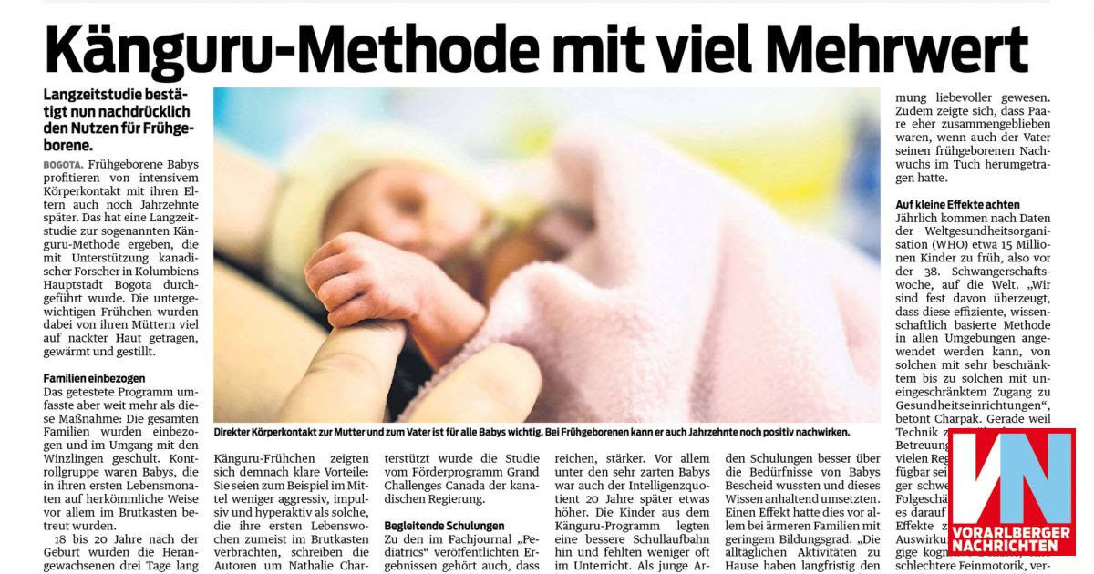

Deutsche Welle, Germany
Chinese
“袋鼠育儿法”对早产儿一生有益 ("Kangaroo Parenting Act" on premature children useful life)
http://www.dw.com/zh/%E8%A2%8B%E9%BC%A0%E8%82%B2%E5%84%BF%E6%B3%95%E5%AF%B9%E6%97%A9%E4%BA%A7%E5%84%BF%E4%B8%80%E7%94%9F%E6%9C%89%E7%9B%8A/a-36762202?&zhongwen=simp

Deutsche Presse Agentur, Germany
Spanish
El método canguro de crianza tiene efectos positivos de por vida
via La Hora, Guatemala
http://lahora.gt/metodo-canguro-crianza-efectos-positivos-vida/
and, in print,
Prensa Libre, Guatemala
Page: 41

Go Riau, Indonesia
'Pelukan Kangguru' Ampuh Tangani Bayi Prematur ('Hug Kangaroo' Powerful Handle Premature Babies)
https://www.goriau.com/kesehatan/pelukan-kangguru-ampuh-tangani-bayi-prematur.html

Humanosphere, USA
No tech needed: Skin-to-skin contact for premature babies saves lives and has long-term benefits
http://www.humanosphere.org/global-health/2016/12/no-tech-needed-skin-skin-contact-premature-babies-saves-lives-long-term-benefits/

eMax, USA
Tiny babies can benefit greatly from Kangaroo Mother Care
http://www.emaxhealth.com/11402/tiny-babies-can-benefit-greatly-kangaroo-mother-care

Reuters, UK
Spanish: Método "mamá canguro" favorece la salud de los niños a largo plazo
https://es-us.noticias.yahoo.com/m%C3%A9todo-mam%C3%A1-canguro-favorece-la-salud-los-ni%C3%B1os-140001673.html

Can Tho Online, Viet Nam
Phương pháp "da kề da" có lợi cho trẻ đến khi trưởng thành
http://www.baocantho.com.vn/?mod=detnews&catid=74&id=187620

Neuf Mois, France
En quoi le peau à peau avec un bébé né prématuré lui est favorable 20 ans plus tard ?
http://www.neufmois.fr/au-fil-de-lactu/quoi-peau-a-peau-bebe-ne-premature-lui-favorable-20-ans-plus-tard

The Post Internazionale, Italy
La Canguro Terapia Migliora La Salute e L'intelligenza Dei Bambini Prematuri
http://www.tpi.it/mondo/colombia/canguro-terapia-migliora-salute-intelligenza-bambini-prematuri

RTVE, Spain,
http://www.rtve.es/alacarta/videos/uned/uned-5-16122016-nacer-ser-padres/3829033/

BBC World Service (Health Check)
9 minutes long, starts ~16 min mark
http://www.bbc.co.uk/programmes/p04kfy77
Major thanks to Nathalie for the GCC acknowledgement!

The Guardian, UK
'Kangaroo care' makes premature babies healthier and wealthier, study finds
https://www.theguardian.com/global-development/2016/dec/14/kangaroo-mother-care-premature-babies-healthier-wealthier-study-claims

O Globo, Brazil
Portuguese: Método canguru faz prematuros serem adultos mais saudáveis e promissores (Kangaroo method makes premature babies are healthier and more promising adults)
http://oglobo.globo.com/sociedade/saude/metodo-canguru-faz-prematuros-serem-adultos-mais-saudaveis-promissores-20647612

Deutsche Welle, Germany
Portuguese: Método canguru beneficia prematuros no longo prazo
http://www.dw.com/pt-br/m%C3%A9todo-canguru-beneficia-prematuros-no-longo-prazo/a-36756639?maca=bra-rss-br-all-1030-rdf

HKN, Korea
캥거루 케어’ 받은 아이, 똑똑하고 튼튼하다 ('Kangaroo Care' receiving child is smart and durable)
http://www.hkn24.com/news/articleView.html?idxno=158964

Klix, Bosnia and Herzegovina
Bosnean: Klokan metoda čini nedonoščad zdravijom i bogatijom (Kangaroo method seems premature babies healthier and richer)
http://www.klix.ba/lifestyle/bebe/klokan-metoda-cini-nedonoscad-zdravijom-i-bogatijom/161214140

Videnskab, Denmark
Danish: 'Kængurupleje' gavner for tidligt fødte bedre end kuvøse ('Kangaroo Care' benefit premature better than incubator)
http://videnskab.dk/krop-sundhed/kaengurupleje-gavner-for-tidligt-foedte-bedre-end-kuvoese

Ethnos, Greece
Greek: Τα πρόωρα βρέφη γίνονται πιο υγιή και... πλούσια με τη φροντίδα «καγκουρό» (Premature babies are healthier and ... rich with care “kangaroo")
http://www.ethnos.gr/epistimi/arthro/ta_proora_brefi_ginontai_pio_ygii_kai_plousia_me_ti_frontida_kagkouro-64760683/

Psychology Today, USA
What We Can Learn from Kangaroos
https://www.psychologytoday.com/blog/birth-babies-and-beyond/201612/what-we-can-learn-kangaroos

ANSA newswire, Italy
Pelle a pelle con mamma e papà, benefici 'canguro-terapia' durano decenni
http://www.ansa.it/canale_saluteebenessere/notizie/salute_bambini/medicina/2016/12/13/pelle-a-pelle-con-mamma-e-papa-benefici-durano-decenni_6f3bc61b-cb82-44a7-bf2d-4e4e5c36ff54.html

Topsante (via Yahoo News, France)
Le peau à peau pour accompagner les bébés prématurés
https://fr.news.yahoo.com/peau-%C3%A0-peau-accompagner-b%C3%A9b%C3%A9s-200100564.html

International Business Times, India (2nd story)
'Kangaroo mother care' turns out to be vital for pre-term babies
http://www.ibtimes.co.in/kangaroo-mother-care-turns-out-be-vital-pre-term-babies-708201

Newser, USA
Study Suggests Moms Take Preemies Out of the Incubator
http://www.newser.com/story/235359/study-suggests-moms-take-preemies-out-of-the-incubator.html

Her Family, Ireland
Babies Given Skin-To-Skin Contact Show Benefits DECADES Later
https://www.herfamily.ie/pregnancy/study-finds-babies-given-skin-skin-contact-show-benefits-decades-later/254242

Wienlive look! Austria
Die Känguru-Methode unterstützt die Entwicklung von Frühgeburten
http://www.looklive.at/lifestyle/2016-12-13-die-kaenguru-methode-unterstuetzt-die-entwicklung-von-fruehgeburten-99045/

Daily Sabah, Turkey
'Kangaroo mothering' boosts mental, physical health in babies
http://www.dailysabah.com/health/2016/12/14/kangaroo-mothering-boosts-mental-physical-health-in-babies

Aponet, Germany
Wie Frühchen von der Känguru-Methode profitieren
https://www.aponet.de/aktuelles/forschung/20161213-wie-fruehchen-von-der-kaenguru-methode-profitieren.html

Heilpraxisnet, Germany
Positive Nähe zur Mutter: Känguru-Methode fördert Frühchen jahrzehntelang
http://www.heilpraxisnet.de/naturheilpraxis/positive-naehe-zur-mutter-kaenguru-methode-foerdert-fruehchen-jahrzehntelang-20161213212799

Huffington Post, USA
Incredible Study Shows Cuddling Preemies Helps Them For Decades
http://www.huffingtonpost.com/entry/incredible-study-shows-cuddling-preemies-helps-them-for-decades_us_584ee5b0e4b0e05aded4db59

Bluewin, Switzerland
Maternité : le contact peau à peau, un atout pour les prématurés
https://www.bluewin.ch/fr/conso/mode-beaute/2016/12/13/maternite---le-contact-peau-a-peau--un-atout-pour-.html

NL Cafe, Hungary
Évtizedekig tarthat a koraszülötteknél alkalmazott módszer jótékony hatása (Six decades of the method used in premature infants beneficial)
http://www.nlcafe.hu/baba/20161212/koraszulott-modszer-kutatas-kenguru/

NBC News, USA
Cuddling Preemies Kangaroo Style Helps Into Adulthood
http://www.nbcnews.com/health/health-news/cuddling-preemies-kangaroo-style-helps-adulthood-n694971

Reuters, UK
Skin-to-skin 'kangaroo' baby care tied to better health years later
http://uk.reuters.com/article/us-health-infants-kangaroo-care-idUKKBN14127B

Agencia EFE, Spain
Los beneficios de método canguro para bebé prematuros duran décadas, dice un estudio
http://www.eldiario.es/cultura/tecnologia/beneficios-canguro-prematuros-decadas-estudio_0_590041810.html

Parents .com, USA
Babies Given Kangaroo Care Show Benefits Decades Later
http://www.parents.com/baby/all-about-babies/babies-given-kangaroo-care-show-benefits-decades-later/

WebMD, USA
Kangaroo mothering 'helps premature babies'
http://www.webmd.boots.com/children/news/20161212/kangaroo-mothering-helps-premature-babies

Spektrum, Germany
Känguru-Methode hilft Frühchen über Jahrzehnte (Kangaroo care helps preemies decades later)
http://www.spektrum.de/news/kaenguru-methode-hilft-fruehchen-ueber-jahrzehnte/1432436

American Academy of Paediatrics, USA
Kangaroo Mother Care 20 Years Later: Connecting Infants and Families
http://pediatrics.aappublications.org/content/early/2016/12/08/peds.2016-3332

CBC, Canada
Kangaroo care for preemies shows profound power of touch
http://www.cbc.ca/news/health/kangaroo-care-1.3892201

HealthDay, USA
'Kangaroo Mother Care' May Improve Preemies Lives into Adulthood
via US News and World Report
http://health.usnews.com/health-care/articles/2016-12-12/kangaroo-mother-care-may-improve-preemies-lives-into-adulthood

LiveScience, USA
Benefits of 'Kangaroo Mother Care': Do They Last?
http://www.livescience.com/57171-benefits-of-kangaroo-mother-care-last-decades.html

Die Welt, Germany
Känguru-Methode nützt Frühchen noch Jahre später
https://www.welt.de/gesundheit/article160227650/Kaenguru-Methode-nuetzt-Fruehchen-noch-Jahre-spaeter.html

Epoch Times, China
“袋鼠育儿法”有助于提升早产儿的健康和智力 "Kangaroo Parenting Act" to help improve the health and intelligence of premature children
http://www.epochtimes.com/gb/16/12/12/n8584079.htm

Daily Mail, UK (page 23)
How 'kangaroo cuddles' can help premature babies: Infants given skin-to-skin contact with mothers develop better than those placed in incubators
http://www.dailymail.co.uk/health/article-4023388/How-kangaroo-cuddles-help-premature-babies-Infants-given-skin-skin-contact-mothers-develop-better-placed-incubators.html

The Telegraph, UK
'Kangaroo mothering' helps boost a child's health and intelligence, study finds
http://www.telegraph.co.uk/news/2016/12/12/kangaroo-mothering-helps-boost-childs-health-intelligence-study/

International Business Times, UK
How 'kangaroo mothers' help tiny, premature babies survive and thrive
http://www.ibtimes.co.uk/how-kangaroo-mothers-help-tiny-premature-babies-survive-thrive-1595724

Sunday World, UK
'Kangaroo mothering' helps premature babies thrive
https://www.sundayworld.com/style/health/kangaroo-mothering-helps-premature-babies-thrive

Forbes, USA
Kangaroo Care Still Benefits Preemies 20 Years Later
http://www.forbes.com/sites/tarahaelle/2016/12/12/kangaroo-care-still-benefits-preemies-even-20-years-later/#5c3f8fdf76e5

Medpage Today, USA
Kangaroo Care Linked to Long-Term Benefits
http://www.medpagetoday.com/pediatrics/parenting/61988

Deutsch Presse Agentur, Germany
German: Känguru-Methode kann Frühchen lebenslang nützen (Kangaroo method can improve premature life)
http://www.msn.com/de-de/nachrichten/wissenundtechnik/k%C3%A4nguru-methode-kann-fr%C3%BChchen-lebenslang-n%C3%BCtzen/ar-AAlr322
Spanish: Los bebés prematuros se benefician del contacto constante con la piel de la madre, según estudio (Premature babies benefit from constant contact with the skin of the mother, study finds)
http://www.elcomercio.com/tendencias/bebes-prematuros-beneficios-piel-madre.html

Anadolu Agency, Turkey
"Kanguru bakımı" çocukların sağlığını ve zekasını olumlu etkiliyor
http://www.haberturk.com/yerel-haberler/haber/10330962-kanguru-bakimi-cocuklarin-sagligini-ve-zekasini-olumlu-etkiliyor

IndoAsian News Service, India
Kangaroo mother care helps premature babies thrive
http://www.torontotelegraph.com/index.php/sid/250118123

Press Trust of India
Kangaroo cuddles can help premature babies thrive: study
http://indiatoday.intoday.in/story/kangaroo-cuddles-can-help-premature-babies-thrive-study/1/832697.html

ORF Science, Germany
Känguru-Methode schützt Frühchen
http://science.orf.at/stories/2814142/

Helsingin Sanomat, Finland
Kenguruhoidetuilla keskosilla on aikuisena isommat aivot – ja palkkapussi
http://www.hs.fi/tiede/art-2000005003607.html

Sveriges Radio, Sweden
För tidigt födda verkar gynnas av känguruvård
http://sverigesradio.se/sida/artikel.aspx?programid=406&artikel=6584083

HealthMag, Greece
Η αγκαλιά "καγκουρό" κάνει πιο υγιή και πιο έξυπνα τα παιδιά (The "kangaroo” hug makes healthier and smarter children)
http://healthmag.gr/post/5841/h-agkalia-kagkoyro-kanei-pio-ygih-kai-pio-eksypna-ta-paidia

KPRC Houston, USA
New benefits to Kangaroo Mother Care for kids, even 20 years later
http://www.click2houston.com/news/new-benefits-to-kangaroo-mother-care-on-kids-even-20-years-later

